
Instructions
Use this form to assess if home modifications are required to maximise a person’s safety and capabilities in their home. Please note:
- Approval and discussion with a TAC home modifications officer must be obtained prior to completing a home assessment.
- The assessment should be conducted with input from the builder or project manager and the TAC home modifications officer at the site visit.
- Consider alternatives, including modification of technique and/or equipment, prior to providing home modification recommendations.
- Include photographs of any areas of the property or home requiring modifications.
- Provide reasons if you are unable to complete a section, as incomplete forms will be returned.
- For more information contact the TAC Home Modifications team at home_modifications@tac.vic.gov.au

Section 1

TAC client details
First name

Last name

TAC claim number |  | Date of accident | / /

Date of birth | / /

Type of client

Street name and number

Suburb/Town |  | Post code

Client phone number

Client email address

Key contact if not client

Key contact phone number

Relationship of key contact
(e.g. parent, partner, guardian)

Section 2

Property details
Address of property to be assessed

Ownership status of the property

Is property owner aware of potential modifications?

Description of home
(flat or block, 1 or 2 baths, etc.)

Section 3

current living arrangements
Who does the person currently live with?

Describe the home environment.

Is the person intending to remain in this property for the foreseeable future?

Is the property well positioned for community access?

(e.g. public transport)
Other
Identify any areas of risk for future visits to the property. These risks may include home condition (e.g. structurally unsafe, hoarding) and security.
(e.g. firearms, hostile dogs, drug paraphernalia, remote location, fire risk)

Section 4

Assessment details
Date of assessment | / / | Date of report | / /

Occupational therapist’s name

Individuals contributing to this report

Attendees at the property assessment

Section 5

Capabilities
Describe the person’s expected abilities and equipment used on return to home/community living.
Indoor mobility
Outdoor mobility
Upper limb function
Lower limb function
Transfers
Toileting
Dressing
Bathing
Grooming
Eating
Meal preparation
Cleaning
Laundry
Community mobility
and transportation
Work/education/recreation
(within the home environment)
Overnight care requirements
Functional cognitive status
Behavioural issues

Section 6

Expected outcomes post home modifications
Discuss how the home modifications may affect the person’s independence.
Current services provided | Hours per  billing period  (Please refer to TAC  OT Referral) | Post home modifications services required | Will hours per  billing period be the same, reduced or unknown? | Hours per billing period
Personal care |  | Personal care
Therapy support |  | Therapy support
Community access |  | Community access
Inactive sleepovers |  | Inactive sleepovers
Active sleepovers |  | Active sleepovers
Domestic support /  home services |  | Domestic support /  home services
Meal preparation |  | Meal preparation
Gardening |  | Gardening
Fire and emergency risk management |  | Fire and emergency risk management
Other (please specify) |  | Other (please specify)
Comments

Section 7

Evaluation of modifications
Specify how the modifications recommended will increase the person’s independence or safety.
Describe the alternatives trialled or considered.
Describe gratuitous supports provided.
e.g. friends, family other informal supports

Section 8

Summary of recommendations
For each section, insert photos and add brief descriptions. First reduce image file sizes to make it easier to email
this document.

Car parking
Person’s SMART goal

Is modification required?

Does the person have a modified vehicle or is one being provided?
(consider maxi-taxi access if appropriate)
Current status
(e.g. driveway width, carpark
access height and width)
Recommendation

Clinical justification
Insert photos and add brief descriptions.
Before inserting your images, reduce their file sizes. This will make it easier to email this document.


Front access
Person’s SMART goal

Is modification required?

Current status

Recommendation

Clinical justification
Insert photos and add brief descriptions.
Before inserting your images, reduce their file sizes. This will make it easier to email this document.

Rear access
Person’s SMART goal

Is modification required?

Current status

Recommendation

Clinical justification
Insert photos and add brief descriptions.
Before inserting your images, reduce their file sizes. This will make it easier to email this document.

Internal steps
Person’s SMART goal

Is modification required?

Current status

Recommendation

Clinical justification
Insert photos and add brief descriptions.
Before inserting your images, reduce their file sizes. This will make it easier to email this document.

Bedroom
Person’s SMART goal

Is modification required?

Current status

Recommendation

Clinical justification
Insert photos and add brief descriptions.
Before inserting your images, reduce their file sizes. This will make it easier to email this document.

Bathroom and toilet
Person’s SMART goal

Is modification required?

Current status
Width, access and circulation space
- shower

- toilet

- vanity

- floors

- tapwear

Recommendation

Clinical justification
Insert photos and add brief descriptions.
Before inserting your images, reduce their file sizes. This will make it easier to email this document.

Kitchen
Person’s SMART goal

Is modification required?

Current status
Width, access and circulation space
Recommendation

Clinical justification
Insert photos and add brief descriptions.
Before inserting your images, reduce their file sizes. This will make it easier to email this document.

Laundry
Person’s SMART goal

Is modification required?

Current status

Recommendation

Clinical justification
Insert photos and add brief descriptions.
Before inserting your images, reduce their file sizes. This will make it easier to email this document.

Living area
Person’s SMART goal

Is modification required?

Current status

Recommendation

Clinical justification
Insert photos and add brief descriptions.
Before inserting your images, reduce their file sizes. This will make it easier to email this document.

Hallways
Person’s SMART goal

Is modification required?

Current status
(e.g. width, circulation space
for turning)
Recommendation

Clinical justification

Hallways
Insert photos and add brief descriptions.
Before inserting your images, reduce their file sizes. This will make it easier to email this document.

Fire, emergency and safety
Person’s SMART goal

Is modification required?

Current status

Recommendation

Clinical justification
Insert photos and add brief descriptions.
Before inserting your images, reduce their file sizes. This will make it easier to email this document.

Other
(please specify)
Person’s SMART goal

Is modification required?

Current status

Recommendation

Clinical justification
Insert photos and add brief descriptions.
Before inserting your images, reduce their file sizes. This will make it easier to email this document.

Please provide details of current heating and cooling systems.
(This modification only applies to people with medically diagnosed thermoregulation impairment.)

Section 9

Diagrams
Review and complete these diagrams as applicable. Diagrams do not constitute recommendations.
The diagrams and measurements are to capture the key measurements of the person, their equipment and what the modifications need to be.

Wheelchair
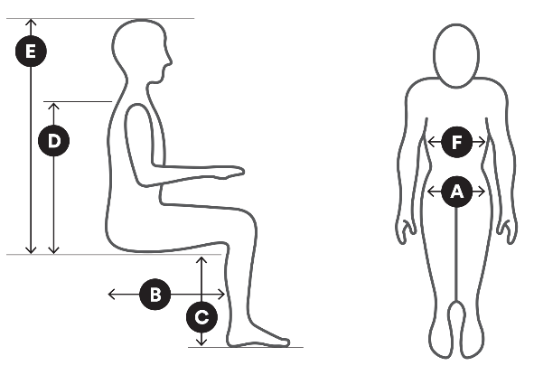 |  |  |  | 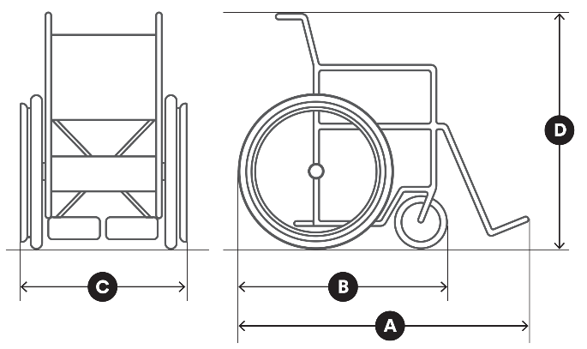
Measurements |  | mm |  | Measurements |  | mm
 | Hip width | mm |  |  | Length of chair | mm
 | Upper leg length | mm |  |  | Wheel base | mm
 | Lower leg length | mm |  |  | Chair width | mm
 | Bottom to top of shoulder | mm |  |  | Chair height | mm
 | Bottom to top of head | mm
 | Chest width | mm

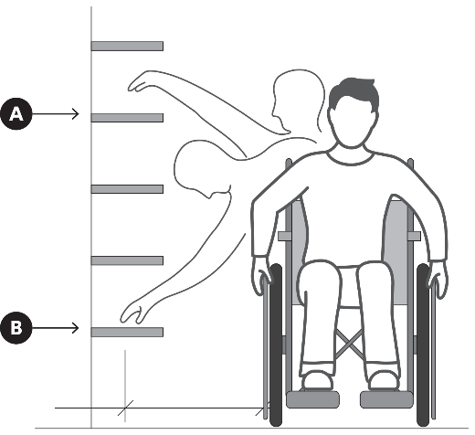 |  |  |  | 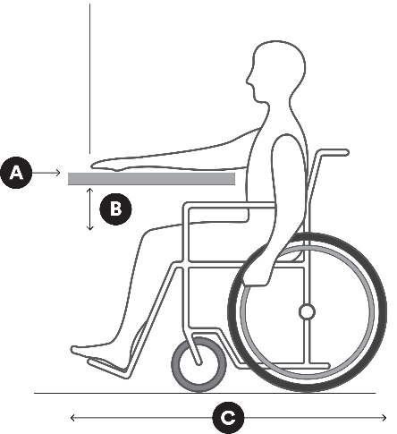
 |  |  |  | Measurements |  | mm
Measurements |  | mm |  |  | Bench height | mm
 | Functional vertical reach | mm |  |  | Leg clearance | mm
 | Functional horizontal reach | mm |  |  | Wheelchair length, incl. feet | mm

Kitchen
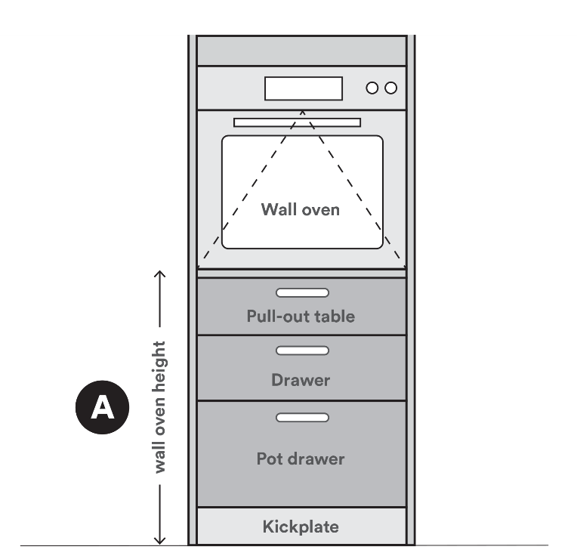 |  |  |  | 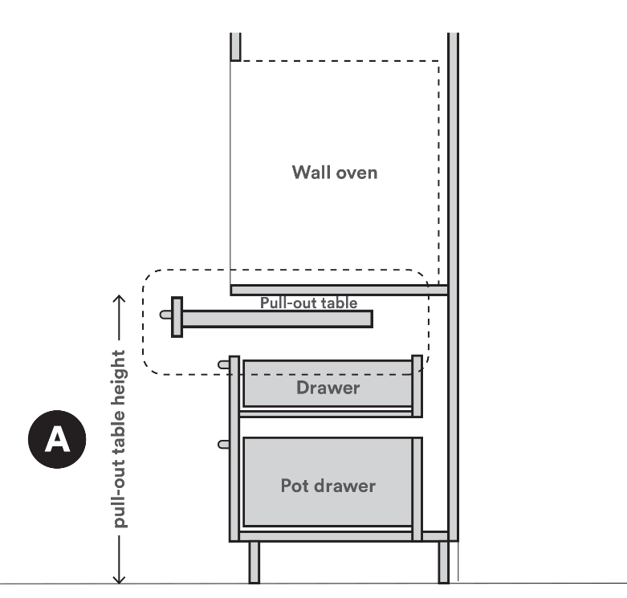
Measurements |  | mm |  | Measurements |  | mm
 | Wall oven height | mm |  |  | Pull-out table height | mm

Sink (vanity basin, kitchen, laundry)
Single sink with drainer tray and bench apron

 | 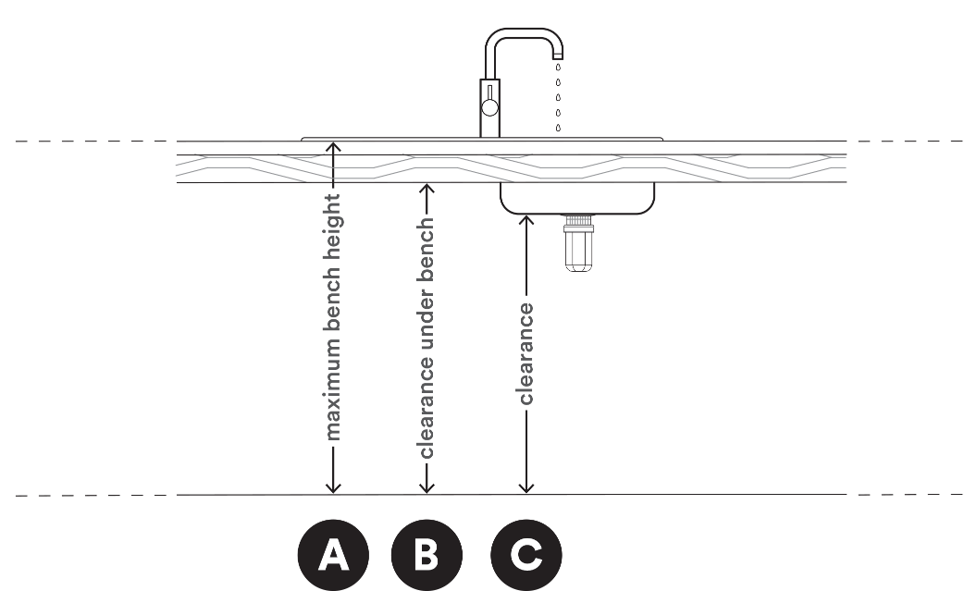
 | Measurements |  | mm
 |  | Maximum bench height | mm
 |  | Clearance under bench | mm
 |  | Clearance under sink | mm

Toilet and rails
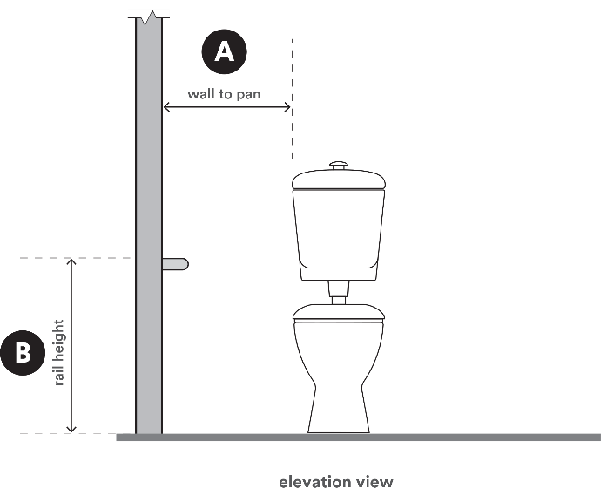 |  |  |  | 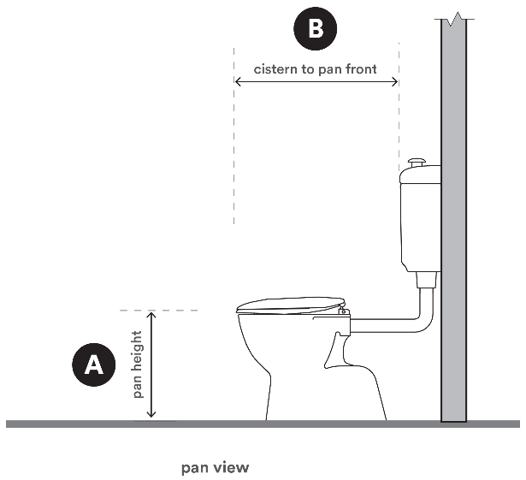
Measurements |  | mm |  | Measurements |  | mm
 | Wall to pan | mm |  |  | Pan height | mm
 | Rail height | mm |  |  | Cistern to pan front | mm
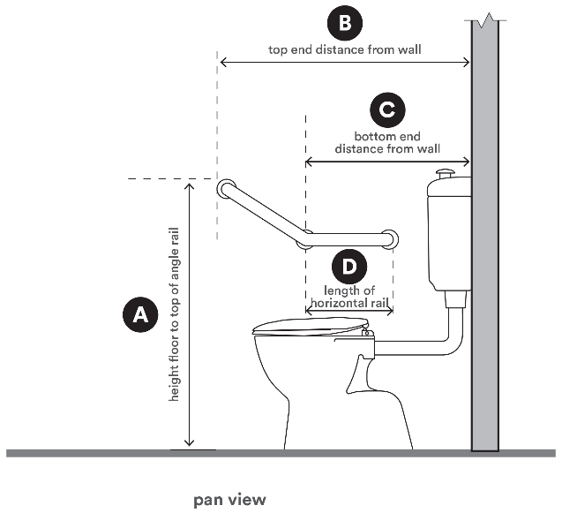
Measurements |  | mm |  | Further details if required
 | Height floor to top of angle rail | mm
 | Top end distance from wall | mm
 | Bottom end distance from wall | mm
 | Length of horizontal rail | mm

Showerhead and grab rails
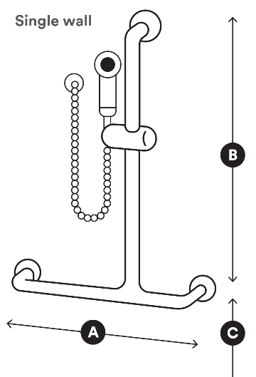 |  |  |  | 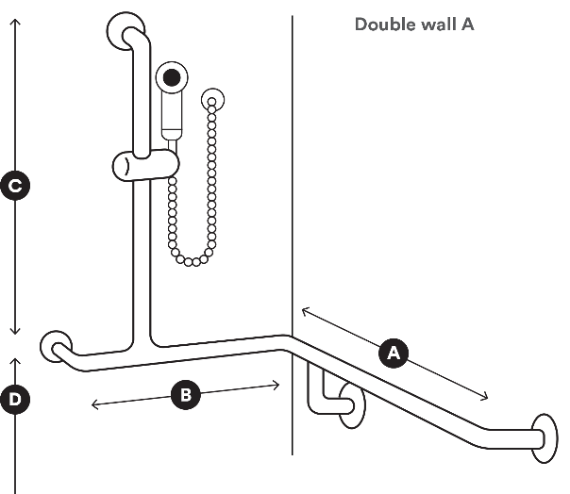
Measurements |  | mm |  | Measurements |  | mm
 | Horizontal rail length | mm |  |  | Horizontal rail length | mm
 | Vertical rail height | mm |  |  | Horizontal rail length | mm
 | Height from floor level | mm |  |  | Vertical rail height | mm
 |  |  |  |  | Height from floor level | mm

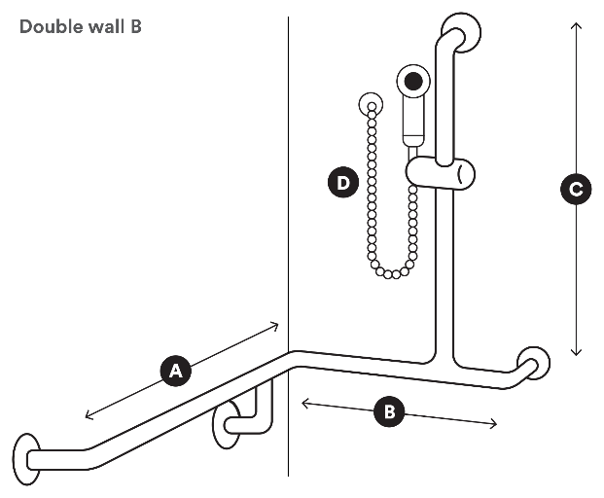
Measurements |  | mm
 | Horizontal rail length | mm
 | Horizontal rail length | mm
 | Vertical rail height | mm
 | Hose length | mm

Other
Insert your own sketches or measurements if different to what has been provided.

Measurements and details | Measurements and details

Section 10

Provider details
Provider name, address,
email and phone number
(Type details or insert image of
practice stamp)

Days/hours available

Signature
Insert image (jpg/png) of signature.
(Or print, sign and scan the form)



Date | / /

Submitting this form
Email your completed form to your TAC claims manager or to info@tac.vic.gov.au with the client’s TAC claim number in the subject line. Please also attach any supporting documentation.

Privacy
The TAC will retain the information provided and may use or disclose it to make further inquiries to assist in the ongoing management of the claim or any claim for common law damages. The TAC may also be required by law
to disclose this information. Without this information, the TAC may be unable to determine entitlements or assess whether the treatment is reasonable and may not be able to approve further benefits and treatment. If you require further information about our privacy policy, please call the TAC on 1300 654 329 or visit our website at www.tac.vic.gov.au
Authorised and published by the Transport Accident Commission

