
Quarterly Statistics – MARCH 2018


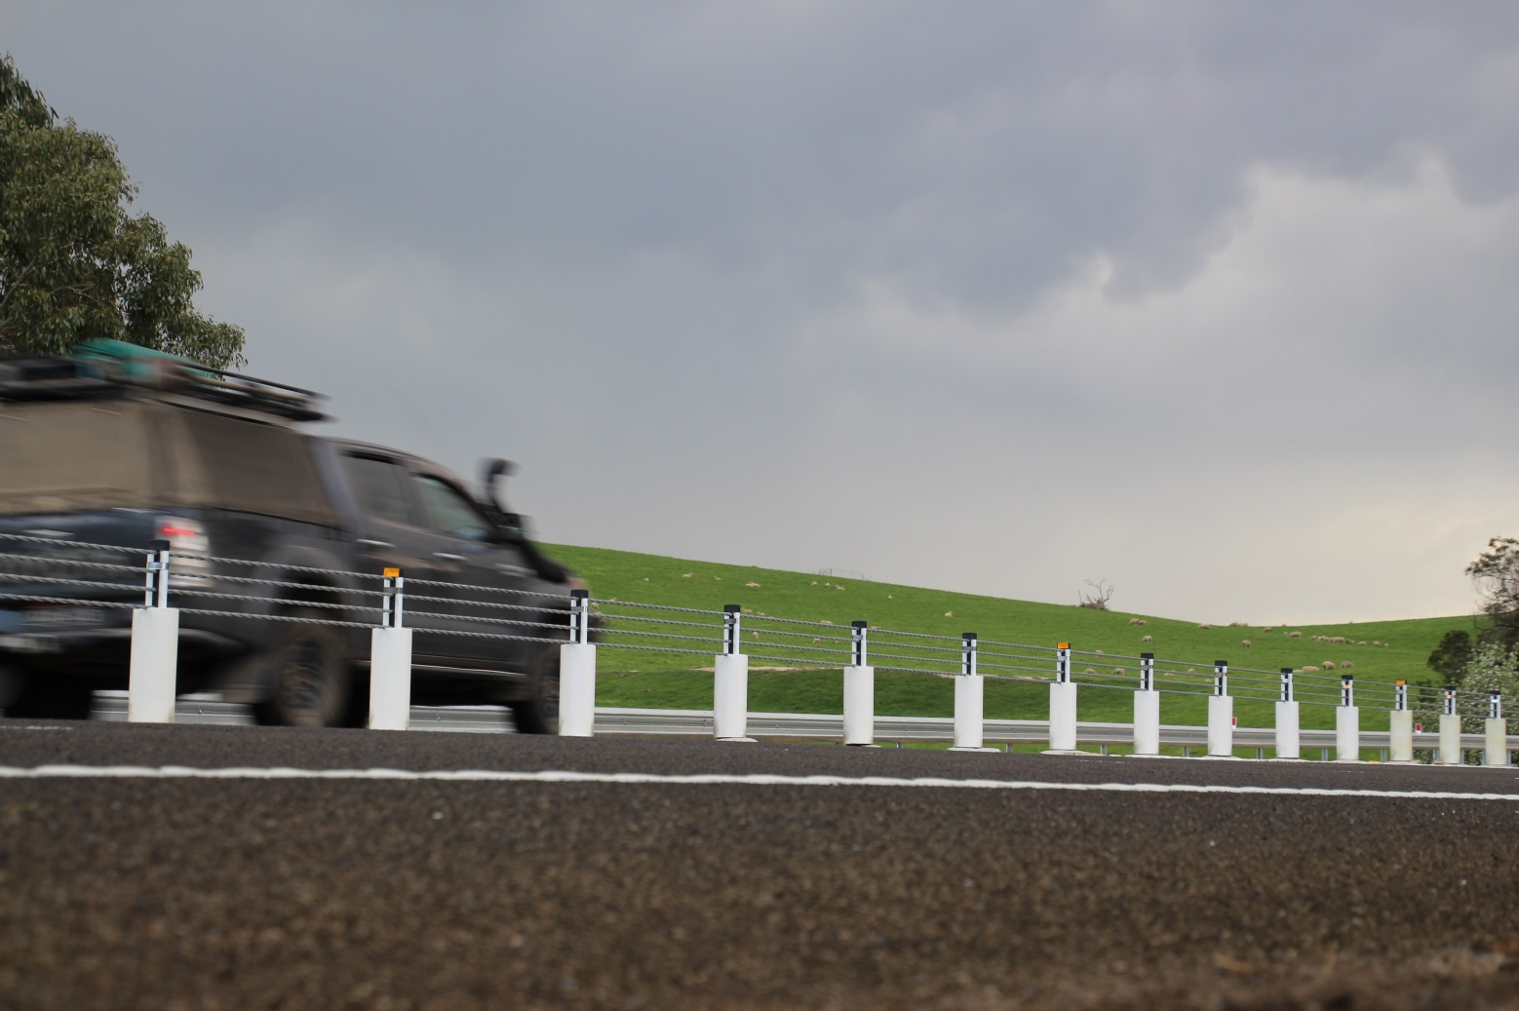

TRANSPORT  ACCIDENT  COMMISSION | 60 Brougham Street  Geelong Vic 3220  PO Box 742  Geelong Vic 3220  Ausdoc DX 216079 Geelong | Telephone 1300 654 329  STD Toll Free 1800 332 556  Fax: 03 9656 9300  www.tac.vic.gov.au  ABN 22 033 947 623

Contents

Status Report 4
Lives lost on Victorian roads 4
Injured claimants who were admitted to hospital within 7 days of accident, (by claim acceptance date – rolling 12 month, to 30th September 2017) 5
Lives lost: 12 months to 31st March 2018 6
Injured claimants who were admitted to hospital within 7 days of accident, 12 months to 30th September (claim acceptance date) 10
Lives Lost by Week (2013 to 2018) 12
The National Picture 13
Booze Bus Random Breath Testing 14
Random Drug Testing 14
Mobile Safety Camera Data 14
Explanations and References 15
Useful Internet Sites 16
Victorian monthly lives lost since 1951 19

Notes about the data in this report
- All data provided in this report is the data most recently available at time of production. Fatality data are updated to the end of report month. A 6-month lag applies to TAC claims data.
- Reported data will have one extra day of exposure for leap years.
- Data is subject to revision as additional information about known accidents/claims is received, and as new accident/claim reports are received and processed.

Status Report

Lives lost on Victorian roads
- The rolling 12 month number of lives lost to 31st March 2018 is 259. The rolling 12 month number of lives lost to 31st March 2017 stood at 268 (a decrease of 9).
- 58 people lost their lives year to date to the end of March 2018 on Victorian roads. This compares to 57 lives lost year to date to the end of March 2017.
- February and March 2018 had lowest number of lives lost since 1952.

Category | 2018 | 2017 | 2016 | 2018 v 2017 | 2018 v 2016 | 5 Year Average
Lives Lost (Rolling 12 Month Total)
Lives Lost (to March) | 259 | 268 | 265 | -9 | -6 | 257
per 10,000 veh | 0.53 | 0.56 | 0.57 | -0.03 | -0.04 | 0.56
per 100,000 pop | 4.07 | 4.30 | 4.41 | -0.22 | -0.34 | 4.33
Crashes (Rolling 12 Month Total)
Fatal crashes (to March) | 240 | 258 | 248 | -18 | -8 | 239
per 10,000 veh | 0.49 | 0.54 | 0.53 | -0.05 | -0.04 | 0.51
per 100,000 pop | 3.77 | 4.14 | 4.13 | -0.36 | -0.36 | 3.94

Victoria – Lives Lost, rolling 12 months total

Injured claimants who were admitted to hospital within 7 days of accident, (by claim acceptance date – rolling 12 month, to 30th September 2017)
Category | 2017 | 2016 | 2015 | 2017v 2016 |  | 2017 v 2015 |  | 5 Year Average
Claims involving hospitalisation over 14 days (Rolling 12 Month Total)
Claims (to September) | 944 | 1,006 | 930 | -62.0 | (-6%) | +14 | (+2%) | 892
per 100,000 pop | 14.9 | 16.4 | 15.7 | -1.6 | (-10%) | -0.9 | (-5%) | 14.0
per 10,000 veh | 2.0 | 2.1 | 2.0 | -0.2 | (-8%) | -0.1 | (-3%) | 1.9
All claims involving hospitalisation (Rolling 12 Month Total)
Claims (to September) | 7,560 | 7,039 | 6,030 | +521 | (+7%) | +1530 | (+25%) | 6,162
per 100,000 pop | 119.0 | 115.0 | 101.9 | +4.0 | (+3%) | +17.1 | (+17%) | 97.0
per 10,000 veh | 15.7 | 15.0 | 13.1 | +0.7 | (+5%) | +2.5 | (+19%) | 12.8

Lives lost: 12 months to 31st March 2018

Category | 2018 | 2017 | 2016 | 2018 v 2017 | 2018 v 2016 | 5 Year Average
Overview
Lives Lost | 259 | 268 | 265 | -9 | -6 | 257
Fatal Crashes | 240 | 257 | 248 | -17 | -8 | 238
Sex
Female | 69 | 77 | 76 | -8 | -7 | 74
Male | 189 | 191 | 189 | -2 | 0 | 183
Road user
Bicyclist | 12 | 6 | 12 | +6 | 0 | 9
Driver | 127 | 151 | 124 | -24 | +3 | 127
Motorcyclist | 41 | 40 | 44 | +1 | -3 | 38
Passenger | 46 | 36 | 54 | +10 | -8 | 46
Pedestrian | 33 | 35 | 31 | -2 | +2 | 37
Location
Melbourne | 108 | 116 | 130 | -8 | -22 | 115
Rural Victoria | 150 | 152 | 135 | -2 | +15 | 142
Age group
0-4 | 1 | 4 | 1 | -3 | 0 | 2
5-15 | 3 | 4 | 4 | -1 | -1 | 5
16-17 | 4 | 4 | 16 |  | -12 | 7
18-20 | 21 | 11 | 32 | +10 | -11 | 19
21-25 | 24 | 27 | 16 | -3 | +8 | 24
26-29 | 13 | 24 | 20 | -11 | -7 | 19
30-39 | 39 | 41 | 29 | -2 | +10 | 35
40-49 | 38 | 52 | 35 | -14 | +3 | 38
50-59 | 31 | 34 | 32 | -3 | -1 | 31
60-69 | 31 | 24 | 27 | +7 | +4 | 28
70+ | 52 | 42 | 53 | +10 | -1 | 49
Accident Type
Intersection
Adjacent direction | 34 | 28 | 34 | +6 | 0 | 33
Opposing direction | 12 | 5 | 10 | +7 | +2 | 8
Mid-block/other
Head on | 40 | 50 | 47 | -10 | -7 | 43
Same direction | 19 | 23 | 17 | -4 | +2 | 16
Manoeuvre/o'taking | 15 | 10 | 19 | +5 | -4 | 13
On path | 7 | 9 | 3 | -2 | +4 | 6
Single vehicle | 95 | 103 | 102 | -8 | -7 | 97
Other (incl peds) | 37 | 40 | 33 | -3 | +4 | 41

Lives Lost: 12 months to 31st March 2018 – Continued

Category | 2018 | 2017 | 2016 | 5 Year Average | Category | 2018 | 2017 | 2016 | 5 Year Average
Local Government Area |  |  |  |  | Local Government Area
ALPINE | 1 | 0 | 0 | 1 | MANSFIELD | 3 | 3 | 2 | 2
ARARAT | 1 | 1 | 3 | 1 | MARIBYRNONG | 5 | 2 | 4 | 2
BALLARAT | 4 | 7 | 2 | 4 | MAROONDAH | 1 | 2 | 1 | 1
BANYULE | 4 | 1 | 2 | 1 | MELBOURNE | 3 | 4 | 1 | 3
BASS COAST | 2 | 4 | 0 | 2 | MELTON | 3 | 4 | 5 | 5
BAW BAW | 3 | 3 | 2 | 3 | MILDURA | 1 | 2 | 5 | 3
BAYSIDE | 4 | 4 | 0 | 3 | MITCHELL | 6 | 3 | 4 | 3
BENALLA | 3 | 2 | 4 | 2 | MOIRA | 6 | 5 | 6 | 4
BOROONDARA | 3 | 4 | 2 | 3 | MONASH | 5 | 6 | 4 | 3
BRIMBANK | 4 | 11 | 8 | 6 | MOONEE VALLEY | 2 | 4 | 0 | 2
BULOKE | 1 | 2 | 2 | 2 | MOORABOOL | 5 | 7 | 3 | 3
CAMPASPE | 5 | 4 | 4 | 4 | MORELAND | 1 | 6 | 1 | 3
CARDINIA | 8 | 4 | 11 | 5 | MORNINGTON PENINSULA | 4 | 4 | 14 | 6
CASEY | 7 | 9 | 7 | 6 | MOUNT ALEXANDER | 3 | 0 | 2 | 2
CENTRAL GOLDFIELDS | 1 | 1 | 1 | 2 | MOYNE | 2 | 2 | 0 | 2
COLAC-OTWAY | 8 | 3 | 2 | 2 | MURRINDINDI | 7 | 4 | 5 | 5
CORANGAMITE | 3 | 1 | 4 | 4 | NILLUMBIK | 2 | 4 | 2 | 2
DAREBIN | 4 | 0 | 5 | 2 | NORTHERN GRAMPIANS | 3 | 3 | 1 | 2
EAST GIPPSLAND | 8 | 4 | 9 | 5 | PORT PHILLIP | 2 | 0 | 2 | 1
FRANKSTON | 6 | 1 | 3 | 2 | PYRENEES | 4 | 3 | 0 | 1
GANNAWARRA | 4 | 0 | 0 | 1 | QUEENSCLIFFE | 0 | 0 | 0 | 0
GLEN EIRA | 1 | 3 | 2 | 2 | SOUTH GIPPSLAND | 3 | 3 | 6 | 4
GLENELG | 4 | 4 | 2 | 3 | SOUTHERN GRAMPIANS | 1 | 4 | 2 | 1
GOLDEN PLAINS | 4 | 3 | 4 | 2 | STONNINGTON | 1 | 0 | 2 | 2
GREATER BENDIGO | 5 | 5 | 4 | 4 | STRATHBOGIE | 3 | 1 | 5 | 3
GREATER DANDENONG | 6 | 1 | 7 | 3 | SURF COAST | 3 | 2 | 4 | 2
GREATER GEELONG | 8 | 12 | 4 | 6 | SWAN HILL | 1 | 4 | 2 | 2
GREATER SHEPPARTON | 9 | 7 | 7 | 5 | TOWONG | 2 | 1 | 0 | 0
HEPBURN | 2 | 7 | 0 | 2 | WANGARATTA | 3 | 5 | 4 | 3
HINDMARSH | 0 | 0 | 2 | 1 | WARRNAMBOOL | 0 | 1 | 1 | 1
HORSHAM | 1 | 4 | 4 | 2 | WEST WIMMERA | 0 | 1 | 0 | 0
HUME | 3 | 3 | 6 | 4 | WHITEHORSE | 3 | 4 | 2 | 3
INDIGO | 2 | 5 | 2 | 3 | WHITTLESEA | 4 | 5 | 3 | 4
KINGSTON | 4 | 4 | 4 | 4 | WODONGA | 1 | 3 | 2 | 2
KNOX | 1 | 6 | 6 | 4 | WYNDHAM | 3 | 10 | 8 | 5
LATROBE | 3 | 3 | 6 | 4 | YARRA | 2 | 1 | 2 | 1
LODDON | 1 | 2 | 2 | 1 | YARRA RANGES | 8 | 5 | 12 | 6
MACEDON RANGES | 3 | 3 | 6 | 4 | YARRIAMBIACK | 1 | 2 | 0 | 1
MANNINGHAM | 3 | 3 | 1 | 1

Injured claimants who were admitted to hospital within 7 days of the accident with a hospital stay of more than 14 days, 12 months to 30th September (claim acceptance date)

Category | 2017 | 2016 | 2015 | 2017 v 2016 |  | 2017 v 2015 |  | 5 Year Average
Overview
Claims | 944 | 1,006 | 930 | -62 | -6% | +14 | 2% | 892
Sex
Female | 370 | 422 | 402 | -52 | -12% | -32 | -8% | 368
Male | 574 | 584 | 527 | -10 | -2% | +47 | 9% | 524
Road user
Bicyclist | 35 | 36 | 40 | -1 | -3% | -5 | -13% | 34
Driver | 326 | 399 | 344 | -73 | -18% | -18 | -5% | 345
Motorcyclist | 192 | 162 | 187 | +30 | 19% | +5 | 3% | 160
Passenger | 138 | 150 | 146 | -12 | -8% | -8 | -5% | 135
Pedestrian | 213 | 213 | 185 |  | 0% | +28 | 15% | 190
Train/Tram | 11 | 5 | 10 | +6 | 120% | +1 | 10% | 7
Location
Melbourne | 560 | 646 | 618 | -86 | -13% | -58 | -9% | 563
Rural Victoria | 328 | 307 | 289 | +21 | 7% | 39 | 13% | 299
Age group
0-4 | 2 | 7 | 4 | -5 | -71% | -2 | -50% | 3
5-15 | 9 | 17 | 18 | -8 | -47% | -9 | -50% | 13
16-17 | 14 | 13 | 13 | +1 | 8% | 1 | 8% | 13
18-20 | 53 | 72 | 44 | -19 | -26% | 9 | 20% | 55
21-25 | 94 | 87 | 81 | +7 | 8% | 13 | 16% | 81
26-29 | 57 | 57 | 57 |  | 0% | 0 | 0% | 49
30-39 | 126 | 136 | 98 | -10 | -7% | 28 | 29% | 110
40-49 | 107 | 107 | 120 |  | 0% | -13 | -11% | 106
50-59 | 123 | 98 | 125 | +25 | 26% | -2 | -2% | 106
60-69 | 113 | 128 | 106 | -15 | -12% | 7 | 7% | 107
70+ | 246 | 284 | 264 | -38 | -13% | -18 | -7% | 250
Accident Type
Intersection
Adjacent direction | 100 | 108 | 101 | -8 | -7% | -1 | -1% | 102
Opposing direction | 54 | 59 | 61 | -5 | -8% | -7 | -11% | 57
Mid-block/other
Head on | 62 | 106 | 83 | -44 | -42% | -21 | -25% | 79
Same direction | 63 | 69 | 98 | -6 | -9% | -35 | -36% | 70
Manoeuvre/overtaking | 44 | 60 | 54 | -16 | -27% | -10 | -19% | 52
On path | 17 | 31 | 33 | -14 | -45% | -16 | -48% | 25
Single vehicle | 231 | 294 | 269 | -63 | -21% | -38 | -14% | 247
Other (incl pedestrians) | 373 | 279 | 231 | +94 | 34% | 142 | 61% | 259

Note: Excludes rejected claims and claims for interstate crashes.

Injured claimants who were admitted to hospital within 7 days of the accident with a hospital stay of more than 14 days, 12 months to 30th September (claim acceptance date) – Continued

Category | 2017 | 2016 | 2015 | 5 Year Average | Category | 2017 | 2016 | 2015 | 5 Year Average
Local Government Area |  |  |  |  | Local Government Area
ALPINE | 5 | 2 | 5 | 2 | MANSFIELD | 8 | 5 | 2 | 3
ARARAT | 3 | 2 | 10 | 5 | MARIBYRNONG | 17 | 10 | 12 | 7
BALLARAT | 18 | 11 | 15 | 12 | MAROONDAH | 6 | 10 | 6 | 5
BANYULE | 9 | 9 | 11 | 8 | MELBOURNE | 35 | 32 | 34 | 24
BASS COAST | 5 | 4 | 11 | 7 | MELTON | 10 | 12 | 21 | 10
BAW BAW | 11 | 8 | 8 | 6 | MILDURA | 8 | 3 | 5 | 5
BAYSIDE | 14 | 10 | 8 | 7 | MITCHELL | 11 | 8 | 6 | 7
BENALLA | 4 | 3 | 6 | 3 | MOIRA | 10 | 7 | 6 | 6
BOROONDARA | 15 | 12 | 21 | 15 | MONASH | 25 | 21 | 24 | 16
BRIMBANK | 23 | 36 | 34 | 20 | MOONEE VALLEY | 11 | 25 | 21 | 16
BULOKE | 0 | 5 | 4 | 3 | MOORABOOL | 11 | 11 | 7 | 7
CAMPASPE | 14 | 7 | 9 | 6 | MORELAND | 30 | 28 | 28 | 21
CARDINIA | 22 | 16 | 14 | 10 | MORNINGTON PENINSULA | 22 | 31 | 25 | 20
CASEY | 32 | 39 | 32 | 24 | MOUNT ALEXANDER | 0 | 2 | 5 | 4
CENTRAL GOLDFIELDS | 1 | 4 | 1 | 3 | MOYNE | 7 | 3 | 2 | 3
COLAC-OTWAY | 9 | 8 | 10 | 7 | MURRINDINDI | 15 | 7 | 17 | 8
CORANGAMITE | 6 | 3 | 5 | 4 | NILLUMBIK | 4 | 9 | 11 | 6
DAREBIN | 17 | 30 | 16 | 15 | NORTHERN GRAMPIANS | 3 | 3 | 2 | 3
EAST GIPPSLAND | 13 | 8 | 11 | 6 | PORT PHILLIP | 13 | 18 | 17 | 13
FRANKSTON | 13 | 15 | 20 | 11 | PYRENEES | 1 | 2 | 2 | 1
GANNAWARRA | 4 | 2 | 2 | 2 | QUEENSCLIFFE | 0 | 1 | 0 | 0
GLEN EIRA | 7 | 17 | 14 | 14 | SOUTH GIPPSLAND | 6 | 15 | 8 | 6
GLENELG | 2 | 6 | 6 | 4 | SOUTHERN GRAMPIANS | 2 | 3 | 2 | 3
GOLDEN PLAINS | 6 | 9 | 5 | 5 | STONNINGTON | 13 | 14 | 15 | 11
GREATER BENDIGO | 19 | 14 | 12 | 11 | STRATHBOGIE | 5 | 11 | 7 | 6
GREATER DANDENONG | 26 | 27 | 15 | 19 | SURF COAST | 5 | 6 | 5 | 4
GREATER GEELONG | 34 | 17 | 21 | 19 | SWAN HILL | 3 | 8 | 5 | 3
GREATER SHEPPARTON | 22 | 20 | 9 | 10 | TOWONG | 1 | 3 | 1 | 2
HEPBURN | 2 | 3 | 5 | 3 | WANGARATTA | 7 | 6 | 6 | 4
HINDMARSH | 4 | 1 | 1 | 1 | WARRNAMBOOL | 4 | 3 | 2 | 3
HOBSONS BAY | 10 | 5 | 12 | 7 | WELLINGTON | 12 | 7 | 8 | 6
HORSHAM | 1 | 5 | 3 | 3 | WEST WIMMERA | 2 | 0 | 1 | 1
HUME | 28 | 34 | 35 | 22 | WHITEHORSE | 22 | 21 | 18 | 14
INDIGO | 4 | 9 | 5 | 3 | WHITTLESEA | 24 | 33 | 30 | 20
KINGSTON | 15 | 14 | 25 | 16 | WODONGA | 2 | 5 | 5 | 4
KNOX | 20 | 17 | 16 | 12 | WYNDHAM | 22 | 35 | 20 | 20
LATROBE | 4 | 13 | 14 | 9 | YARRA | 9 | 14 | 15 | 11
LODDON | 0 | 3 | 1 | 1 | YARRA RANGES | 29 | 34 | 37 | 26
MACEDON RANGES | 13 | 20 | 6 | 10 | YARRIAMBIACK | 1 | 1 | 0 | 1
MANNINGHAM | 17 | 18 | 11 | 10

Note: excludes rejected claims and claims for interstate crashes

Injured claimants who were admitted to hospital within 7 days of accident, 12 months to 30th September (claim acceptance date)

Category | 2017 | 2016 | 2015 | 2017 v 2016 |  | 2017 v 2015 |  | 5 Year Average
Overview
Claims | 7,560 | 7,039 | 6,030 | +521 | 7% | +1530 | 25% | 6,162
Sex
Female | 3,263 | 3,086 | 2,612 | +177 | 6% | +651 | 25% | 2,638
Male | 4,288 | 3,939 | 3,411 | +349 | 9% | +877 | 26% | 3,516
Road user
Bicyclist | 458 | 424 | 388 | +34 | 8% | +70 | 18% | 389
Driver | 3,600 | 3,342 | 2,754 | +258 | 8% | +846 | 31% | 2,854
Motorcyclist | 1,269 | 1,166 | 1,092 | +103 | 9% | +177 | 16% | 1,077
Passenger | 1,079 | 1,097 | 1,014 | -18 | -2% | +65 | 6% | 989
Pedestrian | 774 | 719 | 606 | +55 | 8% | +168 | 28% | 646
Train/Tram | 58 | 29 | 31 | +29 | 100% | +27 | 87% | 34
Location
Melbourne | 4,588 | 4,687 | 4,042 | -99 | -2% | +546 | 14% | 4,041
Rural Victoria | 2,201 | 1,985 | 1,758 | +216 | 11% | +443 | 25% | 1,807
Age group
0-4 | 64 | 56 | 41 | +8 | 14% | +23 | 56% | 50
5-15 | 201 | 227 | 230 | -26 | -11% | -29 | -13% | 192
16-17 | 114 | 131 | 106 | -17 | -13% | +8 | 8% | 104
18-20 | 551 | 540 | 459 | +11 | 2% | +92 | 20% | 485
21-25 | 958 | 891 | 706 | +67 | 8% | +252 | 36% | 768
26-29 | 654 | 610 | 484 | +44 | 7% | +170 | 35% | 508
30-39 | 1,192 | 1,128 | 957 | +64 | 6% | +235 | 25% | 957
40-49 | 1,129 | 990 | 879 | +139 | 14% | +250 | 28% | 908
50-59 | 1,032 | 853 | 789 | +179 | 21% | +243 | 31% | 788
60-69 | 698 | 700 | 554 | -2 | 0% | +144 | 26% | 576
70+ | 967 | 913 | 825 | +54 | 6% | +142 | 17% | 824
Accident Type
Intersection
Adjacent direction | 901 | 907 | 774 | -6 | -1% | +127 | 16% | 799
Opposing direction | 547 | 582 | 519 | -35 | -6% | +28 | 5% | 508
Mid-block/other
Head on | 329 | 380 | 279 | -51 | -13% | +50 | 18% | 309
Same direction | 975 | 1,067 | 913 | -92 | -9% | +62 | 7% | 884
Manoeuvre/overtaking | 361 | 400 | 352 | -39 | -10% | +9 | 3% | 338
On path | 222 | 321 | 296 | -99 | -31% | -74 | -25% | 262
Single vehicle | 1,500 | 1,710 | 1,710 | -210 | -12% | -210 | -12% | 1,545
Other (incl pedestrians) | 2,725 | 1,672 | 1,187 | +1053 | 63% | +1538 | 130% | 1,517

Note: excludes rejected claims and claims for interstate crashes
Injured claimants who were admitted to hospital within 7 days of accident, 12 months to 30th September (claim acceptance date) – Continued

Category | 2017 | 2016 | 2015 | 5 Year Average | Category | 2017 | 2016 | 2015 | 5 Year Average
Local Government Area |  |  |  |  | Local Government Area
ALPINE | 27 | 25 | 23 | 22 | MANSFIELD | 35 | 40 | 21 | 25
ARARAT | 16 | 15 | 25 | 15 | MARIBYRNONG | 98 | 74 | 77 | 55
BALLARAT | 101 | 104 | 69 | 65 | MAROONDAH | 54 | 69 | 58 | 44
BANYULE | 61 | 58 | 39 | 43 | MELBOURNE | 322 | 348 | 238 | 205
BASS COAST | 30 | 47 | 60 | 37 | MELTON | 80 | 94 | 90 | 61
BAW BAW | 48 | 48 | 46 | 40 | MILDURA | 24 | 31 | 30 | 26
BAYSIDE | 87 | 94 | 72 | 60 | MITCHELL | 73 | 70 | 60 | 49
BENALLA | 24 | 19 | 32 | 16 | MOIRA | 43 | 40 | 32 | 27
BOROONDARA | 137 | 121 | 138 | 102 | MONASH | 203 | 196 | 192 | 148
BRIMBANK | 155 | 136 | 143 | 104 | MOONEE VALLEY | 113 | 150 | 118 | 95
BULOKE | 11 | 9 | 10 | 7 | MOORABOOL | 60 | 53 | 34 | 35
CAMPASPE | 58 | 48 | 39 | 29 | MORELAND | 181 | 168 | 151 | 116
CARDINIA | 138 | 150 | 109 | 88 | MORNINGTON PENINSULA | 178 | 171 | 154 | 113
CASEY | 342 | 352 | 297 | 217 | MOUNT ALEXANDER | 17 | 21 | 29 | 21
CENTRAL GOLDFIELDS | 17 | 15 | 7 | 10 | MOYNE | 29 | 22 | 15 | 15
COLAC-OTWAY | 53 | 44 | 40 | 28 | MURRINDINDI | 75 | 60 | 59 | 45
CORANGAMITE | 45 | 23 | 25 | 19 | NILLUMBIK | 34 | 50 | 45 | 30
DAREBIN | 118 | 113 | 85 | 74 | NORTHERN GRAMPIANS | 16 | 15 | 16 | 13
EAST GIPPSLAND | 67 | 52 | 69 | 43 | PORT PHILLIP | 137 | 142 | 145 | 105
FRANKSTON | 131 | 140 | 141 | 95 | PYRENEES | 12 | 12 | 12 | 8
GANNAWARRA | 14 | 10 | 10 | 9 | QUEENSCLIFFE | 3 | 1 | 1 | 1
GLEN EIRA | 111 | 132 | 104 | 88 | SOUTH GIPPSLAND | 44 | 53 | 22 | 30
GLENELG | 14 | 26 | 16 | 15 | SOUTHERN GRAMPIANS | 13 | 29 | 20 | 21
GOLDEN PLAINS | 59 | 41 | 27 | 24 | STONNINGTON | 131 | 151 | 139 | 107
GREATER BENDIGO | 132 | 107 | 108 | 71 | STRATHBOGIE | 36 | 41 | 39 | 26
GREATER DANDENONG | 259 | 269 | 238 | 193 | SURF COAST | 58 | 56 | 41 | 32
GREATER GEELONG | 390 | 225 | 230 | 166 | SWAN HILL | 16 | 24 | 19 | 12
GREATER SHEPPARTON | 123 | 116 | 76 | 61 | TOWONG | 14 | 20 | 16 | 12
HEPBURN | 23 | 31 | 30 | 23 | WANGARATTA | 27 | 42 | 36 | 25
HINDMARSH | 12 | 8 | 6 | 6 | WARRNAMBOOL | 35 | 29 | 18 | 17
HOBSONS BAY | 71 | 69 | 69 | 48 | WELLINGTON | 64 | 73 | 70 | 53
HORSHAM | 24 | 17 | 28 | 15 | WEST WIMMERA | 7 | 5 | 4 | 4
HUME | 251 | 230 | 192 | 143 | WHITEHORSE | 162 | 136 | 96 | 86
INDIGO | 26 | 27 | 20 | 15 | WHITTLESEA | 227 | 215 | 156 | 123
KINGSTON | 121 | 142 | 136 | 106 | WODONGA | 18 | 34 | 28 | 21
KNOX | 144 | 146 | 105 | 87 | WYNDHAM | 168 | 155 | 140 | 115
LATROBE | 58 | 70 | 53 | 48 | YARRA | 99 | 141 | 118 | 89
LODDON | 9 | 10 | 15 | 10 | YARRA RANGES | 178 | 178 | 176 | 127
MACEDON RANGES | 93 | 74 | 63 | 52 | YARRIAMBIACK | 7 | 3 | 9 | 4
MANNINGHAM | 97 | 97 | 81 | 58

Note: excludes rejected claims and claims for interstate crashes

Lives Lost by Week (2013 to 2018)

Week |  |  |  |  |  |  | Cumulative | 12 Month
Ending | 2013 | 2014 | 2015 | 2016 | 2017 | 2018 | 2018 | Moving Total
7-Jan | 3 | 0 | 5 | 2 | 2 | 7 | 7 | 263
14-Jan | 2 | 8 | 6 | 5 | 6 | 4 | 11 | 261
21-Jan | 5 | 5 | 5 | 2 | 4 | 2 | 13 | 259
28-Jan | 4 | 8 | 7 | 11 | 4 | 4 | 17 | 259
4-Feb | 6 | 8 | 6 | 4 | 3 | 4 | 21 | 260
11-Feb | 7 | 4 | 4 | 10 | 3 | 5 | 26 | 262
18-Feb | 4 | 7 | 6 | 7 | 6 | 7 | 33 | 263
25-Feb | 7 | 2 | 3 | 9 | 4 | 3 | 36 | 262
4-Mar | 1 | 5 | 4 | 10 | 5 | 4 | 40 | 261
11-Mar | 5 | 10 | 11 | 9 | 3 | 7 | 47 | 265
18-Mar | 5 | 3 | 4 | 5 | 5 | 4 | 51 | 264
25-Mar | 10 | 3 | 2 | 4 | 9 | 4 | 55 | 259
1-Apr | 5 | 8 | 4 | 1 | 3 | 3 | 58 | 259
8-Apr | 3 | 7 | 5 | 1 | 7
15-Apr | 4 | 4 | 5 | 4 | 10
22-Apr | 5 | 1 | 6 | 5 | 8
29-Apr | 5 | 2 | 6 | 5 | 2
6-May | 6 | 3 | 2 | 6 | 5
13-May | 3 | 4 | 8 | 5 | 7
20-May | 0 | 5 | 4 | 6 | 3
27-May | 3 | 7 | 3 | 7 | 3
3-Jun | 10 | 5 | 4 | 4 | 4
10-Jun | 3 | 3 | 5 | 5 | 3
17-Jun | 1 | 2 | 7 | 5 | 2
24-Jun | 5 | 2 | 2 | 5 | 7
1-Jul | 2 | 10 | 9 | 7 | 3
8-Jul | 4 | 5 | 6 | 3 | 7
15-Jul | 7 | 6 | 1 | 5 | 5
22-Jul | 5 | 3 | 3 | 6 | 8
29-Jul | 3 | 5 | 3 | 10 | 1
5-Aug | 8 | 4 | 6 | 6 | 3
12-Aug | 1 | 4 | 7 | 7 | 7
19-Aug | 5 | 6 | 9 | 8 | 7
26-Aug | 5 | 4 | 4 | 11 | 2
2-Sep | 4 | 6 | 4 | 1 | 8
9-Sep | 6 | 6 | 2 | 4 | 8
16-Sep | 2 | 4 | 4 | 4 | 2
23-Sep | 4 | 6 | 4 | 4 | 3
30-Sep | 7 | 3 | 4 | 5 | 3
7-Oct | 3 | 3 | 7 | 3 | 3
14-Oct | 2 | 7 | 4 | 7 | 6
21-Oct | 3 | 0 | 5 | 3 | 3
28-Oct | 4 | 8 | 9 | 6 | 0
4-Nov | 8 | 2 | 3 | 3 | 3
11-Nov | 5 | 7 | 4 | 7 | 12
18-Nov | 2 | 7 | 5 | 5 | 5
25-Nov | 8 | 3 | 2 | 8 | 9
2-Dec | 3 | 10 | 5 | 9 | 3
9-Dec | 7 | 5 | 9 | 4 | 6
16-Dec | 12 | 3 | 1 | 7 | 5
23-Dec | 9 | 2 | 3 | 2 | 9
30-Dec | 2 | 3 | 5 | 8 | 9
31-Dec | 0 | 0 | 0 | 0 | 0
Total | 243 | 248 | 252 | 290 | 258 | 58

The National Picture
State |  | Lives Lost (12 months to March)
 |  | 2018 | 2017 | 2016 |  | 2015 |  |  | 2018 v 2017
NSW |  | 412 | 367 | 362 |  | 295 |  |  | +45 |  | (+12%)
VIC |  | 258 | 268 | 265 |  | 243 |  |  | -10 |  | (-4%)
QLD |  | 256 | 250 | 252 |  | 218 |  |  | +6 |  | (+2%)
SA |  | 103 | 84 | 101 |  | 103 |  |  | +19 |  | (+23%)
WA |  | 161 | 181 | 171 |  | 184 |  |  | -20 |  | (-11%)
TAS |  | 43 | 30 | 34 |  | 39 |  |  | +13 |  | (+43%)
NT |  | 38 | 44 | 50 |  | 38 |  |  | -6 |  | (-14%)
ACT |  | 5 | 12 | 16 |  | 7 |  |  | -7 |  | (-58%)
AUST TOTAL |  | 1,276 | 1,236 | 1,251 |  | 1,127 |  |  | +40 |  | (+3%)
AUST minus VIC |  | 1,018 | 968 | 986 |  | 884 |  |  | +50 |  | (+5%)
 | 12 months to March
State | Lives Lost per 10,000 registered vehicles |  |  |  |  |  | Fatalities per 100,000 population
 | (12 months to September) |  |  |  |  |  | (12 months to September)
 | 2018 |  | 2017 |  | 2016 |  | 2018 | 2017 |  | 2016
NSW | 0.74 |  | 0.67 |  | 0.68 |  | 5.22 | 4.72 |  | 4.73
VIC | 0.53 |  | 0.56 |  | 0.57 |  | 4.06 | 4.31 |  | 4.41
QLD | 0.64 |  | 0.64 |  | 0.66 |  | 5.17 | 5.13 |  | 5.25
SA | 0.74 |  | 0.61 |  | 0.74 |  | 5.97 | 4.90 |  | 6.01
WA | 0.72 |  | 0.82 |  | 0.78 |  | 6.23 | 7.06 |  | 5.93
TAS | 0.90 |  | 0.64 |  | 0.75 |  | 8.24 | 5.79 |  | 6.58
NT | 2.47 |  | 2.82 |  | 3.19 |  | 15.43 | 17.90 |  | 20.43
ACT | 0.17 |  | 0.41 |  | 0.56 |  | 1.23 | 2.80 |  | 3.98
AUST TOTAL | 0.67 |  | 0.66 |  | 0.69 |  | 5.18 | 5.09 |  | 5.24
AUST minus VIC | 0.72 |  | 0.70 |  | 0.72 |  | 5.57 | 5.35 |  | 5.51

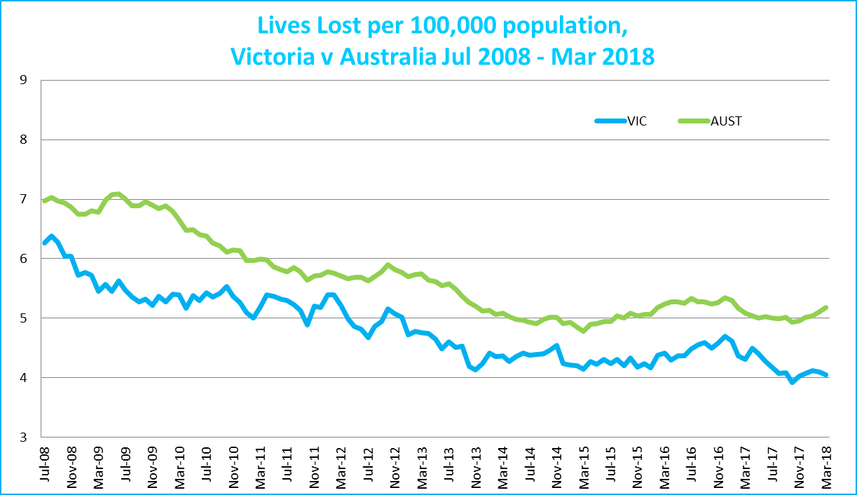
Victoria v Australia – 12 Month Moving Lives Lost Rate

Booze Bus Random Breath Testing

Booze Bus Random Breath Testing (12 months to March 2018 (monthly totals)
 | 2017 |  |  |  |  |  |  |  |  | 2018
 | Apr | May | Jun | Jul | Aug | Sep | Oct | Nov | Dec | Jan | Feb | Mar
Melbourne | 83,566 | 83,363 | 88,913 | 89,786 | 98,917 | 98,907 | 117,207 | 88,467 | 108,748 | 98,546 | 90,559 | 96,738
Country | 19,820 | 18,261 | 10,793 | 4,525 | 4,304 | 8,261 | 12,889 | 14,307 | 15,152 | 10,962 | 16,569 | 6,855
Vic Total | 103,386 | 101,624 | 99,706 | 94,311 | 103,221 | 107,168 | 130,096 | 102,774 | 123,900 | 109,508 | 107,128 | 103,593

Random Drug Testing

Random Drug Tests (12 months to March 2018 vs previous 12 months)

 |  |  |  | 2018 |  | 2017 |  | 2016 |  | 2018 v 2017 |  |  |  | 2018 v 2016
Victoria |  |  |  | 102,424 |  | 95,210 |  | 110,527 |  | +7214 |  | (+8%) |  | -8103 |  | (-7%)
12 months to March 2018 (monthly totals)
 | 2017 |  |  |  |  |  |  |  |  |  |  |  |  |  |  |  | 2018
 | Apr | May | Jun |  | Jul |  | Aug |  | Sep |  | Oct |  | Nov |  | Dec |  | Jan |  | Feb |  | Mar
Victoria | 8,766 | 7,972 | 9,369 |  | 7,260 |  | 7,067 |  | 7,233 |  | 8,125 |  | 10,614 |  | 8,809 |  | 10,492 |  | 8,347 |  | 8,370

Mobile Safety Camera Data
Speed Infringements Issued from Mobile Cameras (monthly totals) Monthly Average = 30,909
2017 |  |  |  |  |  |  |  |  | 2018
Apr | May | Jun | Jul | Aug | Sep | Oct | Nov | Dec | Jan | Feb | Mar
31,176 | 34,445 | 27,838 | 31,079 | 29,788 | 28,581 | 33,953 | 28,402 | 21,408 | 39,249 | 32,973 | 32,021

Excessive Speed Infringements (ESI) Issued from Mobile Cameras (monthly totals) Monthly Average = 338
2017 |  |  |  |  |  |  |  |  | 2018
Apr | May | Jun | Jul | Aug | Sep | Oct | Nov | Dec | Jan | Feb | Mar
330 | 405 | 315 | 323 | 362 | 272 | 332 | 279 | 272 | 156 | 675 | 334
Notes: An ESI is defined as 25km/h over the speed limit except in a 110km/h zone where it is 20km/h over the limit.

Explanations and References
LGA: Local Government Areas. Crash locations for acute hospitalised claims are assigned to LGA’s based on the crash postcode recorded by Victoria Police. Crash locations for fatal crashes are coded exactly to an LGA by Victoria Police.
Claimants: Refers to people injured in transport accidents who have an accepted claim with the TAC.
Hospitalisation: refers to all hospital admission that occurred within 7 days of accident.

Useful Internet Sites
TAC Sites
- TAC Safety (Road Safety) www.tacsafety.com.au
- TAC How safe is your car www.howsafeisyourcar.com.au
- TAC How safe is your first car www.howsafeisyourfirstcar.com.au
- TAC Motorcycle Safety Website www.spokes.com.au
- TAC Corporate site www.tac.vic.gov.au
- Drivesmart www.drivesmart.vic.gov.au
- Ridesmart www.ridesmartonline.com.au
Victorian Sites:
- VicRoads www.vicroads.vic.gov.au
- Victoria Police www.police.vic.gov.au
- Parliamentary Road Safety Committee https://www.parliament.vic.gov.au/57th-parliament/rsc
- RACV www.racv.com.au
- Monash University Accident Research Centre www.monash.edu.au/muarc
- Cameras Save Lives www.camerassavelives.vic.gov.au
- VicRoads Learner Driver Site www.lsite.vicroads.vic.gov.au/Learners
- Road Safety Education Victoria www.roadsafetyeducation.vic.gov.au
National and Interstate Sites:
- ARRB Transport Research www.arrb.com.au
- Australian Transport Safety Bureau www.atsb.gov.au
- Motor Accidents Authority (NSW) www.maa.nsw.gov.au
- Motor Accidents Insurance Board (TAS) www.maib.tas.gov.au
- Motor Accident Commission, Allianz (SA) www.mac.sa.gov.au
- Motor Accidents Compensation, TIO, (NT) www.tiofi.com.au/mac
- Insurance Commission of Western Australia www.icwa.wa.gov.au
- Motor Accident Insurance Commission (QLD) www.maic.qld.gov.au
International Sites:
- National Highway Traffic Safety Admin (USA) www.nhtsa.dot.gov
- Swedish Road and Transport Institute (VTI) www.vti.se
- SWOV Institute for Road Safety Research www.swov.nl
Related Sites:
- Alcohol and Drug Foundation www.adf.org.au
Figures
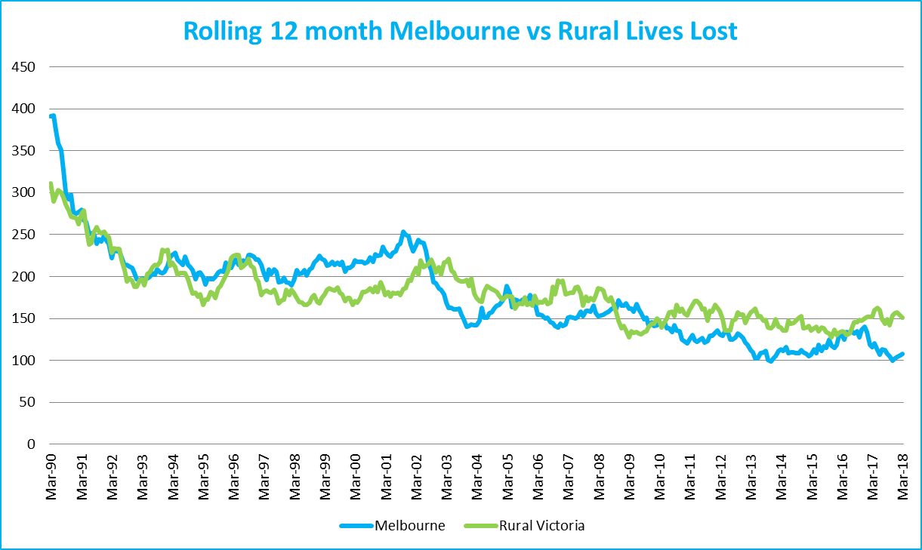
Graph 1a – Melbourne/country lives lost

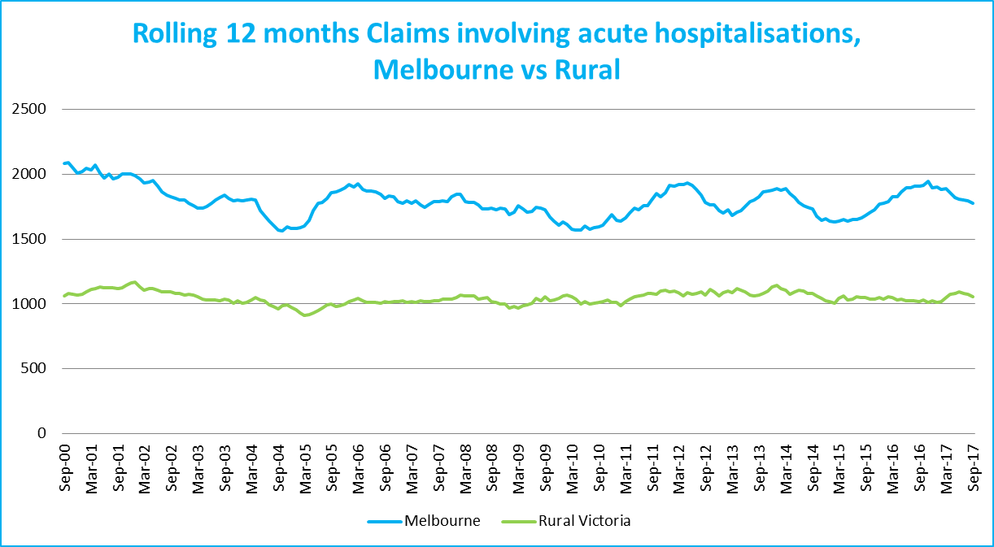
Graph 1b – Melbourne/country Claims involving an acute hospital admission

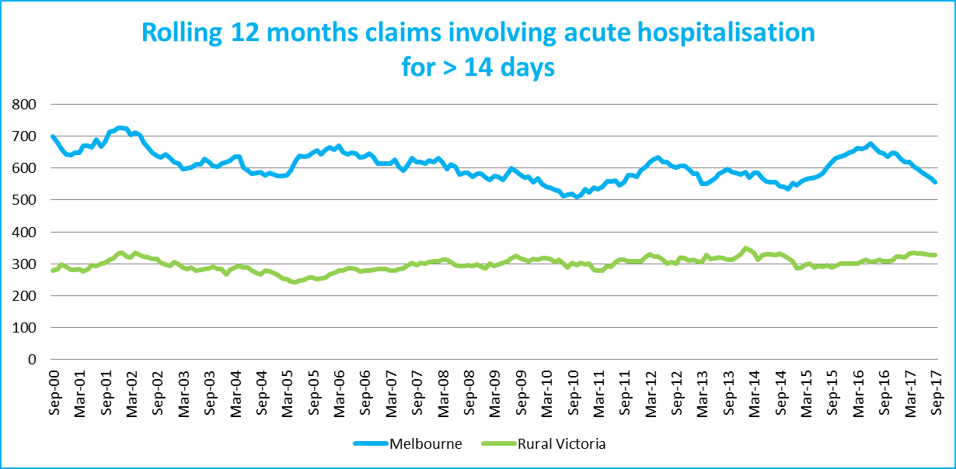
Graph 1c – Melbourne/country Claims involving hospital admission greater than 14 days

Victorian monthly lives lost since 1951

