

TAC road safety
Quarterly statistics
March 2021

Contents

Status Report 3
Lives lost: Rolling 12 months 5
Injured claimants admitted to hospital within 7 days of the accident with a hospital stay of more than 14 days 7
Injured claimants who were admitted to hospital within 7 days of accident 9
The national picture 12
Booze bus random breath testing 12
International Road Safety Comparison 14
Explanations and references 16
Useful websites 17
Victorian monthly lives lost since 1951 21

Notes about the data in this report
- All data provided in this report is the data most recently available at time of production. Fatality data updated to the end of report month. A 6-month lag applies to TAC claims data.
- Reported data will have one extra day of exposure for leap years.
- Data is subject to revision as additional information about known accidents/claims is received, and as new accident/claim reports are received and processed.

Status Report

Lives lost on Victorian roads
- In a 12-month period from 1st April 2020 to the end of March 2021, 207 people lost their lives compared to 258 people lost their lives during the previous 12-month period from April 2019 to March 2020. This represents 51 less lives lost.

Category | 2021 | 2020 | 2019 | 2021 v 2020 | 2021 v 2019 | 5 Year Average
Lives Lost (Rolling 12 Month Total)
Lives Lost (to March) | 207 | 258 | 232 | -51 | -25 | 245
per 10,000 veh | 0.40 | 0.51 | 0.46 | -0.11 | -0.06 | 0.51
per 100,000 pop | 3.08 | 3.90 | 3.57 | -0.82 | -0.49 | 3.89
Crashes (Rolling 12 Month Total)
Fatal crashes (to March) | 192 | 240 | 219 | -48 | -27 | 229
per 10,000 veh | 0.37 | 0.47 | 0.44 | -0.10 | -0.07 | 0.48
per 100,000 pop | 2.86 | 3.63 | 3.37 | -0.77 | -0.51 | 3.65

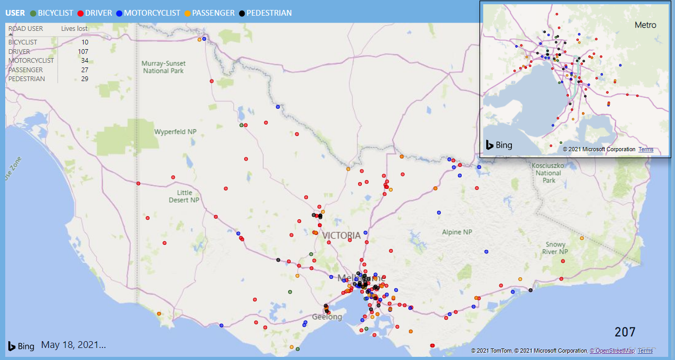
Victoria – Lives Lost, 12 months to March 2021

Injured claimants who were admitted to hospital within 7 days of accident
Rolling 12 month to 30th September 2020 (claim acceptance date)
Category | 2020 | 2019 | 2018 | 2020 v 2019 |  | 2020 v 2018 |  | 5 Year Average
Claims involving an hospitalisation over 14 days (Rolling 12 Month Total)
Claims (to September) | 669 | 935 | 953 | -266 | (-28%) | -284 | (-30%) | 901
per 100,000 pop | 10.0 | 14.2 | 14.8 | -4.2 | (-30%) | -4.8 | (-32%) | 14.8
per 10,000 veh | 1.3 | 1.9 | 1.9 | -0.6 | (-32%) | -0.6 | (-32%) | 1.9
All claims involving an hospitalisation (Rolling 12 Month Total)
Claims (to September) | 5,975 | 8,297 | 8,089 | -2322 | (-28%) | -2114 | (-26%) | 7391
per 100,000 pop | 89.6 | 126.4 | 125.9 | -36.8 | (-29%) | -36.3 | (-29%) | 117.5
per 10,000 veh | 11.6 | 16.4 | 16.4 | -4.8 | (-29%) | -4.8 | (-29%) | 15.3
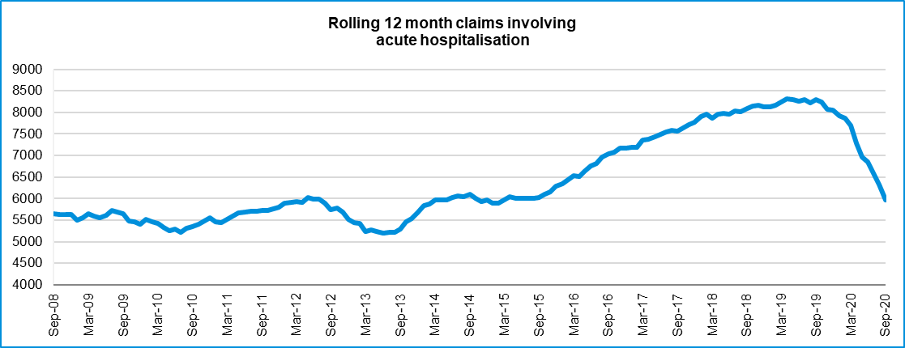
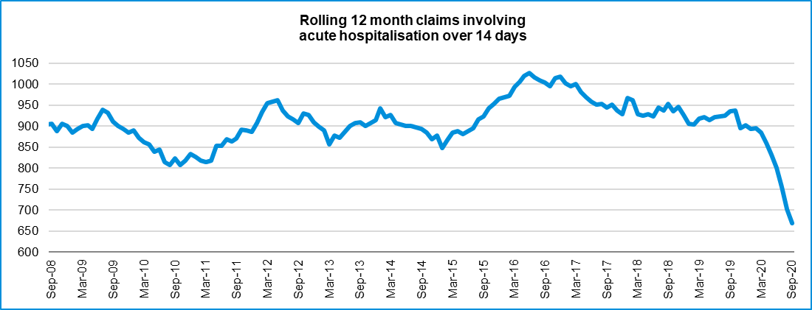

Lives lost: Rolling 12 months

12 months to 31st March 2021
Category | 2021 | 2020 | 2019 | 2021 v 2020 | 2021 v 2019 | 5 Year Average
Overview
Lives Lost | 207 | 258 | 232 | -51 | -25 | 245
Fatal Crashes | 192 | 240 | 219 | -48 | -27 | 229
Sex
Female | 50 | 66 | 64 | -16 | -14 | 65
Male | 157 | 192 | 168 | -35 | -11 | 179
Road user
Bicyclist | 10 | 13 | 10 | -3 | 0 | 10
Driver | 107 | 114 | 102 | -7 | +5 | 120
Motorcyclist | 34 | 37 | 46 | -3 | -12 | 40
Passenger | 27 | 46 | 35 | -19 | -8 | 38
Pedestrian | 29 | 48 | 39 | -19 | -10 | 37
Location
Melbourne | 93 | 119 | 105 | -26 | -12 | 109
Rural Victoria | 114 | 139 | 127 | -25 | -13 | 136
Age group
0-4 | 3 | 1 | 2 | +2 | +1 | 2
5-15 | 2 | 5 | 9 | -3 | -7 | 5
16-17 | 5 | 4 | 3 | +1 | +2 | 4
18-20 | 6 | 21 | 13 | -15 | -7 | 14
21-25 | 19 | 28 | 18 | -9 | +1 | 23
26-29 | 23 | 23 | 18 |  | +5 | 20
30-39 | 36 | 39 | 38 | -3 | -2 | 39
40-49 | 29 | 29 | 21 |  | +8 | 34
50-59 | 24 | 27 | 31 | -3 | -7 | 29
60-69 | 21 | 30 | 28 | -9 | -7 | 27
70+ | 37 | 51 | 50 | -14 | -13 | 47
Accident Type
Intersection
Adjacent direction | 19 | 31 | 33 | -12 | -14 | 29
Opposing direction | 8 | 12 | 8 | -4 | 0 | 9
Mid-block/other
Head on | 22 | 36 | 29 | -14 | -7 | 36
Same direction | 25 | 15 | 22 | +10 | +3 | 21
Manoeuvre/o'taking | 10 | 18 | 14 | -8 | -4 | 13
On path | 7 | 4 | 2 | +3 | +5 | 6
Single vehicle | 86 | 85 | 82 | +1 | +4 | 90
Other (incl peds) | 30 | 57 | 42 | -27 | -12 | 41

Lives Lost: 12 months to 31st March 2021 (claim acceptance date) – Continued
Category | 2021 | 2020 | 2019 | 5 Year Average | Category | 2021 | 2020 | 2019 | 5 Year Average
Local Government Area |  |  |  |  | Local Government Area
ALPINE | 1 | 2 | 3 | 1 | MANSFIELD | 0 | 1 | 2 | 2
ARARAT | 0 | 3 | 1 | 2 | MARIBYRNONG | 2 | 2 | 3 | 2
BALLARAT | 2 | 2 | 3 | 3 | MAROONDAH | 2 | 1 | 6 | 2
BANYULE | 2 | 0 | 2 | 1 | MELBOURNE | 4 | 2 | 2 | 2
BASS COAST | 2 | 4 | 0 | 2 | MELTON | 2 | 2 | 7 | 4
BAW BAW | 2 | 4 | 4 | 3 | MILDURA | 3 | 5 | 5 | 3
BAYSIDE | 1 | 0 | 1 | 2 | MITCHELL | 4 | 3 | 1 | 3
BENALLA | 0 | 0 | 3 | 2 | MOIRA | 2 | 4 | 4 | 4
BOROONDARA | 7 | 2 | 3 | 2 | MONASH | 4 | 10 | 5 | 6
BRIMBANK | 1 | 9 | 4 | 7 | MOONEE VALLEY | 0 | 2 | 3 | 2
BULOKE | 3 | 1 | 1 | 1 | MOORABOOL | 2 | 3 | 4 | 4
CAMPASPE | 4 | 2 | 2 | 3 | MORELAND | 1 | 1 | 4 | 2
CARDINIA | 11 | 3 | 4 | 5 | MORNINGTON PENINSULA | 5 | 17 | 3 | 7
CASEY | 7 | 7 | 3 | 6 | MOUNT ALEXANDER | 6 | 4 | 2 | 2
CENTRAL GOLDFIELDS | 1 | 3 | 1 | 1 | MOYNE | 0 | 3 | 1 | 2
COLAC-OTWAY | 2 | 3 | 1 | 3 | MURRINDINDI | 1 | 3 | 4 | 4
CORANGAMITE | 3 | 4 | 2 | 2 | NILLUMBIK | 3 | 0 | 2 | 2
DAREBIN | 1 | 7 | 2 | 3 | NORTHERN GRAMPIANS | 3 | 2 | 6 | 3
EAST GIPPSLAND | 7 | 3 | 6 | 5 | PORT PHILLIP | 1 | 2 | 0 | 1
FRANKSTON | 2 | 9 | 1 | 4 | PYRENEES | 1 | 2 | 1 | 2
GANNAWARRA | 1 | 0 | 3 | 1 | QUEENSCLIFFE | 0 | 0 | 0 | 0
GLEN EIRA | 0 | 4 | 0 | 2 | SOUTH GIPPSLAND | 4 | 6 | 7 | 4
GLENELG | 2 | 0 | 4 | 2 | SOUTHERN GRAMPIANS | 0 | 2 | 2 | 2
GOLDEN PLAINS | 2 | 0 | 7 | 3 | STONNINGTON | 0 | 0 | 5 | 1
GREATER BENDIGO | 8 | 7 | 6 | 5 | STRATHBOGIE | 0 | 1 | 2 | 2
GREATER DANDENONG | 6 | 4 | 3 | 3 | SURF COAST | 2 | 0 | 1 | 1
GREATER GEELONG | 7 | 15 | 5 | 8 | SWAN HILL | 2 | 3 | 0 | 2
GREATER SHEPPARTON | 8 | 5 | 6 | 6 | TOWONG | 1 | 3 | 1 | 1
HEPBURN | 2 | 5 | 4 | 4 | WANGARATTA | 3 | 0 | 1 | 2
HINDMARSH | 1 | 0 | 0 | 0 | WARRNAMBOOL | 1 | 3 | 2 | 1
HOBSONS BAY | 2 | 0 | 2 | 1 | WELLINGTON | 5 | 2 | 2 | 3
HORSHAM | 1 | 7 | 1 | 3 | WEST WIMMERA | 3 | 3 | 1 | 1
HUME | 3 | 9 | 7 | 5 | WHITEHORSE | 2 | 1 | 1 | 2
INDIGO | 4 | 1 | 2 | 2 | WHITTLESEA | 4 | 3 | 4 | 3
KINGSTON | 3 | 4 | 5 | 4 | WODONGA | 1 | 1 | 0 | 1
KNOX | 1 | 1 | 7 | 3 | WYNDHAM | 5 | 6 | 6 | 6
LATROBE | 3 | 7 | 5 | 4 | YARRA | 2 | 1 | 0 | 1
LODDON | 2 | 4 | 2 | 2 | YARRA RANGES | 8 | 8 | 8 | 6
MACEDON RANGES | 1 | 2 | 6 | 3 | YARRIAMBIACK | 1 | 1 | 0 | 1
MANNINGHAM | 1 | 2 | 2 | 2

Injured claimants admitted to hospital within 7 days of the accident with a hospital stay of more than 14 days
12 months to 30th September 2020 (claim acceptance date)
Category | 2020 | 2019 | 2018 | 2020 v 2019 |  | 2020 v 2018 |  | 5 Year Average
Overview
Claims | 669 | 935 | 953 | -266 | -28% | -284 | -30% | 849
Sex
Female | 245 | 392 | 384 | -147 | -38% | -139 | -36% | 339
Male | 423 | 543 | 569 | -120 | -22% | -146 | -26% | 509
Road user
Bicyclist | 34 | 33 | 36 | +1 | 3% | -2 | -6% | 32
Driver | 255 | 356 | 351 | -101 | -28% | -96 | -27% | 317
Motorcyclist | 160 | 179 | 193 | -19 | -11% | -33 | -17% | 171
Passenger | 83 | 133 | 139 | -50 | -38% | -56 | -40% | 121
Pedestrian | 115 | 198 | 193 | -83 | -42% | -78 | -40% | 176
Train/Tram | 2 | 11 | 11 | -9 | -82% | -9 | -82% | 8
Location
Melbourne | 391 | 548 | 577 | -157 | -29% | -186 | -32% | 512
Rural Victoria | 249 | 327 | 307 | -78 | -24% | -58 | -19% | 287
Age group
0-4 | 3 | 5 | 4 | -2 | -40% | -1 | -25% | 4
5-15 | 10 | 16 | 13 | -6 | -38% | -3 | -23% | 11
16-17 | 13 | 13 | 11 |  | 0% | 2 | 18% | 12
18-20 | 30 | 50 | 30 | -20 | -40% | 0 | 0% | 44
21-25 | 55 | 73 | 86 | -18 | -25% | -31 | -36% | 74
26-29 | 46 | 45 | 55 | +1 | 2% | -9 | -16% | 49
30-39 | 77 | 103 | 120 | -26 | -25% | -43 | -36% | 104
40-49 | 88 | 96 | 122 | -8 | -8% | -34 | -28% | 99
50-59 | 82 | 132 | 117 | -50 | -38% | -35 | -30% | 105
60-69 | 92 | 128 | 115 | -36 | -28% | -23 | -20% | 110
70+ | 173 | 274 | 280 | -101 | -37% | -107 | -38% | 236
Accident Type
Intersection
Adjacent direction | 79 | 75 | 83 | +4 | 5% | -4 | -5% | 84
Opposing direction | 31 | 62 | 50 | -31 | -50% | -19 | -38% | 49
Mid-block/other
Head on | 45 | 81 | 48 | -36 | -44% | -3 | -6% | 63
Same direction | 57 | 75 | 69 | -18 | -24% | -12 | -17% | 65
Manoeuvre/o'taking | 45 | 46 | 49 | -1 | -2% | -4 | -8% | 46
On path | 18 | 29 | 28 | -11 | -38% | -10 | -36% | 24
Single vehicle | 210 | 229 | 224 | -19 | -8% | -14 | -6% | 223
Other (incl peds) | 184 | 338 | 402 | -154 | -46% | -218 | -54% | 296
Note: excludes rejected claims and claims for interstate crashes.

Injured claimants who were admitted to hospital within 7 days of the accident with a hospital stay of more than 14 days
12 months to 30th September 2020 (claim acceptance date) – Continued
Category | 2020 | 2019 | 2018 | 5 Year Average | Category | 2020 | 2019 | 2018 | 5 Year Average
Local Government Area |  |  |  |  | Local Government Area
ALPINE | 4 | 10 | 4 | 4 | MANSFIELD | 5 | 5 | 8 | 5
ARARAT | 3 | 5 | 1 | 2 | MARIBYRNONG | 7 | 10 | 13 | 10
BALLARAT | 11 | 20 | 14 | 12 | MAROONDAH | 11 | 9 | 7 | 6
BANYULE | 6 | 8 | 13 | 7 | MELBOURNE | 24 | 25 | 39 | 26
BASS COAST | 2 | 9 | 10 | 6 | MELTON | 4 | 9 | 11 | 8
BAW BAW | 8 | 7 | 9 | 6 | MILDURA | 4 | 5 | 10 | 5
BAYSIDE | 2 | 14 | 4 | 8 | MITCHELL | 12 | 8 | 7 | 6
BENALLA | 1 | 3 | 7 | 3 | MOIRA | 4 | 12 | 10 | 8
BOROONDARA | 11 | 19 | 12 | 11 | MONASH | 11 | 28 | 17 | 17
BRIMBANK | 8 | 22 | 19 | 17 | MOONEE VALLEY | 12 | 12 | 19 | 12
BULOKE | 0 | 4 | 2 | 2 | MOORABOOL | 7 | 7 | 5 | 6
CAMPASPE | 12 | 8 | 5 | 6 | MORELAND | 13 | 26 | 30 | 22
CARDINIA | 11 | 15 | 15 | 12 | MORNINGTON PENINSULA | 18 | 24 | 22 | 18
CASEY | 25 | 25 | 31 | 24 | MOUNT ALEXANDER | 0 | 3 | 3 | 1
CENTRAL GOLDFIELDS | 3 | 5 | 4 | 2 | MOYNE | 5 | 7 | 4 | 4
COLAC-OTWAY | 4 | 5 | 6 | 5 | MURRINDINDI | 5 | 7 | 14 | 8
CORANGAMITE | 3 | 2 | 12 | 5 | NILLUMBIK | 6 | 14 | 3 | 6
DAREBIN | 10 | 18 | 19 | 16 | NORTHERN GRAMPIANS | 2 | 2 | 7 | 3
EAST GIPPSLAND | 10 | 12 | 9 | 8 | PORT PHILLIP | 14 | 10 | 12 | 10
FRANKSTON | 8 | 9 | 19 | 11 | PYRENEES | 2 | 4 | 1 | 2
GANNAWARRA | 3 | 2 | 1 | 2 | QUEENSCLIFFE | 2 | 2 | 1 | 1
GLEN EIRA | 9 | 22 | 17 | 12 | SOUTH GIPPSLAND | 6 | 7 | 8 | 6
GLENELG | 2 | 4 | 3 | 3 | SOUTHERN GRAMPIANS | 4 | 4 | 4 | 2
GOLDEN PLAINS | 5 | 5 | 3 | 5 | STONNINGTON | 6 | 9 | 14 | 8
GREATER BENDIGO | 16 | 21 | 22 | 14 | STRATHBOGIE | 6 | 1 | 4 | 3
GREATER DANDENONG | 18 | 29 | 24 | 20 | SURF COAST | 7 | 4 | 7 | 4
GREATER GEELONG | 28 | 39 | 23 | 21 | SWAN HILL | 5 | 5 | 3 | 4
GREATER SHEPPARTON | 9 | 6 | 17 | 11 | TOWONG | 3 | 4 | 4 | 3
HEPBURN | 4 | 5 | 4 | 3 | WANGARATTA | 3 | 6 | 5 | 5
HINDMARSH | 3 | 0 | 0 | 1 | WARRNAMBOOL | 5 | 4 | 1 | 2
HOBSONS BAY | 6 | 8 | 7 | 6 | WELLINGTON | 9 | 8 | 9 | 7
HORSHAM | 1 | 6 | 4 | 3 | WEST WIMMERA | 0 | 1 | 0 | 1
HUME | 21 | 25 | 25 | 21 | WHITEHORSE | 18 | 25 | 22 | 18
INDIGO | 3 | 5 | 3 | 4 | WHITTLESEA | 20 | 22 | 30 | 20
KINGSTON | 12 | 16 | 23 | 12 | WODONGA | 2 | 6 | 3 | 3
KNOX | 17 | 25 | 20 | 16 | WYNDHAM | 21 | 16 | 23 | 17
LATROBE | 7 | 13 | 14 | 8 | YARRA | 12 | 12 | 16 | 10
LODDON | 2 | 5 | 1 | 2 | YARRA RANGES | 22 | 25 | 34 | 22
MACEDON RANGES | 6 | 12 | 9 | 9 | YARRIAMBIACK | 1 | 2 | 2 | 1
MANNINGHAM | 8 | 17 | 17 | 13

Note: excludes rejected claims and claims for interstate crashes

Injured claimants who were admitted to hospital within 7 days of accident
12 months to 30th September 2020 (claim acceptance date)
Category | 2020 | 2019 | 2018 | 2020 v 2019 |  | 2020 v 2018 |  | 5 Year Average
Overview
Claims | 5,975 | 8,297 | 8,089 | -2322 | -28% | -2114 | -26% | 7,044
Sex
Female | 2,481 | 3,599 | 3,509 | -1118 | -31% | -1028 | -29% | 3,038
Male | 3,485 | 4,688 | 4,570 | -1203 | -26% | -1085 | -24% | 3,997
Road user
Bicyclist | 441 | 526 | 542 | -85 | -16% | -101 | -19% | 457
Driver | 2,867 | 4,031 | 3,824 | -1164 | -29% | -957 | -25% | 3,371
Motorcyclist | 1,048 | 1,408 | 1,364 | -360 | -26% | -316 | -23% | 1,194
Passenger | 792 | 1,207 | 1,152 | -415 | -34% | -360 | -31% | 1,015
Pedestrian | 505 | 822 | 821 | -317 | -39% | -316 | -38% | 695
Train/Tram | 30 | 35 | 46 | -5 | -14% | -16 | -35% | 39
Location
Melbourne | 3,719 | 5,001 | 4,731 | -1282 | -26% | -1012 | -21% | 4,312
Rural Victoria | 1,932 | 2,455 | 2,304 | -523 | -21% | -372 | -16% | 2,074
Age group
0-4 | 35 | 61 | 69 | -26 | -43% | -34 | -49% | 54
5-15 | 132 | 231 | 246 | -99 | -43% | -114 | -46% | 195
16-17 | 103 | 129 | 140 | -26 | -20% | -37 | -26% | 116
18-20 | 420 | 624 | 574 | -204 | -33% | -154 | -27% | 519
21-25 | 695 | 999 | 1,030 | -304 | -30% | -335 | -33% | 871
26-29 | 531 | 693 | 686 | -162 | -23% | -155 | -23% | 602
30-39 | 984 | 1,341 | 1,296 | -357 | -27% | -312 | -24% | 1,131
40-49 | 870 | 1,080 | 1,160 | -210 | -19% | -290 | -25% | 999
50-59 | 806 | 1,128 | 1,067 | -322 | -29% | -261 | -24% | 935
60-69 | 661 | 844 | 793 | -183 | -22% | -132 | -17% | 707
70+ | 738 | 1,167 | 1,028 | -429 | -37% | -290 | -28% | 914
Accident Type
Intersection
Adjacent direction | 970 | 976 | 812 | -6 | -1% | +158 | 19% | 867
Opposing direction | 409 | 576 | 444 | -167 | -29% | -35 | -8% | 487
Mid-block/other
Head on | 271 | 378 | 298 | -107 | -28% | -27 | -9% | 312
Same direction | 972 | 1,047 | 884 | -75 | -7% | +88 | 10% | 940
Manoeuvre/o'taking | 410 | 337 | 350 | +73 | 22% | +60 | 17% | 349
On path | 226 | 229 | 233 | -3 | -1% | -7 | -3% | 236
Single vehicle | 1,347 | 1,421 | 1,314 | -74 | -5% | +33 | 3% | 1,407
Other (incl peds) | 1,370 | 3,333 | 3,754 | -1963 | -59% | -2384 | -64% | 2,447
Note: excludes rejected claims and claims for interstate crashes

Injured claimants who were admitted to hospital within 7 days of accident
12 months to 30th September 2020 (claim acceptance date) – Continued
Category | 2020 | 2019 | 2018 | 5 Year Average | Category | 2020 | 2019 | 2018 | 5 Year Average
Local Government Area |  |  |  |  | Local Government Area
ALPINE | 24 | 41 | 25 | 22 | MANSFIELD | 30 | 44 | 39 | 30
ARARAT | 16 | 19 | 12 | 12 | MARIBYRNONG | 65 | 98 | 103 | 72
BALLARAT | 87 | 119 | 77 | 74 | MAROONDAH | 55 | 72 | 65 | 49
BANYULE | 38 | 69 | 73 | 50 | MELBOURNE | 200 | 270 | 317 | 236
BASS COAST | 33 | 49 | 56 | 35 | MELTON | 77 | 95 | 70 | 61
BAW BAW | 67 | 61 | 56 | 40 | MILDURA | 40 | 30 | 28 | 21
BAYSIDE | 73 | 100 | 75 | 66 | MITCHELL | 75 | 77 | 63 | 54
BENALLA | 9 | 28 | 23 | 17 | MOIRA | 34 | 47 | 34 | 31
BOROONDARA | 95 | 166 | 140 | 106 | MONASH | 138 | 215 | 208 | 153
BRIMBANK | 148 | 182 | 182 | 123 | MOONEE VALLEY | 116 | 145 | 155 | 105
BULOKE | 4 | 15 | 6 | 8 | MOORABOOL | 52 | 57 | 49 | 40
CAMPASPE | 41 | 50 | 44 | 37 | MORELAND | 137 | 199 | 203 | 143
CARDINIA | 117 | 121 | 121 | 98 | MORNINGTON PENINSULA | 160 | 194 | 181 | 135
CASEY | 280 | 355 | 309 | 256 | MOUNT ALEXANDER | 20 | 22 | 24 | 15
CENTRAL GOLDFIELDS | 19 | 29 | 16 | 15 | MOYNE | 30 | 32 | 45 | 25
COLAC-OTWAY | 61 | 61 | 81 | 46 | MURRINDINDI | 44 | 64 | 53 | 48
CORANGAMITE | 27 | 34 | 44 | 28 | NILLUMBIK | 39 | 54 | 32 | 32
DAREBIN | 96 | 140 | 104 | 89 | NORTHERN GRAMPIANS | 18 | 21 | 40 | 17
EAST GIPPSLAND | 44 | 49 | 62 | 43 | PORT PHILLIP | 119 | 155 | 159 | 112
FRANKSTON | 125 | 156 | 150 | 109 | PYRENEES | 13 | 18 | 9 | 10
GANNAWARRA | 11 | 11 | 8 | 8 | QUEENSCLIFFE | 4 | 8 | 9 | 4
GLEN EIRA | 121 | 139 | 134 | 97 | SOUTH GIPPSLAND | 38 | 54 | 36 | 35
GLENELG | 18 | 22 | 32 | 17 | SOUTHERN GRAMPIANS | 34 | 26 | 19 | 16
GOLDEN PLAINS | 45 | 46 | 47 | 37 | STONNINGTON | 100 | 145 | 135 | 103
GREATER BENDIGO | 118 | 152 | 140 | 98 | STRATHBOGIE | 35 | 35 | 37 | 27
GREATER DANDENONG | 210 | 310 | 254 | 208 | SURF COAST | 57 | 66 | 74 | 48
GREATER GEELONG | 331 | 459 | 453 | 295 | SWAN HILL | 22 | 21 | 15 | 14
GREATER SHEPPARTON | 72 | 81 | 90 | 75 | TOWONG | 12 | 15 | 24 | 14
HEPBURN | 27 | 33 | 33 | 23 | WANGARATTA | 32 | 45 | 35 | 28
HINDMARSH | 13 | 18 | 11 | 9 | WARRNAMBOOL | 27 | 30 | 26 | 23
HOBSONS BAY | 70 | 87 | 94 | 60 | WELLINGTON | 50 | 73 | 69 | 52
HORSHAM | 25 | 32 | 30 | 19 | WEST WIMMERA | 3 | 3 | 7 | 4
HUME | 215 | 251 | 268 | 190 | WHITEHORSE | 73 | 169 | 139 | 116
INDIGO | 18 | 29 | 22 | 20 | WHITTLESEA | 163 | 206 | 243 | 171
KINGSTON | 127 | 137 | 134 | 100 | WODONGA | 20 | 23 | 28 | 19
KNOX | 99 | 151 | 128 | 105 | WYNDHAM | 185 | 223 | 173 | 133
LATROBE | 65 | 103 | 74 | 58 | YARRA | 88 | 120 | 114 | 88
LODDON | 11 | 24 | 9 | 10 | YARRA RANGES | 148 | 178 | 180 | 130
MACEDON RANGES | 50 | 74 | 78 | 61 | YARRIAMBIACK | 6 | 5 | 12 | 5
MANNINGHAM | 42 | 99 | 88 | 72
Note: excludes rejected claims and claims for interstate crashes
Lives lost by week (2016 to 2021)
Week Ending | 2016 | 2017 | 2018 | 2019 | 2020 | 2021 | 2021 | 12 month Moving Total
03-Jan | 2 | 0 | 4 | 0 | 5 | 3 | 3 | 209
10-Jan | 3 | 5 | 6 | 5 | 3 | 1 | 4 | 207
17-Jan | 3 | 6 | 2 | 3 | 5 | 0 | 4 | 202
24-Jan | 3 | 4 | 2 | 7 | 2 | 6 | 10 | 206
31-Jan | 10 | 2 | 6 | 8 | 9 | 4 | 14 | 201
07-Feb | 6 | 4 | 3 | 9 | 5 | 6 | 20 | 202
14-Feb | 12 | 3 | 4 | 9 | 6 | 6 | 26 | 202
21-Feb | 6 | 6 | 7 | 4 | 5 | 4 | 30 | 201
28-Feb | 9 | 5 | 2 | 12 | 1 | 6 | 36 | 206
07-Mar | 9 | 3 | 5 | 0 | 4 | 10 | 46 | 212
14-Mar | 9 | 5 | 7 | 5 | 9 | 4 | 50 | 207
21-Mar | 5 | 5 | 3 | 7 | 10 | 5 | 55 | 202
28-Mar | 1 | 7 | 4 | 6 | 1 | 7 | 62 | 208
04-Apr | 1 | 4 | 3 | 3 | 7
11-Apr | 1 | 12 | 0 | 10 | 1
18-Apr | 7 | 7 | 1 | 6 | 1
25-Apr | 4 | 6 | 5 | 4 | 9
02-May | 5 | 3 | 3 | 3 | 2
09-May | 7 | 7 | 13 | 9 | 2
16-May | 5 | 4 | 3 | 9 | 5
23-May | 5 | 2 | 3 | 6 | 2
30-May | 8 | 6 | 2 | 7 | 5
06-Jun | 4 | 2 | 1 | 4 | 1
13-Jun | 5 | 3 | 8 | 3 | 5
20-Jun | 5 | 4 | 1 | 5 | 4
27-Jun | 8 | 4 | 2 | 4 | 4
04-Jul | 2 | 5 | 1 | 7 | 4
11-Jul | 3 | 5 | 3 | 3 | 3
18-Jul | 7 | 9 | 5 | 2 | 3
25-Jul | 11 | 4 | 5 | 5 | 5
01-Aug | 6 | 0 | 2 | 3 | 4
08-Aug | 5 | 7 | 4 | 3 | 3
15-Aug | 7 | 9 | 3 | 5 | 4
22-Aug | 8 | 2 | 6 | 3 | 2
29-Aug | 8 | 8 | 4 | 4 | 3
05-Sep | 3 | 6 | 4 | 3 | 4
12-Sep | 3 | 6 | 3 | 5 | 4
19-Sep | 5 | 3 | 7 | 4 | 1
26-Sep | 5 | 3 | 2 | 3 | 0
03-Oct | 2 | 2 | 5 | 6 | 7
10-Oct | 6 | 4 | 7 | 6 | 3
17-Oct | 4 | 6 | 2 | 5 | 6
24-Oct | 7 | 0 | 3 | 4 | 7
31-Oct | 5 | 1 | 7 | 9 | 4
07-Nov | 2 | 11 | 5 | 3 | 3
14-Nov | 7 | 5 | 2 | 5 | 5
21-Nov | 5 | 4 | 12 | 5 | 3
28-Nov | 9 | 11 | 3 | 4 | 4
05-Dec | 9 | 3 | 3 | 4 | 2
12-Dec | 5 | 5 | 3 | 5 | 4
19-Dec | 5 | 7 | 5 | 7 | 4
26-Dec | 2 | 11 | 5 | 1 | 5
31-Dec | 6 | 3 | 2 | 4 | 1
Total | 290 | 259 | 213 | 266 | 211 | 62

Booze bus random breath testing
Booze-bus Random Breath Tests (12 months to March 2020 vs previous 12 months)
 | 2020 | 2019 | 2018 | 2019 v 2018 |  | 2019 v 2017
Melbourne | 1,025,495 | 1,226,599 | 1,143,717 | -201104 | (-16%) | -118222 | (-10%)
Country | 183,858 | 115,731 | 142,698 | +68127 | (+59%) | +41160 | (+29%)
Vic Total | 1,209,353 | 1,342,330 | 1,286,415 | -132977 | (-10%) | -77062 | (-6%)

12 months to March 2020 (monthly totals)
 | 2019 |  |  |  |  |  |  |  |  | 2020
 | Apr | May | Sep | Jul | Aug | Sep | Oct | Nov | Dec | Jan | Feb | Mar
Melbourne | 79,988 | 84,478 | 101,799 | 98,380 | 102,592 | 96,574 | 89,177 | 88,460 | 82,298 | 62,544 | 103,896 | 35,309
Country | 19,119 | 14,068 | 10,318 | 5,826 | 11,098 | 12,571 | 17,551 | 25,867 | 16,566 | 15,206 | 23,588 | 12,080
Vic Total | 99,107 | 98,546 | 112,117 | 104,206 | 113,690 | 109,145 | 106,728 | 114,327 | 98,864 | 77,750 | 127,484 | 47,389

Random Drug Testing
Random Drug Tests (12 months to March 2020 vs previous 12 months)
 | 2020 | 2019 | 2018 | 2020 v 2019 |  | 2020 v 2018
Victoria | 161,283 | 122,730 | 102,551 | 38,553 | 31% | 58,732 | 57%

12 months to March 2020 (monthly totals)
 | 2019 |  |  |  |  |  |  |  |  | 2020
 | Apr | May | Jun | Jul | Aug | Sep | Oct | Nov | Dec | Jan | Feb | Mar
Victoria | 17,337 | 19,571 | 15,441 | 13,817 | 18692 | 15,244 | 12181 | 12646 | 11,000 | 9,157 | 7,904 | 8,293

Speed Infringements Issued from Mobile Cameras (monthly totals) |  | Monthly Average = | 27,147
Mobile Safety Camera Data
2020 |  |  |  |  |  |  |  |  | 2021
Apr | May | Jun | Jul | Aug | Sep | Oct | Nov | Dec | Jan | Feb | Mar
28,397 | 25,862 | 30,541 | 20,144 | 18,901 | 31,482 | 31,150 | 26,491 | 31,356 | 32,224 | 33,995 | 34,267

Excessive Speed Infringements (ESI) Issued from Mobile Cameras (monthly totals) |  |  |  |  |  |  |  |  | Monthly Average = |  |  |  | 409
2020 |  |  |  |  |  |  |  |  |  | 2021
Apr | May | Jun | Jul | Aug | Sep | Oct | Nov | Dec |  | Jan | Feb |  |  | Mar
354 | 314 | 344 | 250 | 233 | 426 | 343 | 358 | 310 |  | 583 | 625 |  |  | 762
Notes: An ESI is defined as 25km/h over the speed limit except in a 110km/h zone where it is 20km/h over the limit.

Notes: 1. The definition of ESIs changed on 15 December 2002 to 25km/h over the speed limit from 30km/h over the speed limit except in a 110km/h zone where it has always been 20km/h over the limit.

The national picture
State | Lives Lost (12 months to September)
 | 2021 | 2020 | 2019 | 2018 | 2021 v 2020
NSW | 292 | 324 | 361 | 406 | -32 | (-10%)
VIC | 207 | 258 | 232 | 258 | -51 | (-20%)
QLD | 304 | 219 | 229 | 256 | +85 | (+39%)
SA | 95 | 114 | 91 | 102 | -19 | (-17%)
WA | 165 | 151 | 167 | 161 | +14 | (+9%)
TAS | 25 | 36 | 29 | 41 | -11 | (-31%)
NT | 30 | 34 | 42 | 38 | -4 | (-12%)
ACT | 11 | 5 | 7 | 5 | +6 | (+120%)
AUST TOTAL | 1,129 | 1,141 | 1,158 | 1,267 | -12 | (-1%)
AUST minus VIC | 922 | 883 | 926 | 1,009 | +39 | (+4%)

State | Lives Lost per 10,000 registered vehicles |  |  | Fatalities per 100,000 population
 | (12 months to June) |  |  | (12 months to June)
 | 2021 | 2020 | 2019 | 2021 | 2020 | 2019
NSW | 0.50 | 0.56 | 0.64 | 4.00 | 4.51 | 4.76
VIC | 0.40 | 0.51 | 0.46 | 3.90 | 3.57 | 3.50
QLD | 0.64 | 0.50 | 0.56 | 4.28 | 4.55 | 5.05
SA | 0.30 | 0.54 | 0.64 | 6.49 | 5.23 | 4.85
WA | 0.72 | 0.67 | 0.75 | 5.74 | 6.42 | 6.60
TAS | 0.49 | 0.72 | 0.59 | 6.72 | 5.48 | 7.03
NT | 1.88 | 2.11 | 2.59 | 13.83 | 17.01 | 18.19
ACT | 0.35 | 0.16 | 0.23 | 1.17 | 1.66 | 2.15
AUST TOTAL | 0.56 | 0.58 | 0.60 | 4.48 | 4.62 | 4.83
AUST minus VIC | 0.62 | 0.60 | 0.64 | 4.69 | 4.98 | 5.29

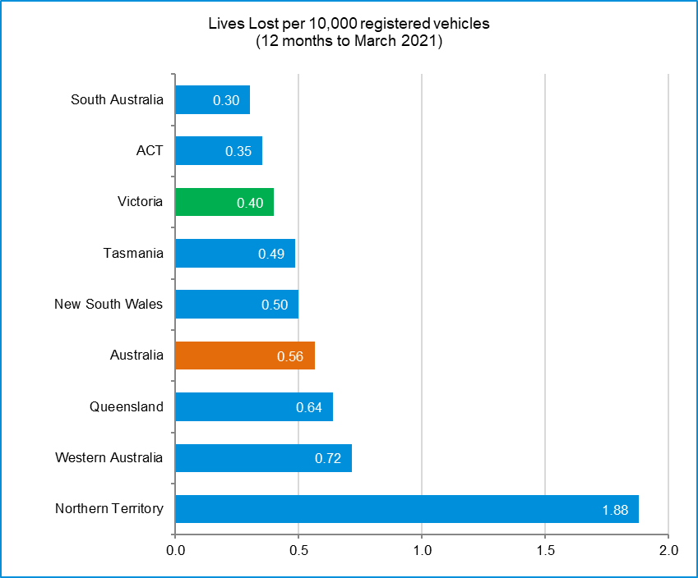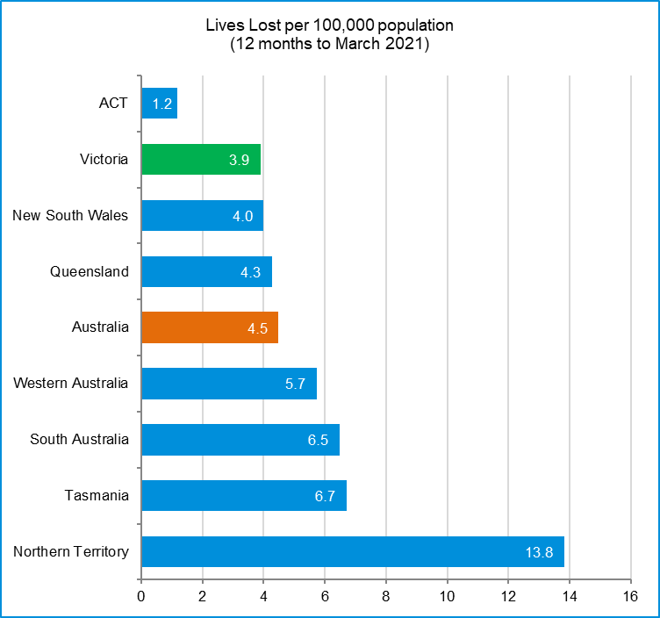

International Road Safety Comparison
Selected OECD countries, Australia and Victoria, 1990, 2000, 2010, 2015 to 2018

Lives lost rate per 100,000 population
Countries | 1990 | 2000 | 2010 | 2015 | 2016 | 2017 | 2018
Australia | 13.7 | 9.5 | 6.1 | 5.1 | 5.3 | 5.0 | 4.5
Canada | 14.3 | 9.5 | 6.6 | 5.3 | 5.3 | 5.1 | 4.9
New Zealand | 21.5 | 12.0 | 8.6 | 6.9 | 7.0 | 7.9 | 7.7
Norway | 7.8 | 7.6 | 4.3 | 2.3 | 2.6 | 2.0 | 2.0
Sweden | 9.0 | 6.7 | 2.8 | 2.6 | 2.7 | 2.5 | 3.2
Switzerland | 13.8 | 8.2 | 4.2 | 3.1 | 2.6 | 2.7 | 2.7
United Kingdom | 9.4 | 6.1 | 3.0 | 2.8 | 2.8 | 2.8 | 2.8
United States | 17.9 | 14.9 | 10.7 | 11.1 | 11.7 | 11.5 | 11.2
Victoria | 12.5 | 8.7 | 5.3 | 4.2 | 4.7 | 4.1 | 3.3

Lives lost rate per100 million vehicle kilometres travelled (VKT)
Countries | 1990 | 2000 | 2010 | 2015 | 2016 | 2017 | 2018
Australia | 1.4 | 0.9 | 0.6 | 0.5 | 0.5 | 0.5 | 0.4
Canada | - | 0.9 | 0.7 | 0.5 | 0.5 | 0.5 | 0.5
New Zealand | - | 1.4 | 0.9 | 0.7 | 0.7 | 0.8 | 0.8
Norway | 1.2 | 1.0 | 0.5 | 0.3 | 0.3 | 0.2 | 0.2
Sweden | 1.2 | 0.9 | 0.3 | 0.3 | 0.3 | 0.3 | 0.4
Switzerland | 1.9 | 1.1 | 0.5 | 0.4 | 0.3 | 0.3 | 0.3
United Kingdom | - | - | - | - | - | - | -
United States | 1.3 | 0.9 | 0.7 | 0.7 | 0.7 | 0.7 | 0.7
Victoria | 1.2 | 0.8 | 0.5 | 0.4 | 0.4 | 0.4 | 0.3

Lives lost rate per 10,000 registered vehicles

Countries | 1990 | 2000 | 2010 | 2015 | 2016 | 2017 | 2018
Australia | 2.3 | 1.5 | 0.8 | 0.7 | 0.7 | 0.7 | 0.6
Canada | 2.3 | 1.6 | 1.0 | 0.8 | 0.8 | 0.8 | 0.7
New Zealand | 3.3 | 1.8 | 1.2 | 0.9 | 0.9 | 1.0 | 0.9
Norway | 1.4 | 1.2 | 0.6 | 0.3 | 0.3 | 0.3 | 0.3
Sweden | 1.7 | 1.2 | 0.5 | 0.4 | 0.4 | 0.4 | 0.5
Switzerland | 2.2 | 1.2 | 0.6 | 0.4 | 0.4 | 0.4 | 0.4
United Kingdom | 2.1 | 1.2 | 0.5 | 0.5 | 0.5 | 0.5 | 0.5
United States | 2.4 | 1.9 | 1.3 | 1.3 | 1.3 | 1.3 | 1.2
Victoria | 2.1 | 1.2 | 0.7 | 0.6 | 0.6 | 0.5 | 0.4

Lives lost rate per 100,000 population - OECD countries, 2018

Source: ABS 2020a, Australian Road Deaths Database and IRTAD 2020

Explanations and references
LGA: Local Government Areas. Crash locations for acute hospitalised claims are assigned to LGA’s based on the crash postcode recorded by Victoria Police. Crash locations for fatal crashes are coded exactly to an LGA by Victoria Police.
Claimants: Refers to people injured in transport accidents who have an accepted claim with the TAC.
Hospitalisation: refers to all hospital admission that occurred within 7 days of accident.

Useful websites
TAC Sites
- TAC Safety (Road Safety) www.tacsafety.com.au
- TAC How safe is your car www.howsafeisyourcar.com.au
- TAC How safe is your first car www.howsafeisyourfirstcar.com.au
- TAC Motorcycle Safety Website www.spokes.com.au
- TAC Corporate site www.tac.vic.gov.au
- Drivesmart www.drivesmart.vic.gov.au
- Ridesmart www.ridesmartonline.com.au

Victorian Sites
- VicRoads www.vicroads.vic.gov.au
- Victoria Police www.police.vic.gov.au
- Parliamentary Road Safety Committee https://www.parliament.vic.gov.au/57th-parliament/rsc
- RACV www.racv.com.au
- Monash University Accident Research Centre www.monash.edu.au/muarc
- Cameras Save Lives www.camerassavelives.vic.gov.au
- VicRoads Learner Driver Site www.lsite.vicroads.vic.gov.au/Learners
- Road Safety Education Victoria www.roadsafetyeducation.vic.gov.au

National and Interstate Sites
- ARRB Transport Research www.arrb.com.au
- Australian Transport Safety Bureau www.atsb.gov.au
- Motor Accidents Authority (NSW) www.maa.nsw.gov.au
- Motor Accidents Insurance Board (TAS) www.maib.tas.gov.au
- Motor Accident Commission, Allianz (SA) www.mac.sa.gov.au
- Motor Accidents Compensation, TIO, (NT) www.tiofi.com.au/mac
- Insurance Commission of Western Australia www.icwa.wa.gov.au
- Motor Accident Insurance Commission (QLD) www.maic.qld.gov.au

International Sites
- National Highway Traffic Safety Admin (USA) www.nhtsa.dot.gov
- Swedish Road and Transport Institute (VTI) www.vti.se
- SWOV Institute for Road Safety Research www.swov.nl

Related Sites
- Alcohol and Drug Foundation www.adf.org.au
Figures
Victoria – Lives Lost, rolling 12 months total

Graph 1a – Melbourne/Rural lives lost

Graph 1b – Melbourne/Rural claims involving acute hospitalisations

Graph 1c – Melbourne/Rural Claims involving hospital admission greater than 14 days

Graph 1d – Victoria/Australia lives lost per 100,000 population

Victorian monthly lives lost since 1951

