
Quarterly Statistics – JUNE 2018


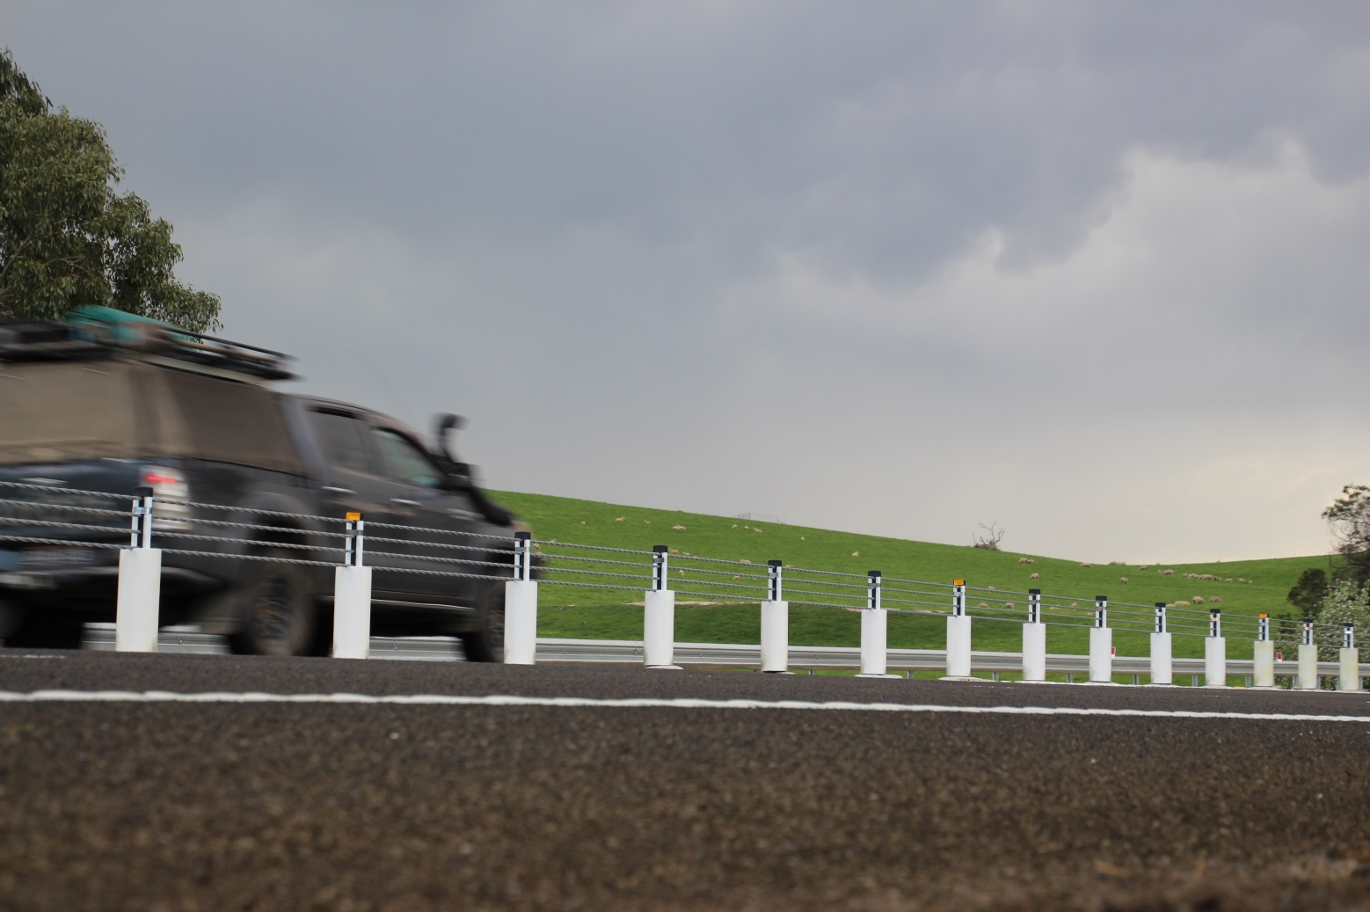

TRANSPORT  ACCIDENT  COMMISSION | 60 Brougham Street  Geelong Vic 3220  PO Box 742  Geelong Vic 3220  Ausdoc DX 216079 Geelong | Telephone 1300 654 329  STD Toll Free 1800 332 556  Fax: 03 9656 9300  www.tac.vic.gov.au  ABN 22 033 947 623

Contents

Status Report 4
Lives lost on Victorian roads 4
Injured claimants who were admitted to hospital within 7 days of accident, (by claim acceptance date – rolling 12 month, to 31st December 2017) 5
Lives lost: 12 months to 30th June 2018 6
Injured claimants who were admitted to hospital within 7 days of accident, 12 months to 31st December (claim acceptance date) 9
Lives Lost by Week (2013 to 2018) 12
The National Picture 13
Explanations and References 15
Useful Internet Sites 16
Victorian monthly lives lost since 1951 19

Notes about the data in this report
- All data provided in this report is the data most recently available at time of production. Fatality data are updated to the end of report month. A 6-month lag applies to TAC claims data.
- Reported data will have one extra day of exposure for leap years.
- Data is subject to revision as additional information about known accidents/claims is received, and as new accident/claim reports are received and processed.

Status Report
- The rolling 12 month number of lives lost to 30th June 2018 is 238. The rolling 12 month number of lives lost to 30th June 2017 stood at 267 (a decrease of 29).
- 101 people lost their lives year to date to the end of June 2018 on Victorian roads. This compares to 121 lives lost year to date to the end of June 2017.
- Four months (February, March, April and June) of the first half of 2018 had lowest number of lives lost since 1952.
- Lives lost by crash location: Melbourne 104 (44%), Rural Victoria 134 (56%)
- Victoria has the second lowest number of lives lost per 10,000 vehicles (0.49) and per 100,000 populations (3.74) among other states and territories after the ACT.

Lives lost on Victorian roads

Category | 2018 | 2017 | 2016 | 2018 v 2017 | 2018 v 2016 | 5 Year Average
Lives Lost (Rolling 12 Month Total)
Lives Lost (to June) | 238 | 267 | 265 | -29 | -27 | 256
per 10,000 veh | 0.49 | 0.56 | 0.57 | -0.07 | -0.08 | 0.56
per 100,000 pop | 3.72 | 4.24 | 4.37 | -0.52 | -0.65 | 4.28
Crashes (Rolling 12 Month Total)
Fatal crashes (to June) | 220 | 258 | 249 | -38 | -29 | 237
per 10,000 veh | 0.45 | 0.54 | 0.53 | -0.09 | -0.08 | 0.51
per 100,000 pop | 3.43 | 4.10 | 4.11 | -0.67 | -0.68 | 3.96

Victoria – Lives Lost, rolling 12 months total

Injured claimants who were admitted to hospital within 7 days of accident, (by claim acceptance date – rolling 12 month, to 31st December 2017)
Category | 2017 | 2016 | 2015 | 2017v 2016 |  | 2017 v 2015 |  | 5 Year Average
Claims involving hospitalisation over 14 days (Rolling 12 Month Total)
Claims (to December) | 928 | 1,021 | 970 | -93.0 | (-9%) | -42 | (-4%) | 943
per 100,000 pop | 14.7 | 16.5 | 16.3 | -1.8 | (-11%) | -1.6 | (-10%) | 15.7
per 10,000 veh | 1.9 | 2.2 | 2.1 | -0.3 | (-14%) | -0.2 | (-10%) | 2.0
All claims involving hospitalisation (Rolling 12 Month Total)
Claims (to December) | 7,704 | 7,179 | 6,294 | +525 | (+7%) | +1410 | (+22%) | 6,565
per 100,000 pop | 121.8 | 116.2 | 105.9 | +5.6 | (+5%) | +15.9 | (+15%) | 106.9
per 10,000 veh | 15.9 | 15.2 | 13.6 | +0.7 | (+5%) | +2.3 | (+17%) | 13.8

Lives lost: 12 months to 30th June

Category | 2018 | 2017 | 2016 | 2018 v 2017 | 2018 v 2016 | 5 Year Average
Overview
Lives Lost | 238 | 267 | 265 | -29 | -27 | 256
Fatal Crashes | 220 | 258 | 249 | -38 | -29 | 237
Sex
Female | 67 | 72 | 74 | -5 | -7 | 72
Male | 171 | 195 | 191 | -24 | -20 | 184
Road user
Bicyclist | 8 | 9 | 9 | -1 | -1 | 9
Driver | 116 | 147 | 128 | -31 | -12 | 127
Motorcyclist | 37 | 41 | 49 | -4 | -12 | 38
Passenger | 43 | 35 | 47 | +8 | -4 | 46
Pedestrian | 34 | 35 | 32 | -1 | +2 | 36
Location
Melbourne | 104 | 107 | 133 | -3 | -29 | 114
Rural Victoria | 134 | 160 | 132 | -26 | +2 | 142
Age group
0-4 | 0 | 4 | 2 | -4 | -2 | 2
5-15 | 4 | 3 | 4 | +1 | 0 | 5
16-17 | 4 | 3 | 9 | +1 | -5 | 6
18-20 | 17 | 15 | 24 | +2 | -7 | 18
21-25 | 24 | 26 | 17 | -2 | +7 | 24
26-29 | 10 | 22 | 21 | -12 | -11 | 19
30-39 | 38 | 40 | 36 | -2 | +2 | 36
40-49 | 34 | 41 | 45 | -7 | -11 | 37
50-59 | 33 | 31 | 33 | +2 | 0 | 32
60-69 | 29 | 26 | 29 | +3 | 0 | 27
70+ | 44 | 55 | 45 | -11 | -1 | 49
Accident Type
Intersection
Adjacent direction | 31 | 35 | 30 | -4 | +1 | 33
Opposing direction | 10 | 7 | 8 | +3 | +2 | 8
Mid-block/other
Head on | 39 | 42 | 51 | -3 | -12 | 42
Same direction | 19 | 19 | 23 | 0 | -4 | 17
Manoeuvre/overtaking | 13 | 9 | 18 | +4 | -5 | 13
On path | 7 | 7 | 6 | 0 | +1 | 6
Single vehicle | 81 | 107 | 96 | -26 | -15 | 96
Other (incl pedestrians) | 37 | 41 | 33 | -4 | +4 | 40

Note: Excludes unknowns.

Lives Lost: 12 months to 30th June – Continued

Category | 2018 | 2017 | 2016 | 5 Year Average | Category | 2018 | 2017 | 2016 | 5 Year Average
Local Government area |  |  |  |  | Local Government Area
ALPINE | 2 | 0 | 0 | 1 | MANSFIELD | 3 | 3 | 1 | 2
ARARAT | 1 | 1 | 3 | 1 | MARIBYRNONG | 4 | 3 | 2 | 2
BALLARAT | 4 | 3 | 5 | 4 | MAROONDAH | 2 | 2 | 0 | 1
BANYULE | 2 | 3 | 2 | 2 | MELBOURNE | 3 | 4 | 2 | 3
BASS COAST | 2 | 2 | 2 | 2 | MELTON | 3 | 4 | 3 | 5
BAW BAW | 1 | 5 | 2 | 4 | MILDURA | 0 | 2 | 5 | 3
BAYSIDE | 3 | 4 | 1 | 3 | MITCHELL | 5 | 2 | 4 | 4
BENALLA | 2 | 4 | 1 | 2 | MOIRA | 7 | 5 | 7 | 4
BOROONDARA | 3 | 3 | 3 | 3 | MONASH | 7 | 6 | 3 | 3
BRIMBANK | 4 | 10 | 10 | 6 | MOONEE VALLEY | 3 | 2 | 2 | 2
BULOKE | 0 | 3 | 1 | 2 | MOORABOOL | 2 | 8 | 3 | 4
CAMPASPE | 5 | 4 | 3 | 4 | MORELAND | 2 | 4 | 3 | 3
CARDINIA | 6 | 7 | 7 | 6 | MORNINGTON PENINSULA | 4 | 5 | 11 | 7
CASEY | 5 | 10 | 7 | 6 | MOUNT ALEXANDER | 5 | 0 | 2 | 2
CENTRAL GOLDFIELDS | 0 | 2 | 1 | 2 | MOYNE | 2 | 2 | 0 | 2
COLAC-OTWAY | 8 | 2 | 4 | 2 | MURRINDINDI | 3 | 6 | 5 | 5
CORANGAMITE | 3 | 1 | 3 | 4 | NILLUMBIK | 2 | 1 | 4 | 2
DAREBIN | 4 | 1 | 3 | 2 | NORTHERN GRAMPIANS | 8 | 3 | 1 | 2
EAST GIPPSLAND | 7 | 3 | 8 | 5 | PORT PHILLIP | 0 | 2 | 2 | 2
FRANKSTON | 5 | 2 | 3 | 2 | PYRENEES | 4 | 3 | 0 | 1
GANNAWARRA | 4 | 0 | 0 | 1 | QUEENSCLIFFE | 0 | 0 | 0 | 0
GLEN EIRA | 1 | 3 | 2 | 2 | SOUTH GIPPSLAND | 4 | 3 | 4 | 4
GLENELG | 3 | 4 | 2 | 3 | SOUTHERN GRAMPIANS | 1 | 3 | 3 | 1
GOLDEN PLAINS | 1 | 6 | 1 | 3 | STONNINGTON | 2 | 0 | 2 | 2
GREATER BENDIGO | 7 | 6 | 4 | 4 | STRATHBOGIE | 2 | 2 | 5 | 3
GREATER DANDENONG | 5 | 3 | 6 | 4 | SURF COAST | 3 | 2 | 4 | 2
GREATER GEELONG | 6 | 14 | 3 | 6 | SWAN HILL | 1 | 4 | 2 | 2
GREATER SHEPPARTON | 5 | 11 | 7 | 6 | TOWONG | 1 | 1 | 1 | 1
HEPBURN | 3 | 5 | 2 | 2 | WANGARATTA | 1 | 6 | 5 | 4
HINDMARSH | 0 | 0 | 2 | 1 | WARRNAMBOOL | 0 | 0 | 2 | 1
HORSHAM | 1 | 4 | 4 | 2 | WEST WIMMERA | 0 | 1 | 0 | 0
HUME | 4 | 1 | 7 | 4 | WHITEHORSE | 2 | 3 | 4 | 3
INDIGO | 2 | 3 | 4 | 3 | WHITTLESEA | 5 | 1 | 7 | 4
KINGSTON | 4 | 3 | 5 | 4 | WODONGA | 1 | 3 | 1 | 2
KNOX | 3 | 4 | 5 | 4 | WYNDHAM | 4 | 7 | 7 | 5
LATROBE | 3 | 4 | 6 | 4 | YARRA | 2 | 1 | 2 | 1
LODDON | 1 | 1 | 2 | 1 | YARRA RANGES | 7 | 5 | 12 | 7
MACEDON RANGES | 3 | 3 | 4 | 4 | YARRIAMBIACK | 1 | 1 | 1 | 1
MANNINGHAM | 3 | 3 | 1 | 1

Note: Excludes unknown local government area.

Injured claimants who were admitted to hospital within 7 days of the accident with a hospital stay of more than 14 days, 12 months to 31st December (claim acceptance date)

 | Category |  | 2017 |  | 2016 |  | 2015 |  | 2017 v 2016 |  |  |  |  |  | 2017 v 2015 |  |  |  |  |  | 5 Year Average
 | Overview
Claims |  | 928 |  | 1,021 |  | 970 |  | -93 |  |  |  | -9% |  | -42 |  |  | -4% |  | 943
Sex
Female |  | 353 |  | 425 |  | 429 |  | -72 |  |  |  | -17% |  | -76 |  |  | -18% |  | 388
Male |  | 575 |  | 596 |  | 541 |  | -21 |  |  |  | -4% |  | +34 |  |  | 6% |  | 555
Road user
Bicyclist |  | 41 |  | 31 |  | 48 |  | +10 |  |  |  | 32% |  | -7 |  |  | -15% |  | 37
Driver |  | 312 |  | 397 |  | 365 |  | -85 |  |  |  | -21% |  | -53 |  |  | -15% |  | 362
Motorcyclist |  | 193 |  | 187 |  | 169 |  | +6 |  |  |  | 3% |  | +24 |  |  | 14% |  | 171
Passenger |  | 135 |  | 150 |  | 147 |  | -15 |  |  |  | -10% |  | -12 |  |  | -8% |  | 143
Pedestrian |  | 209 |  | 221 |  | 199 |  | -12 |  |  |  | -5% |  | +10 |  |  | 5% |  | 201
Train/Tram |  | 14 |  | 7 |  | 8 |  | +7 |  |  |  | 100% |  | +6 |  |  | 75% |  | 9
Location
Melbourne |  | 554 |  | 644 |  | 639 |  | -90 |  |  |  | -14% |  | -85 |  |  | -13% |  | 594
Rural Victoria |  | 311 |  | 322 |  | 302 |  | -11 |  |  |  | -3% |  | 9 |  |  | 3% |  | 315
Age group
0-4 |  | 5 |  | 4 |  | 4 |  | +1 |  |  |  | 25% |  | 1 |  |  | 25% |  | 4
5-15 |  | 6 |  | 13 |  | 20 |  | -7 |  |  |  | -54% |  | -14 |  |  | -70% |  | 13
16-17 |  | 13 |  | 13 |  | 14 |  |  |  |  |  | 0% |  | -1 |  |  | -7% |  | 13
18-20 |  | 48 |  | 74 |  | 43 |  | -26 |  |  |  | -35% |  | 5 |  |  | 12% |  | 57
21-25 |  | 90 |  | 82 |  | 88 |  | +8 |  |  |  | 10% |  | 2 |  |  | 2% |  | 84
26-29 |  | 59 |  | 57 |  | 50 |  | +2 |  |  |  | 4% |  | 9 |  |  | 18% |  | 52
30-39 |  | 125 |  | 135 |  | 122 |  | -10 |  |  |  | -7% |  | 3 |  |  | 2% |  | 118
40-49 |  | 101 |  | 120 |  | 119 |  | -19 |  |  |  | -16% |  | -18 |  |  | -15% |  | 112
50-59 |  | 119 |  | 108 |  | 124 |  | +11 |  |  |  | 10% |  | -5 |  |  | -4% |  | 112
60-69 |  | 125 |  | 130 |  | 110 |  | -5 |  |  |  | -4% |  | 15 |  |  | 14% |  | 114
70+ |  | 237 |  | 285 |  | 276 |  | -48 |  |  |  | -17% |  | -39 |  |  | -14% |  | 263
 | Accident Type
 | Intersection
 | Adjacent direction |  | 91 |  | 108 |  | 102 |  | -17 |  | -16% |  |  |  | -11 |  | -11% |  |  |  | 106
 | Opposing direction |  | 52 |  | 62 |  | 66 |  | -10 |  | -16% |  |  |  | -14 |  | -21% |  |  |  | 61
 | Mid-block/other
 | Head on |  | 63 |  | 97 |  | 96 |  | -34 |  | -35% |  |  |  | -33 |  | -34% |  |  |  | 83
 | Same direction |  | 55 |  | 77 |  | 82 |  | -22 |  | -29% |  |  |  | -27 |  | -33% |  |  |  | 72
 | Manoeuvre/overtaking |  | 47 |  | 58 |  | 62 |  | -11 |  | -19% |  |  |  | -15 |  | -24% |  |  |  | 55
 | On path |  | 21 |  | 31 |  | 28 |  | -10 |  | -32% |  |  |  | -7 |  | -25% |  |  |  | 27
 | Single vehicle |  | 226 |  | 268 |  | 290 |  | -42 |  | -16% |  |  |  | -64 |  | -22% |  |  |  | 259
 | Other (incl pedestrians) |  | 373 |  | 320 |  | 244 |  | +53 |  | 17% |  |  |  | 129 |  | 53% |  |  |  | 280

Note: Excludes unknown, rejected claims and claims for interstate crashes.

Injured claimants who were admitted to hospital within 7 days of the accident with a hospital stay of more than 14 days, 12 months to 31st December (claim acceptance date) – Continued

Category | 2017 | 2016 | 2015 | 5 Year Average | Category | 2017 | 2016 | 2015 | 5 Year Average
Local Government Area |  |  |  |  | Local Government Area
ALPINE | 4 | 3 | 2 | 2 | MANSFIELD | 5 | 9 | 2 | 4
ARARAT | 2 | 3 | 9 | 5 | MARIBYRNONG | 22 | 10 | 13 | 8
BALLARAT | 17 | 12 | 18 | 13 | MAROONDAH | 9 | 8 | 6 | 5
BANYULE | 10 | 9 | 12 | 8 | MELBOURNE | 43 | 39 | 26 | 26
BASS COAST | 4 | 5 | 9 | 7 | MELTON | 9 | 11 | 20 | 10
BAW BAW | 10 | 5 | 12 | 6 | MILDURA | 11 | 4 | 4 | 5
BAYSIDE | 11 | 11 | 11 | 8 | MITCHELL | 7 | 11 | 8 | 9
BENALLA | 6 | 2 | 7 | 4 | MOIRA | 13 | 9 | 7 | 6
BOROONDARA | 16 | 12 | 22 | 16 | MONASH | 22 | 23 | 28 | 18
BRIMBANK | 20 | 32 | 34 | 22 | MOONEE VALLEY | 14 | 19 | 20 | 16
BULOKE | 0 | 3 | 6 | 3 | MOORABOOL | 7 | 11 | 10 | 8
CAMPASPE | 12 | 9 | 8 | 6 | MORELAND | 21 | 35 | 29 | 24
CARDINIA | 20 | 14 | 18 | 11 | MORNINGTON PENINSULA | 19 | 30 | 27 | 22
CASEY | 29 | 39 | 34 | 26 | MOUNT ALEXANDER | 0 | 1 | 3 | 4
CENTRAL GOLDFIELDS | 2 | 2 | 2 | 3 | MOYNE | 9 | 4 | 2 | 3
COLAC-OTWAY | 11 | 7 | 12 | 7 | MURRINDINDI | 20 | 7 | 15 | 8
CORANGAMITE | 6 | 8 | 4 | 5 | NILLUMBIK | 5 | 7 | 13 | 6
DAREBIN | 13 | 31 | 15 | 16 | NORTHERN GRAMPIANS | 6 | 3 | 1 | 3
EAST GIPPSLAND | 13 | 7 | 9 | 7 | PORT PHILLIP | 10 | 21 | 17 | 14
FRANKSTON | 15 | 19 | 15 | 12 | PYRENEES | 0 | 3 | 2 | 2
GANNAWARRA | 4 | 2 | 2 | 2 | QUEENSCLIFFE | 1 | 1 | 0 | 0
GLEN EIRA | 12 | 15 | 15 | 14 | SOUTH GIPPSLAND | 5 | 14 | 8 | 7
GLENELG | 1 | 7 | 4 | 4 | SOUTHERN GRAMPIANS | 2 | 3 | 3 | 3
GOLDEN PLAINS | 5 | 10 | 5 | 5 | STONNINGTON | 14 | 10 | 21 | 12
GREATER BENDIGO | 21 | 12 | 15 | 11 | STRATHBOGIE | 2 | 9 | 9 | 7
GREATER DANDENONG | 24 | 27 | 17 | 20 | SURF COAST | 4 | 7 | 6 | 4
GREATER GEELONG | 36 | 17 | 20 | 20 | SWAN HILL | 4 | 7 | 3 | 3
GREATER SHEPPARTON | 17 | 20 | 15 | 12 | TOWONG | 3 | 4 | 1 | 2
HEPBURN | 2 | 2 | 4 | 3 | WANGARATTA | 5 | 8 | 5 | 5
HINDMARSH | 2 | 3 | 1 | 1 | WARRNAMBOOL | 4 | 3 | 2 | 3
HOBSONS BAY | 9 | 6 | 11 | 7 | WELLINGTON | 7 | 14 | 5 | 8
HORSHAM | 2 | 4 | 3 | 3 | WEST WIMMERA | 1 | 1 | 1 | 1
HUME | 21 | 39 | 37 | 24 | WHITEHORSE | 21 | 26 | 14 | 16
INDIGO | 3 | 9 | 5 | 3 | WHITTLESEA | 21 | 33 | 28 | 21
KINGSTON | 16 | 12 | 27 | 17 | WODONGA | 3 | 4 | 4 | 4
KNOX | 21 | 17 | 19 | 13 | WYNDHAM | 24 | 26 | 25 | 20
LATROBE | 4 | 10 | 16 | 9 | YARRA | 12 | 18 | 11 | 12
LODDON | 0 | 2 | 2 | 1 | YARRA RANGES | 29 | 28 | 43 | 28
MACEDON RANGES | 6 | 20 | 11 | 12 | YARRIAMBIACK | 2 | 1 | 0 | 1
MANNINGHAM | 22 | 17 | 11 | 11

Note: excludes unknown, rejected claims and claims for interstate crashes

Injured claimants who were admitted to hospital within 7 days of accident, 12 months to 31st December (claim acceptance date)
Category | 2017 | 2016 | 2015 | 2017 v 2016 |  | 2017 v 2015 |  | 5 Year Average
Overview
Claims | 7,704 | 7,179 | 6,294 | +525 | 7% | +1410 | 22% | 6,565
Sex
Female | 3,316 | 3,172 | 2,728 | +144 | 5% | +588 | 22% | 2,814
Male | 4,382 | 3,995 | 3,553 | +387 | 10% | +829 | 23% | 3,743
Road user
Bicyclist | 503 | 423 | 389 | +80 | 19% | +114 | 29% | 419
Driver | 3,602 | 3,437 | 2,894 | +165 | 5% | +708 | 24% | 3,034
Motorcyclist | 1,320 | 1,175 | 1,099 | +145 | 12% | +221 | 20% | 1,147
Passenger | 1,128 | 1,096 | 1,044 | +32 | 3% | +84 | 8% | 1,054
Pedestrian | 778 | 746 | 644 | +32 | 4% | +134 | 21% | 688
Train/Tram | 55 | 36 | 28 | +19 | 53% | +27 | 96% | 36
Location
Melbourne | 4,542 | 4,735 | 4,208 | -193 | -4% | +334 | 8% | 4,275
Rural Victoria | 2,236 | 2,035 | 1,847 | +201 | 10% | +389 | 21% | 1,926
Age group
0-4 | 61 | 60 | 42 | +1 | 2% | +19 | 45% | 53
5-15 | 206 | 223 | 238 | -17 | -8% | -32 | -13% | 206
16-17 | 118 | 122 | 117 | -4 | -3% | +1 | 1% | 111
18-20 | 565 | 567 | 453 | -2 | 0% | +112 | 25% | 515
21-25 | 989 | 886 | 746 | +103 | 12% | +243 | 33% | 817
26-29 | 646 | 625 | 530 | +21 | 3% | +116 | 22% | 541
30-39 | 1,232 | 1,122 | 999 | +110 | 10% | +233 | 23% | 1,021
40-49 | 1,127 | 1,036 | 891 | +91 | 9% | +236 | 26% | 964
50-59 | 1,072 | 880 | 815 | +192 | 22% | +257 | 32% | 844
60-69 | 714 | 733 | 586 | -19 | -3% | +128 | 22% | 619
70+ | 974 | 925 | 877 | +49 | 5% | +97 | 11% | 876
Accident Type
Intersection
Adjacent direction | 894 | 906 | 795 | -12 | -1% | +99 | 12% | 843
Opposing direction | 560 | 558 | 546 | +2 | 0% | +14 | 3% | 534
Mid-block/other
Head on | 339 | 360 | 315 | -21 | -6% | +24 | 8% | 328
Same direction | 911 | 1,087 | 932 | -176 | -16% | -21 | -2% | 926
Manoeuvre/overtaking | 365 | 388 | 391 | -23 | -6% | -26 | -7% | 358
On path | 232 | 317 | 296 | -85 | -27% | -64 | -22% | 276
Single vehicle | 1,465 | 1,659 | 1,725 | -194 | -12% | -260 | -15% | 1,620
Other (incl pedestrians) | 2,938 | 1,904 | 1,294 | +1034 | 54% | +1644 | 127% | 1,680

Note: excludes unknown, rejected claims and claims for interstate crashes
Injured claimants who were admitted to hospital within 7 days of accident, 12 months to 31st December (claim acceptance date) – Continued
Category | 2017 | 2016 | 2015 | 5 Year Average | Category | 2017 | 2016 | 2015 | 5 Year Average
Local Government Area |  |  |  |  | Local Government Area
ALPINE | 28 | 19 | 24 | 23 | MANSFIELD | 29 | 40 | 27 | 27
ARARAT | 10 | 22 | 23 | 17 | MARIBYRNONG | 91 | 88 | 73 | 61
BALLARAT | 88 | 105 | 86 | 71 | MAROONDAH | 48 | 70 | 62 | 48
BANYULE | 67 | 62 | 40 | 46 | MELBOURNE | 341 | 335 | 259 | 218
BASS COAST | 35 | 41 | 58 | 37 | MELTON | 69 | 87 | 105 | 66
BAW BAW | 60 | 44 | 45 | 42 | MILDURA | 28 | 28 | 33 | 27
BAYSIDE | 89 | 90 | 86 | 64 | MITCHELL | 70 | 77 | 58 | 53
BENALLA | 24 | 17 | 33 | 17 | MOIRA | 42 | 43 | 35 | 29
BOROONDARA | 133 | 125 | 138 | 109 | MONASH | 195 | 203 | 196 | 160
BRIMBANK | 167 | 133 | 136 | 111 | MOONEE VALLEY | 120 | 140 | 122 | 101
BULOKE | 7 | 11 | 12 | 8 | MOORABOOL | 45 | 54 | 43 | 40
CAMPASPE | 59 | 48 | 42 | 32 | MORELAND | 177 | 180 | 145 | 125
CARDINIA | 128 | 149 | 116 | 96 | MORNINGTON PENINSULA | 149 | 192 | 158 | 126
CASEY | 330 | 359 | 311 | 233 | MOUNT ALEXANDER | 20 | 15 | 28 | 21
CENTRAL GOLDFIELDS | 19 | 14 | 7 | 10 | MOYNE | 39 | 24 | 16 | 16
COLAC-OTWAY | 77 | 43 | 42 | 29 | MURRINDINDI | 75 | 61 | 56 | 48
CORANGAMITE | 38 | 41 | 20 | 24 | NILLUMBIK | 37 | 47 | 48 | 31
DAREBIN | 103 | 122 | 91 | 81 | NORTHERN GRAMPIANS | 34 | 11 | 15 | 14
EAST GIPPSLAND | 63 | 61 | 57 | 47 | PORT PHILLIP | 148 | 141 | 145 | 111
FRANKSTON | 136 | 149 | 136 | 103 | PYRENEES | 9 | 15 | 12 | 8
GANNAWARRA | 13 | 8 | 12 | 10 | QUEENSCLIFFE | 6 | 1 | 1 | 1
GLEN EIRA | 118 | 128 | 111 | 93 | SOUTH GIPPSLAND | 46 | 55 | 25 | 33
GLENELG | 14 | 24 | 19 | 16 | SOUTHERN GRAMPIANS | 17 | 24 | 26 | 22
GOLDEN PLAINS | 52 | 49 | 33 | 28 | STONNINGTON | 134 | 140 | 141 | 114
GREATER BENDIGO | 142 | 94 | 124 | 76 | STRATHBOGIE | 33 | 39 | 44 | 29
GREATER DANDENONG | 252 | 277 | 242 | 206 | SURF COAST | 72 | 49 | 49 | 34
GREATER GEELONG | 423 | 252 | 223 | 181 | SWAN HILL | 15 | 25 | 14 | 13
GREATER SHEPPARTON | 109 | 114 | 93 | 67 | TOWONG | 15 | 19 | 16 | 13
HEPBURN | 20 | 34 | 28 | 25 | WANGARATTA | 26 | 43 | 35 | 27
HINDMARSH | 12 | 10 | 8 | 7 | WARRNAMBOOL | 34 | 33 | 18 | 18
HOBSONS BAY | 74 | 73 | 64 | 53 | WELLINGTON | 62 | 72 | 67 | 56
HORSHAM | 21 | 14 | 35 | 16 | WEST WIMMERA | 3 | 8 | 6 | 5
HUME | 250 | 245 | 204 | 156 | WHITEHORSE | 161 | 149 | 104 | 94
INDIGO | 21 | 31 | 20 | 16 | WHITTLESEA | 211 | 242 | 146 | 136
KINGSTON | 118 | 144 | 135 | 113 | WODONGA | 24 | 28 | 33 | 22
KNOX | 140 | 133 | 124 | 94 | WYNDHAM | 164 | 148 | 160 | 125
LATROBE | 60 | 72 | 58 | 51 | YARRA | 94 | 138 | 116 | 95
LODDON | 9 | 10 | 13 | 10 | YARRA RANGES | 195 | 152 | 199 | 135
MACEDON RANGES | 78 | 90 | 65 | 58 | YARRIAMBIACK | 9 | 3 | 10 | 4
MANNINGHAM | 103 | 94 | 95 | 62

Note: excludes unknown, rejected claims and claims for interstate crashes

Lives Lost by Week (2013 to 2018)

Week |  |  |  |  |  |  | Cumulative | 12 Month
Ending | 2013 | 2014 | 2015 | 2016 | 2017 | 2018 | 2018 | Moving Total
7-Jan | 3 | 0 | 5 | 2 | 2 | 6 | 6 | 263
14-Jan | 2 | 8 | 6 | 5 | 6 | 4 | 10 | 261
21-Jan | 5 | 5 | 5 | 2 | 4 | 2 | 12 | 259
28-Jan | 4 | 8 | 7 | 11 | 4 | 4 | 16 | 259
4-Feb | 6 | 8 | 6 | 4 | 3 | 4 | 20 | 260
11-Feb | 7 | 4 | 4 | 10 | 3 | 4 | 24 | 261
18-Feb | 4 | 7 | 6 | 7 | 6 | 6 | 30 | 261
25-Feb | 7 | 2 | 3 | 9 | 4 | 3 | 33 | 260
4-Mar | 1 | 5 | 4 | 10 | 5 | 4 | 37 | 259
11-Mar | 5 | 10 | 11 | 9 | 3 | 7 | 44 | 263
18-Mar | 5 | 3 | 4 | 5 | 5 | 4 | 48 | 262
25-Mar | 10 | 3 | 2 | 4 | 9 | 4 | 52 | 257
1-Apr | 5 | 8 | 4 | 1 | 3 | 3 | 55 | 257
8-Apr | 3 | 7 | 5 | 1 | 7 | 3 | 58 | 253
15-Apr | 4 | 4 | 5 | 4 | 10 | 0 | 58 | 243
22-Apr | 5 | 1 | 6 | 5 | 8 | 3 | 61 | 238
29-Apr | 5 | 2 | 6 | 5 | 2 | 4 | 65 | 240
6-May | 6 | 3 | 2 | 6 | 5 | 11 | 76 | 246
13-May | 3 | 4 | 8 | 5 | 7 | 4 | 80 | 243
20-May | 0 | 5 | 4 | 6 | 3 | 3 | 83 | 243
27-May | 3 | 7 | 3 | 7 | 3 | 5 | 88 | 245
3-Jun | 10 | 5 | 4 | 4 | 4 | 0 | 88 | 241
10-Jun | 3 | 3 | 5 | 5 | 3 | 4 | 92 | 242
17-Jun | 1 | 2 | 7 | 5 | 2 | 6 | 98 | 246
24-Jun | 5 | 2 | 2 | 5 | 7 | 1 | 99 | 240
1-Jul | 2 | 10 | 9 | 7 | 3
8-Jul | 4 | 5 | 6 | 3 | 7
15-Jul | 7 | 6 | 1 | 5 | 5
22-Jul | 5 | 3 | 3 | 6 | 8
29-Jul | 3 | 5 | 3 | 10 | 1
5-Aug | 8 | 4 | 6 | 6 | 3
12-Aug | 1 | 4 | 7 | 7 | 7
19-Aug | 5 | 6 | 9 | 8 | 8
26-Aug | 5 | 4 | 4 | 11 | 2
2-Sep | 4 | 6 | 4 | 1 | 8
9-Sep | 6 | 6 | 2 | 4 | 8
16-Sep | 2 | 4 | 4 | 4 | 2
23-Sep | 4 | 6 | 4 | 4 | 3
30-Sep | 7 | 3 | 4 | 5 | 3
7-Oct | 3 | 3 | 7 | 3 | 3
14-Oct | 2 | 7 | 4 | 7 | 6
21-Oct | 3 | 0 | 5 | 3 | 3
28-Oct | 4 | 8 | 9 | 6 | 0
4-Nov | 8 | 2 | 3 | 3 | 3
11-Nov | 5 | 7 | 4 | 7 | 12
18-Nov | 2 | 7 | 5 | 5 | 5
25-Nov | 8 | 3 | 2 | 8 | 9
2-Dec | 3 | 10 | 5 | 9 | 3
9-Dec | 7 | 5 | 9 | 4 | 6
16-Dec | 12 | 3 | 1 | 7 | 5
23-Dec | 9 | 2 | 3 | 2 | 9
30-Dec | 2 | 3 | 5 | 8 | 9
31-Dec | 0 | 0 | 0 | 0 | 0
Total | 243 | 248 | 252 | 290 | 259 | 99

The National Picture
State | Lives Lost (12 months to June)
 | 2018 | 2017 | 2016 | 2015 | 2018 v 2017
NSW | 392 | 357 | 386 | 304 | +35 | (+10%)
VIC | 239 | 267 | 265 | 254 | -28 | (-10%)
QLD | 248 | 251 | 244 | 235 | -3 | (-1%)
SA | 99 | 82 | 97 | 113 | +17 | (+21%)
WA | 166 | 183 | 171 | 179 | -17 | (-9%)
TAS | 35 | 31 | 40 | 33 | +4 | (+13%)
NT | 42 | 44 | 44 | 41 | -2 | (-5%)
ACT | 7 | 11 | 13 | 11 | -4 | (-36%)
AUST TOTAL | 1,228 | 1,226 | 1,260 | 1,170 | +2 | (+0%)
AUST minus VIC | 989 | 959 | 995 | 916 | +30 | (+3%)

State | Lives Lost per 10,000 registered vehicles |  |  | Lives lost per 100,000 population
 | (12 months to June) |  |  | (12 months to June)
 | 2018 | 2017 | 2016 | 2018 | 2017 | 2016
NSW | 0.70 | 0.65 | 0.72 | 4.95 | 4.58 | 5.03
VIC | 0.49 | 0.56 | 0.57 | 3.74 | 4.27 | 4.37
QLD | 0.61 | 0.64 | 0.63 | 4.99 | 5.13 | 5.07
SA | 0.70 | 0.59 | 0.71 | 5.73 | 4.77 | 5.74
WA | 0.74 | 0.82 | 0.77 | 6.41 | 7.12 | 6.16
TAS | 0.73 | 0.66 | 0.88 | 6.70 | 5.97 | 7.74
NT | 2.74 | 2.82 | 2.79 | 17.05 | 17.89 | 17.96
ACT | 0.23 | 0.37 | 0.45 | 1.70 | 2.69 | 3.23
AUST TOTAL | 0.64 | 0.65 | 0.69 | 4.96 | 5.03 | 5.25
AUST minus VIC | 0.69 | 0.69 | 0.73 | 5.39 | 5.29 | 5.55

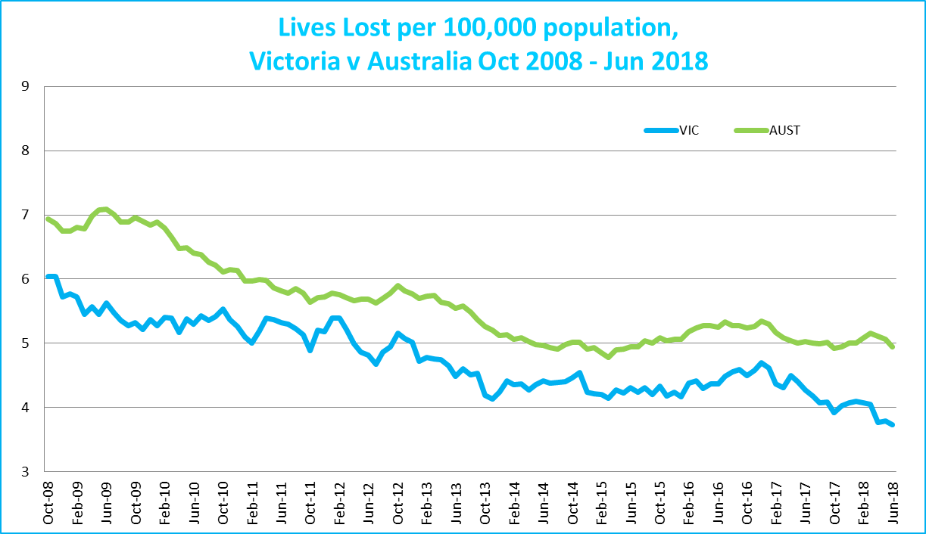
Victoria v Australia – 12 Month Moving Lives Lost Rate

Booze Bus Random Breath Testing

Booze-bus Random Breath Tests (12 months to June 2018 vs previous 12 months)

 | 2018 | 2017 | 2016 | 2017 v 2016 |  | 2017 v 2015
Melbourne | 1,203,695 | 1,019,494 | 992,037 | +184,201 | (+18%) | +211,658 | (+21%)
Country | 130,028 | 136,868 | 90,716 | -6,840 | (-5%) | +39,312 | (+43%)
Vic Total | 1,333,723 | 1,156,362 | 1,082,753 | +177,361 | (+15%) | +250,970 | (+23%)

Booze Bus Random Breath Testing (12 months to June 2018 (monthly totals)
 | 2017 |  |  |  |  |  | 2018
 | Jul | Aug | Sep | Oct | Nov | Dec | Jan | Feb | Mar | Apr | May | Jun
Melbourne | 89,786 | 98,917 | 98,907 | 117,207 | 88,467 | 108,748 | 98,546 | 90,559 | 96,738 | 103,691 | 91,213 | 120,916
Country | 4,525 | 4,304 | 8,261 | 12,889 | 14,307 | 15,152 | 10,962 | 16,569 | 6,855 | 10,813 | 15,444 | 9,947
Vic Total | 94,311 | 103,221 | 107,168 | 130,096 | 102,774 | 123,900 | 109,508 | 107,128 | 103,593 | 114,504 | 106,657 | 130,863

Random Drug Testing

Random Drug Tests (12 months to June 2018 vs previous 12 months)

 | 2018 | 2017 | 2016 | 2018 v 2017 |  | 2018 v 2016
Victoria | 101,948 | 101,442 | 100,237 | +506 | (+0%) | +1711 | (+2%)

12 months to June 2018 (monthly totals)
 | 2017 |  |  |  |  |  | 2018
 | Jul | Aug | Sep | Oct | Nov | Dec | Jan | Feb | Mar | Apr | May | Jun
Victoria | 7,260 | 7,067 | 7,233 | 8,125 | 10,614 | 8,809 | 10,699 | 8,629 | 8,704 | 8,562 | 8,671 | 7,575

Mobile Safety Camera Data

Speed Infringements Issued from Mobile Cameras (monthly totals) Monthly Average = 31,635
2017 |  |  |  |  |  | 2018
Jul | Aug | Sep | Oct | Nov | Dec | Jan | Feb | Mar | Apr | May | Jun
31,079 | 29,788 | 28,581 | 33,953 | 28,402 | 21,408 | 39,249 | 32,973 | 32,021 | 34,027 | 36,169 | 31,965

Excessive Speed Infringements (ESI) Issued from Mobile Cameras (monthly totals) Monthly Average = 351
2017 |  |  |  |  |  | 2018
Jul | Aug | Sep | Oct | Nov | Dec | Jan | Feb | Mar | Apr | May | Jun
323 | 362 | 272 | 332 | 279 | 272 | 156 | 675 | 334 | 391 | 406 | 404
Notes: An ESI is defined as 25km/h over the speed limit except in a 110km/h zone where it is 20km/h over the limit.

Explanations and References
LGA: Local Government Areas. Crash locations for acute hospitalised claims are assigned to LGA’s based on the crash postcode recorded by Victoria Police. Crash locations for fatal crashes are coded exactly to an LGA by Victoria Police.
Claimants: Refers to people injured in transport accidents who have an accepted claim with the TAC.
Hospitalisation: refers to all hospital admission that occurred within 7 days of accident.

Useful Internet Sites
TAC Sites
- TAC Safety (Road Safety) www.tacsafety.com.au
- TAC How safe is your car www.howsafeisyourcar.com.au
- TAC How safe is your first car www.howsafeisyourfirstcar.com.au
- TAC Motorcycle Safety Website www.spokes.com.au
- TAC Corporate site www.tac.vic.gov.au
- Drivesmart www.drivesmart.vic.gov.au
- Ridesmart www.ridesmartonline.com.au
Victorian Sites:
- VicRoads www.vicroads.vic.gov.au
- Victoria Police www.police.vic.gov.au
- Parliamentary Road Safety Committee https://www.parliament.vic.gov.au/57th-parliament/rsc
- RACV www.racv.com.au
- Monash University Accident Research Centre www.monash.edu.au/muarc
- Cameras Save Lives www.camerassavelives.vic.gov.au
- VicRoads Learner Driver Site www.lsite.vicroads.vic.gov.au/Learners
- Road Safety Education Victoria www.roadsafetyeducation.vic.gov.au
National and Interstate Sites:
- ARRB Transport Research www.arrb.com.au
- Australian Transport Safety Bureau www.atsb.gov.au
- Motor Accidents Authority (NSW) www.maa.nsw.gov.au
- Motor Accidents Insurance Board (TAS) www.maib.tas.gov.au
- Motor Accident Commission, Allianz (SA) www.mac.sa.gov.au
- Motor Accidents Compensation, TIO, (NT) www.tiofi.com.au/mac
- Insurance Commission of Western Australia www.icwa.wa.gov.au
- Motor Accident Insurance Commission (QLD) www.maic.qld.gov.au
International Sites:
- National Highway Traffic Safety Admin (USA) www.nhtsa.dot.gov
- Swedish Road and Transport Institute (VTI) www.vti.se
- SWOV Institute for Road Safety Research www.swov.nl
Related Sites:
- Alcohol and Drug Foundation www.adf.org.au
Figures
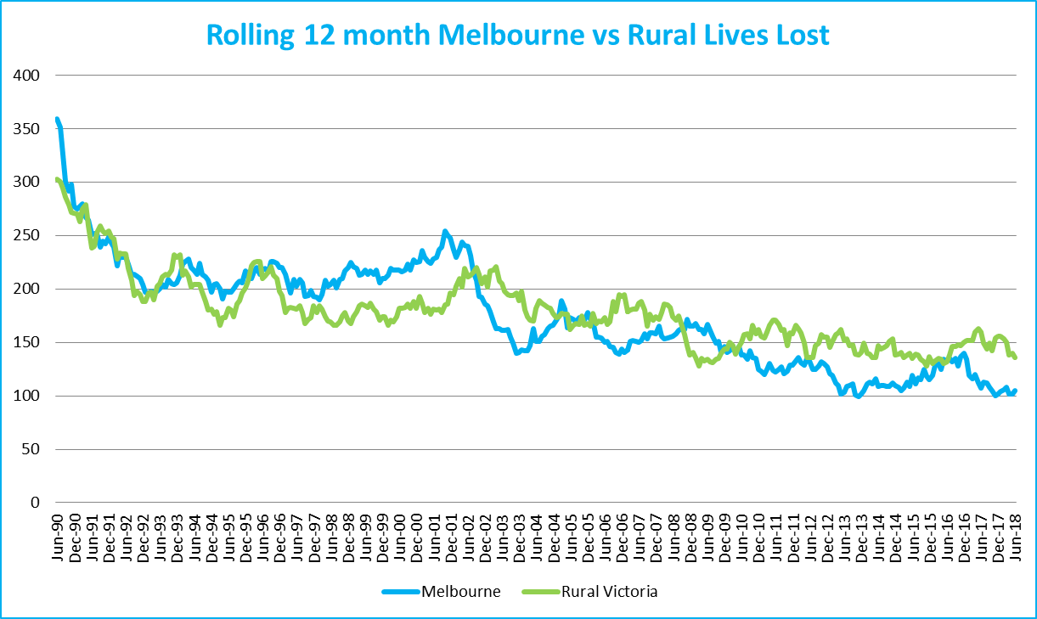
Graph 1a – Melbourne/country lives lost

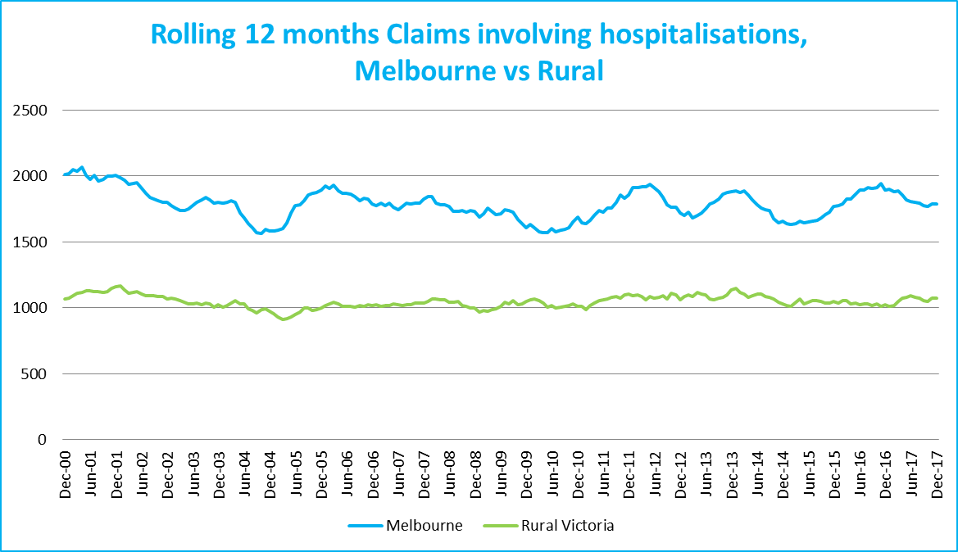
Graph 1b – Melbourne/country Claims involving an acute hospital admission

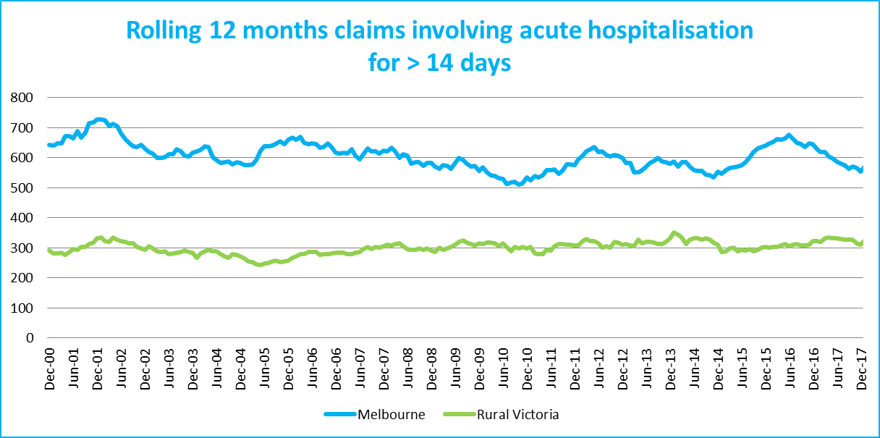
Graph 1c – Melbourne/country Claims involving hospital admission greater than 14 days

Victorian monthly lives lost since 1951

