
Instructions
Complete this form to submit applications for TAC-funded vehicle modifications to ensure the safety, accessibility and independence of TAC clients as drivers or passengers. Include details about the person's transport needs as well as whether their current or pre-accident vehicle is suitable for modification and, where relevant, if it has the capacity to fit a wheelchair.

Section 1

TAC client details
First name

Last name

TAC claim number |  | Date of accident | / /

Date of birth | / /

Street name and number

Suburb/Town |  | Post code

Client phone number

Client email address

Key contact if not client

Key contact phone number

Relationship of key contact
(e.g. parent, partner, guardian)

Date of assessment | / / | Date of report | / /

Has the Community Access and Transport Recommendations assessment been completed?
If no, please contact the TAC.

Section 2

current status and performance
Provide a summary of person’s current capabilities. Include how capabilities relate to injuries from the transport accident and the person’s needs for a modified vehicle. Note any relevant medical history not related to the transport accident that may affect recommendations.
Outline the injuries the person sustained in their transport accident. Include any complications from injuries,
e.g. epilepsy.
Outline the person’s current physical capabilities. Include transfers, indoor/outdoor mobility, upper and lower limb function, balance, splinting and equipment required, such as hoists, manual or powered wheelchairs.
Outline cognitive and behavioural capabilities. Include memory, insight and distractibility.
Outline communication, hearing, vision, tactile and swallowing capabilities. Note any difficulties, support or
special requirements.

Section 3

Current or pre-accident vehicle
For the TAC to determine reasonable contribution, please outline the details of the person’s existing or pre-accident vehicle or other vehicles to which the person has access.
 | Person’s current vehicle | Person’s pre accident vehicle
Make and model
(e.g. Holden Commodore)
Variant/Badge
(e.g. Omega, SV6)
Year of manufacture
Current kilometres
Registration plate
Engine capacity
(1.5L, 2.0L)
Type of transmission
(auto or manual)
Fuel type
(diesel/petrol/hybrid)
Year of purchase

Other vehicles the person has access to
(family members, work vehicles etc.)
Make & model
(e.g. Holden Commodore)
Variant/Badge
(e.g. Omega, SV6)
Year of manufacture
Current kilometres
Registration plate
Engine capacity
(1.5L, 2.0L)
Type of transmission
(auto or manual)
Fuel type
(diesel/petrol/hybrid)
Year of purchase
How often does the person have access to these vehicles? If access to these vehicles is limited, please outline the reasons why.

Is the above vehicle currently available for this person’s use and suitable for modifications?
If no, please provide rationale below

section 4

Wheelchair specifications
If applicable, please outline the details of all wheelchairs the person will be seated in when travelling or transferring from/into vehicle.
Manual
(folding/rigid frame)

Power

Type & model

Wheelchair footprint
Provide overall dimensions when person sitting in wheelchair in usual travel posture and with accessories / medical equipment attached. Include diagram if appropriate.
Type and model | Manual wheelchair | Power wheelchair | 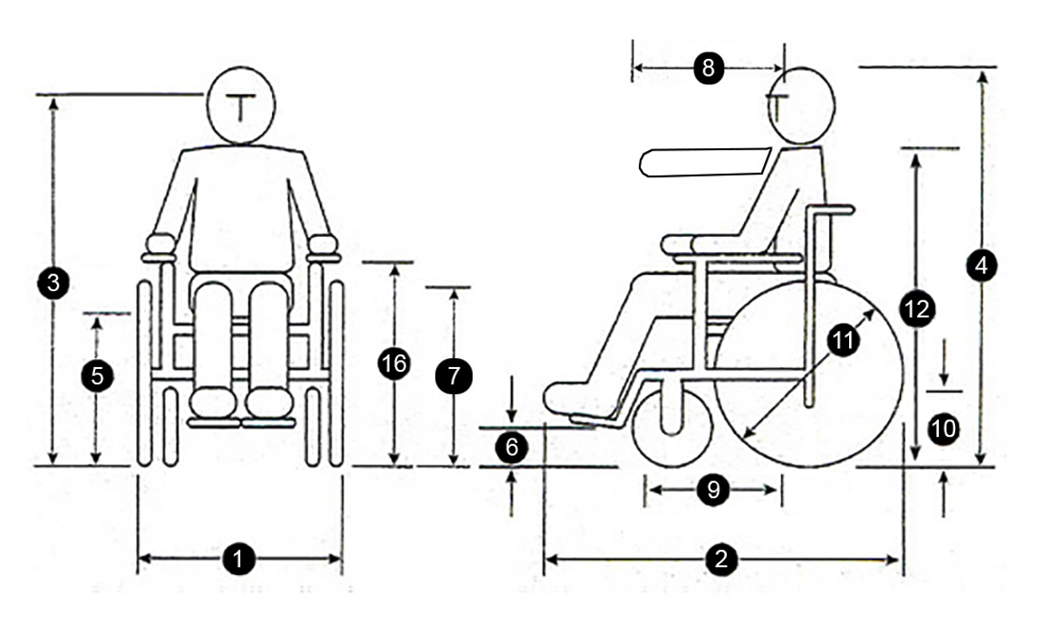
- Chair width | mm | mm
- Chair length | mm | mm
- Floor to eye height | mm | mm
- Floor to top  of head | mm | mm
- Floor to seat height | mm | mm
- Floor to  footplate height | mm | mm
- Floor to  knee height | mm | mm
- Arm extension | mm | mm
- Thigh length | mm | mm
- Castor  wheel size  (front) | mm | mm
- Back wheel size / e-motion  wheel size | mm | mm
- Floor to  shoulder height | mm | mm
- Headrest fitted?
- Chair weight | kg | kg
- Combined  weight in chair | kg | kg
- Floor to  armrest height | mm | mm
- Is the chair suitable to have a docking
pin fitted?

Is the person’s current vehicle/car able to have recommended adaptive equipment and structural modifications installed?

Section 5

Alternate vehicle/cars and modifications
Provide details of all vehicles that have been considered as a part of this assessment process. Please ensure quotes are itemised.
Outline the most appropriate make and model of vehicle to meet the person’s transport needs. Provide details and clinical justification for your recommendation and include the person’s preference. Include itemised quotes for both vehicle purchase and modifications.

Section 6

Request details
Modifications to the person’s own vehicle

Contribution to a standard vehicle and modifications

Contribution to a modified wheelchair accessible van
Please provide clinical rationale for recommendations

Section 7

Anticipated driving status
Person as a driver

Person as a passenger

Person as a driver and passenger

Person as a passenger now, with potential to drive in the future

Anticipated kilometers per year

If person is a driver:
Licence category
(specify, e.g. car, motorcycle)

Current valid driving licence?

If yes, are there restrictions imposed?
If the person has a restricted licence, please provide details of those restrictions.

Has the person had a driving assessment since their injury?

If yes, what is the date of their last driving assessment? | / /

If no, are they required to have a driving assessment?
If there has been an OT driving assessment completed, please attach a copy of the Occupational Therapy Driving Assessment Report and VicRoads Medical Report Form.
Any additional comments

If person is a passenger:
If the person is a passenger only, please comment on who will be driving the vehicle, if they have been consulted and if training requirements exist?

Section 8

Recommended vehicle modifications/vehicle
Please outline rationale for all recommendations
When travelling in the vehicle, recommended seating arrangement for the person is: | Yes or No | Comments
Driver seated in wheelchair
Driver seated in vehicle seat
Passenger seated in wheelchair
Passenger seated in vehicle seat

Detailed recommendations and clinical justification
Wheelchair access into vehicle
and within vehicle
(ramp/hoist, door openings, rear/side entry, required clearance dimensions).
Vehicle seating arrangements:
Where will person sit in vehicle?
Other seats required in vehicle?
Where does the person wish to sit in
the vehicle?
Is specific seating required?
(e.g. seat belts, special seats, head supports)
Are modified vehicle controls required?
(e.g. left foot accelerator, hand controls)
What wheelchair restraints and seatbelt requirements are you recommending?
(e.g. docking station/tie downs)
Are specific vehicle options required?
(e.g. transmission type)
If equipment is to be transported, please comment on how it is to be loaded and stowed.
For example, can the person load equipment with the
help of hoists/lifts? Will a carer be required to load and stow equipment?
Is there a suitable second hand vehicle available to meet the person’s needs outlined above?

section 9

Other transport requirements
Indicate other people/items required to be transported in this vehicle now and in the future. Include whether
equipment items will adequately fit in available space in proposed vehicle. Include predicted needs if person’s needs are expected to change in the future. Consider equipment that has been provided, is awaiting prescription or is yet
to be investigated.
 | Current status | Anticipated future status
People: number and relationship of people who would be using the vehicle apart from the person
Equipment
(e.g. ramps, wheelchair, scooter, mobile
hoist, gait aids)
Other

section 10

Vehicle availability
Have you discussed with the person, their family and carers the need to ensure that the proposed vehicle is readily available for person use?
(i.e. the vehicle must be free for use and readily accessible when needed)
Comments

Section 11

Vehicle access at home
What parking options are available at the person’s home for the proposed vehicle? Has an appropriate location for the vehicle been established? Please describe.
What are the spatial dimensions of the area where loading and unloading will occur, and external dimensions of the proposed vehicle? Is there room for safe loading and unloading, and wheelchair access around the parked vehicle? Please describe.
What is the height of the existing garage or car port? Will the proposed vehicle have adequate clearance, including when the tail gate is fully open? Please describe.
Is it recommended that the vehicle will reverse or front in to the parking / loading area? Please describe.
Does the parking area allow for the person to load and exit the vehicle in an undercover area? Is undercover loading and exit clinically required? Please describe.
What is the condition (e.g. surface, gradient, drainage) of the current parking area and driveway, and is it anticipated that access to the proposed vehicle would require any structural modification to this area? Please describe.

Section 12

Insurance / registration
Has the person been made aware that they will be required to pay for the following? Do they indicate that they understand this?
Comprehensive insurance and any excess incurred by person/carers in case of an accident

TAC levy / registration fee

Any additional options to the vehicle not required due to transport accident injuries

All general maintenance and repairs of vehicle

Fuel

Has the person been made aware that they will be required to sign a Vehicle Modifications Agreement before vehicle handover if modifications exceed $10,000?

Is the person aware they are responsible for general running cost and maintenance to the vehicle?
Additional comments

section 13

Authorisation
Have you discussed this Vehicle Modifications Assessment and Recommendations with the person or the person’s representative?

Has the person or the person’s representative consented to supply the TAC with the personal and health information collected?

section 14

PROVIDER details
I have discussed with the person and/or representatives and other members of the treating team the information contained in this form, including the requested items, aims, predicted outcomes, maintenance
and training requirements.

Provider name, address,
email and phone number
(Type details or insert image of
practice stamp)

Days/hours available

Signature  Insert image (jpg/png) of signature.  (Or print, sign and scan the form) | 


Date | / /

Submitting this form
Email your completed form to your TAC claims manager or to info@tac.vic.gov.au with the client’s TAC claim number in the subject line. Please also attach any supporting documentation.

Privacy
The TAC will retain the information provided and may use or disclose it to make further inquiries to assist in the ongoing management of the claim or any claim for common law damages. The TAC may also be required by law
to disclose this information. Without this information, the TAC may be unable to determine entitlements or assess whether the treatment is reasonable and may not be able to approve further benefits and treatment. If you require further information about our privacy policy, please call the TAC on 1300 654 329 or visit our website at www.tac.vic.gov.au
Authorised and published by the Transport Accident Commission

