Proposed
Spinal Impairment Guides modification document – Regulatory Impact Statement
Transport Accident Commission
Spinal Impairment Guides modification document - Regulatory Impact Statement -
July 2014

Disclaimer
This Regulatory Impact Statement (RIS) was prepared for the Transport Accident Commission pursuant to a contract with the Transport Accident Commission (TAC).
In preparing this RIS we have only considered the circumstances of the TAC. Our RIS is not appropriate for use by persons other than the TAC, and we do not accept or assume responsibility to anyone other than the TAC in respect of our RIS.
The information, statements, statistics and commentary (together the 'Information') contained in this report have been prepared by PricewaterhouseCoopers (PwC) from material provided by the TAC. PwC may at its absolute discretion, but without being under any obligation to do so, update, amend or supplement this document.
The Information contained in this RIS has not been subjected to an Audit or any form of independent verification. PwC does not express an opinion as to the accuracy or completeness of the information provided. PwC disclaims any and all liability arising from actions taken in response to this RIS.

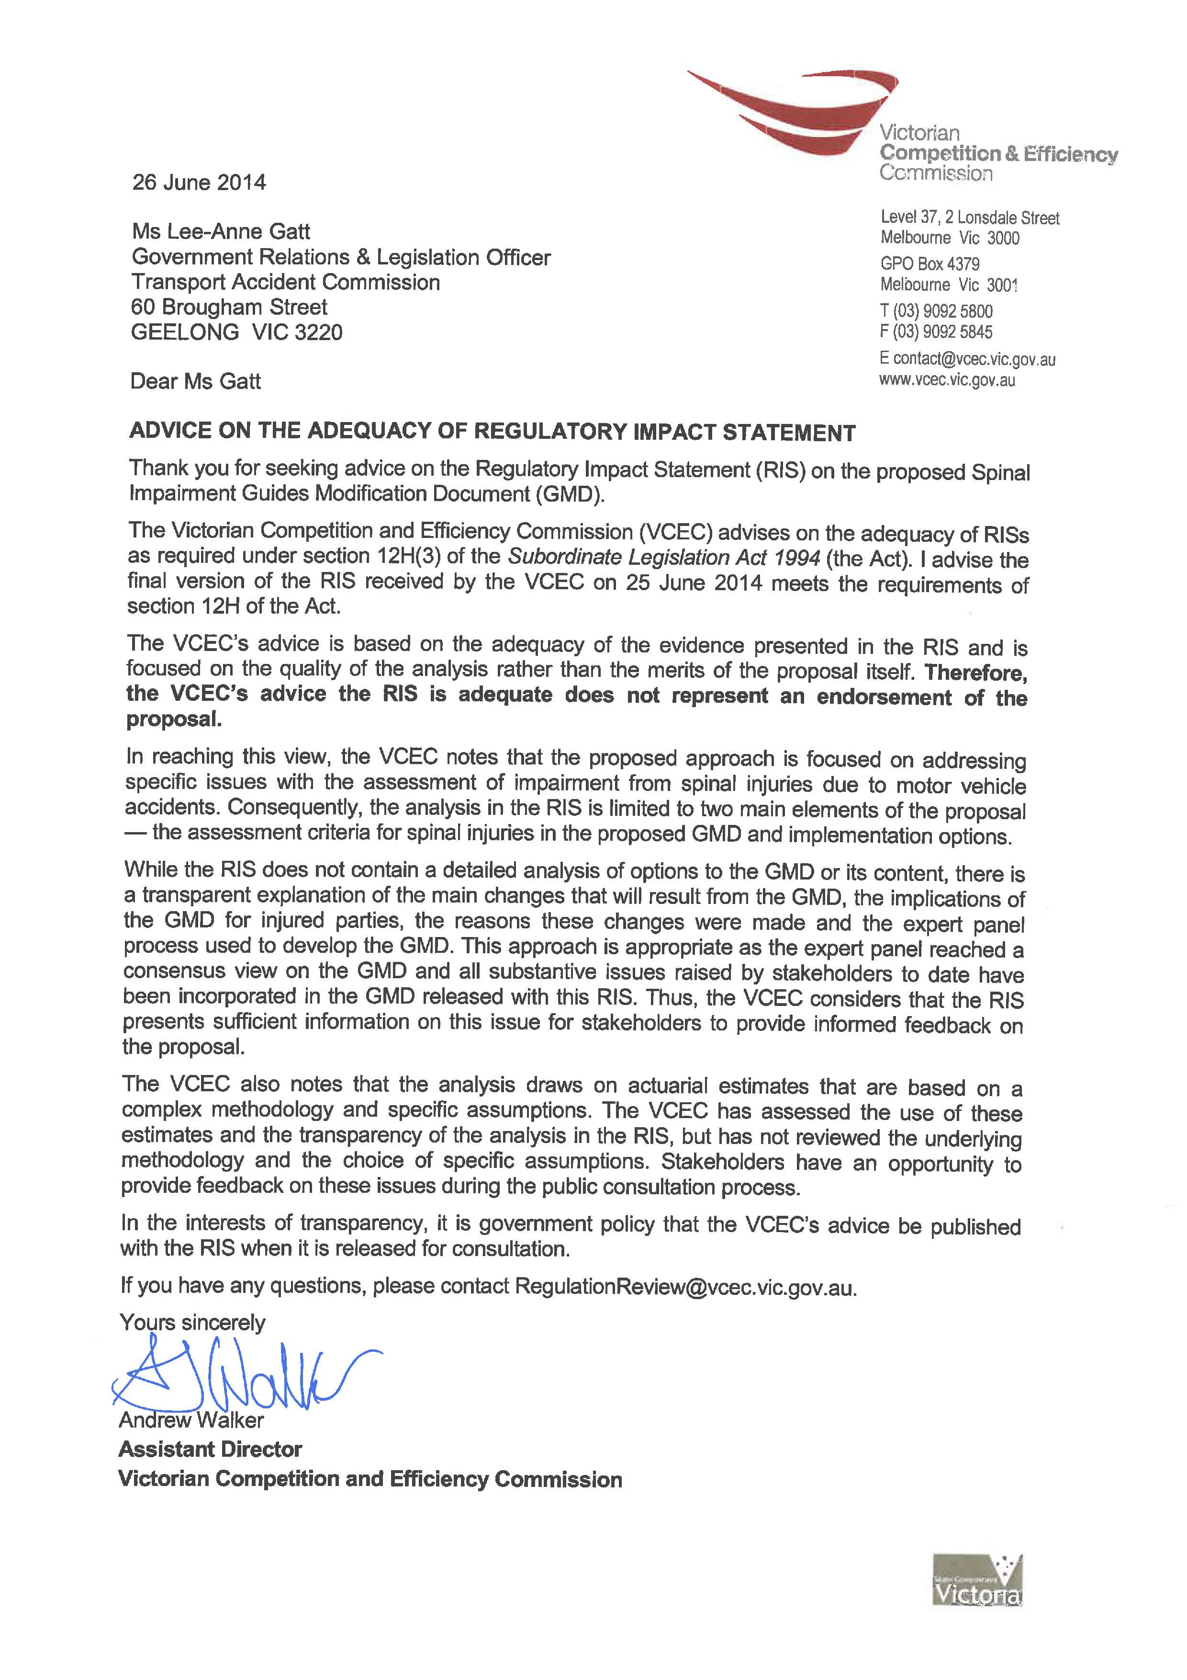

Executive summary
The Transport Accident Commission (Vic) (TAC) administers a statutory no-fault and common law damages compensation scheme for people who are injured or die as a result of a transport accident involving a Victorian registered vehicle. According to the National Competition Policy review of Victoria’s transport accident legislation, one of the core objectives of transport accident insurance is to provide suitable and just compensation to this group.
As part of the comprehensive no-fault benefits funded under the scheme, the TAC provides compensation based on an assessment of a claimant’s level of impairment. The TAC requires claimants who are likely to be entitled to an impairment benefit to undergo an impairment examination with an accredited medical examiner. The TAC uses the assessment reports from these examiners to determine the claimant's total or ‘Whole Person Impairment’ (WPI) score. The WPI score represents their proportionate level of physical and psychological impairment directly caused by the transport accident.
All claimants have access to TAC funded medical and like services and, if unable to return to work, income benefits for up to three years. A claimant may also be entitled to additional compensation determined by their assessed WPI. A claimant’s WPI determines their eligibility for three types of compensation. The additional types of compensation and their relevant criteria is summarised in Table 1 below.
Table 1: Types of additional compensation based on level of Whole Person Impairment (WPI)
 | Criteria | Paid
Impairment benefits | WPI > 10% | Paid in lump sum, incrementally higher based on level of WPI
Common law damages | Claimant cannot be at fault  WPI ≥ 30% or ‘Serious Injury’ certificate granted on narrative criteria | Determined by courts
Ongoing Loss of Earnings Capacity benefits | WPI ≥ 50% | Paid on an ongoing basis up to age of 65
Source: TAC
The assessment of spinal impairment is conducted in accordance with the American Medical Association Guides to the Evaluation of Permanent Impairment (4th Edition) (the Guides). The Guides specify eight categories of impairment severity known as Diagnosis Related Estimate (DRE) categories, which correspond to certain levels of WPI. The eight categories each contain two subsections. The first subsection is entitled ‘Description and Verification’ containing different injury descriptors of the impairment within that particular category. The second subsection of each category is entitled ‘Structural Inclusions’. Structural Inclusions serve as an alternative impairment criteria based on spinal fractures. If a claimant has an injury that corresponds to a Structural Inclusion, the injury is automatically assessed at that impairment category. DRE Category IV, which corresponds to a WPI rating of 20 per cent, contains a Structural Inclusion that includes multiple fractures.
The precedent set in the Supreme Court judgment of the Transport Accident Commission v Serwylo [2010] VSC 421 (Serwylo) changed the long held interpretation of the Structural Inclusion (2) in DRE Category IV and highlighted an issue that has significant impacts for the equity of the scheme.
Previously, multiple fractures in one region of the spine were assessed on whether the fractures had the capacity to disrupt the spinal canal or impair the ability of the spine to provide postural support. However, the Court held that the use of the words “as with fractures” used in the Guides were intended by the authors of the Guides to mean that the presence of multiple fractures in a region of the spine was sufficient to justify DRE Category IV regardless of whether the medical examiners were of the opinion that the fracture actually caused multiple levels of structural compromise.
In this scenario, claimants who have minor spinal fractures that are regarded by medical examiners as being of very little medical significance or physical disability are assessed as significantly impaired. Consequently, these claimants are provided with levels of compensation that are inappropriate when compared with other claimants who are assessed at the same WPI but are more functionally impaired. This also means that claimants who had minor spinal fractures before the accident will be deemed to have a significant pre-existing impairment when the TAC determines their transport accident-related WPI.
This precedent also has implications for the assessment of spinal surgeries and procedures such as fusions. Many examiners now consider that spinal surgery has an effect on bone that is the equivalent to fractures, which justifies DRE Category IV.
Problem
The problem considered in this RIS is the broad and inclusive language used in the Guides' Structural Inclusion (2) of DRE Category IV, which has given rise to potential inequities in impairment assessment. In particular, the application of Structural Inclusion (2) of DRE Category IV post-Serwylo permits minor spinal fractures that result in little or no structural impairment to rate disproportionally higher than the level of impairment that the injury actual causes. This means a claimant who has multiple spinal fractures (even where microscopic) is now assessed at the same level of compensation as a claimant who is more severely impaired from a non-spinal related injury (such as a serious brain injury). As a consequence, persons with minor spinal fractures such as fractures of the transverse processes have been assessed at higher WPI levels and now qualify for additional compensation payments outlined in Table 1. The resulting cost to the scheme has been estimated at $11.4 million per new accident year, leading to an additional liability of $67.5 million for the TAC.
Options
The TAC has proposed to rectify the consequences of the wording in DRE Category IV through enacting the Guides Modification Document (GMD) which can override the relevant sections of the Guides’ methodology for spinal impairment assessments. Due to the complexity of the Guides, the GMD is seen as the only viable alternative to achieve the TAC’s objectives.
The document has been developed by an independent Spinal Expert Panel, which has provided a gradated assessment of multiple fractures based on the increasing severity of certain spinal fractures. Under the proposed change, only spinal surgeries and fractures that have the capacity to compromise the spinal structure will be assessed as DRE IV. The GMD also provides a new DRE Category III rating, however no other section of the Guides (outside spinal impairment assessment) will be amended. The document sets out which Structural Inclusions justify a DRE Category IV rating and by implication what Structural Inclusions justify DRE I to III and DRE V. The document also provides four gradations of DRE Categories for spinal surgery and procedures including a modifier to the assessment based on whether radiculopathy is present after surgery or not.
The proposed GMD, expected to be released on 1 July 2014, will place approximately 80 per cent of these claimants at a pre-Serwylo level of impairment. According to the TAC, the Expert Panel’s approach did not fully restore the pre-Serwylo position as it was an inadequate method of assessing the diverse range of multiple spinal fractures and there was little information about how the consequences of spinal surgery should be assessed.
In addition, the other areas that were considered in the development of the GMD included:
- detailed definitions of what parts of the spine constituted each assessment region (clause 5 of the GMD)
- a new definition of fracture (section 3.4 of the GMD)
- clear direction on the assessment of fractures.
This RIS considers two options in relation to the implementation and timing of the GMD. The implementation options are differentiated by the timing of their application, which has implications for the number of claimants directly affected. Implementation Option 1 would apply the GMD to all persons injured on or after the 1 September 2014 (two months after the expected release date of 1 July 2014). This would mean that claimants who have been injured previously and are currently waiting to be assessed would not be affected by the change.
Implementation Option 2 would apply to claimants who undergo their impairment assessment examinations on or after 1 January 2015. The date of 1 January 2015 was selected on the basis that there is traditionally a six month waiting list for medical assessments with many claimants booked into their impairment assessments in advance. Therefore, Implementation Option 2 provides a buffer for those claimants with minor fractures that are already booked in for their assessment prior to 1 January 2015 to be assessed using the current methodology.
Implementation Option 2 is distinctly different from Implementation Option 1 in that it is partially retrospective, capturing a portion of claimants injured prior to 1 September 2014.
Analysis and conclusion
The key benefit of the implementation options relates to equity, specifically the extent to which a ‘pre-Serwylo’ situation is restored. There are two aspects to equity:
- Horizontal equity refers to treating people with similar characteristics in similar ways. In this context, it refers to claimants with similar functional impairment receiving similar levels of compensation. This RIS focusses on horizontal equity.
- Vertical equity refers to the notion that persons in different situations should be treated differently according to their level of need. In this case, vertical equity means that people with more severe injuries receive higher compensation.
Under Implementation Option 1, the date of the proposed GMD would be 1 September 2014. This implementation option will directly impact 80 per cent of claimants with multiple spinal injuries occurring on or after 1 September 2014 (1,251). This represents 54 per cent of the current and future claimants in the scheme (over the next ten years) with multiple fractures (i.e. the horizontal equity impact).
More broadly however, all persons entering the scheme on or after 1 September 2014 would be placed on a more equitable footing. That is, there is a vertical equity benefit for all other cases over the next ten years (13,187) whereby even though their own compensation level will not change, they will receive a more equitable amount (in a relative sense when compared with multiple fractures claims).
In Implementation Option 2, impacted persons are determined by their assessment examination date rather than their accident date. As it is not possible to be assessed prior to the date of accident, the new GMD will capture every claimant with an accident date of 1 January 2015 and beyond. In addition, we have assumed that no claimant can obtain an assessment within six months of their accident date. Hence, Implementation Option 2 captures the 80 per cent of future claimants outlined in Table 2, which represents the claimants affected under Implementation Option 1 plus the two months of claimants injured between 1 July 2014 and 31 August 2014.
Furthermore, Implementation Option 2 also has a retrospective impact as a proportion of existing claimants with an accident date prior to 1 July 2014 will also be impacted by the GMD. Data provided by the TAC has indicated that the number of claimants in the scheme receiving impairment benefits at any point in time remains relatively constant, hence the current claimant figures outlined in Table 2 below can be used.
Table 2: Number of existing and future claimants (over 10 years)
 | Accident date
Injury type | Existing claimants in the scheme at 1 July 2014 | Future accidents from 1 July 2014 (over 10 years) | Total
Multiple spinal fracture cases | 725 (31%) | 1,590 (69%) | 2,315 (100%)
All other cases (that receive impairment benefits) | 6,115 (31%) | 13,410 (69%) | 19,525 (100%)
Total | 6,840 | 15,000 | 21,840
Sources: TAC data and PwC analysis as described below.
Implementation Option 2 therefore has a retrospective impact of 516 claimants. and a total horizontal equity impact of 1,788 claimants ,representing 77 per cent of the current and future multiple spinal fracture claimants in the scheme (over the next ten years).
There is also a vertical equity benefit for 18,184 claimants.
Both implementation options have one-off implementation costs of $51,320.
However, there are transitional issues associated with the Implementation Option 2:
- The entitlements of existing claimants are affected under Implementation Option 2, unlike Implementation Option 1.
- Similarly, under Implementation Option 2 there is a risk of behaviour changes by claimants, such as attempting to obtain medical assessments prematurely prior to the cut-off date.
Both implementation options change compensation arrangements, and therefore represent a cost saving to the scheme. The largest saving is under Implementation Option 2 ($114.4m), rather than Implementation Option 1 ($68.4 million). In addition, Implementation Option 2 results in a liability saving of $46 million to the scheme. This represents the reduction in the TAC’s potential liability to make payments to existing claimants. Under Implementation Option 1, no existing claimants are affected and therefore the TAC retains its full current liability.
From a cost-benefit analysis perspective, this cost saving simply represents a transfer of resources or redistribution between two groups in society. Transfers can only be regarded as enhancing community wellbeing if a decision is made that one group derives more value from the resources than the other. In this case, we do not make this assumption and so the cost-benefit impact of this transfer is taken to be nil. While transfers involving taxation can have a range of distortionary impacts, the CTP levy represents the cost of certain risks associated with driving, essentially internalising what was an externality.
On balance, Implementation Option 2 is selected as the preferred implementation option. This is primarily due to the fact that it generates more significant equity benefits at the same financial cost as Implementation Option 1. It should be acknowledged, however, that there are some transitional issues associated with this implementation option.
Table 3 below outlines the results of the costs-benefit analysis conducted over the two implementation options relating to the timing and implementation of the GMD.
Table 3: Results of cost-benefit analysis
 | Implementation Option 1: Accident date (1 September 2014) | Implementation Option 2: Assessment date (1 January 2015)
Financial benefits
 | $0 | $0
Financial costs
Implementation costs | ($51,320) | ($51,320)
Net financial benefits | ($51,320) | ($51,320)
Transfers
Redistribution (net effect of zero) | $68.4m | $114.4m
Non-monetary impacts
Changes to benefits (number of people directly impacted) | 1,251 | 1,788
Transitional issue: entitlements (number of people) | Nil | 516
Note: Figures may not sum exactly due to rounding
Source: PwC analysis as outlined in main body

Abbreviations
Abbreviation | Description
AMA | American Medical Association
Act | Transport Accident Act (1986)
DRE | Diagnosis-Related Estimate
GMD | Guides Modification Document
Guides | American Medical Association Guides to the Evaluation of Permanent Impairment (4th Edition)
LOEC | Loss of earnings capacity
NPV | Net Present Value
PwC | PricewaterhouseCoopers
Serwylo | TAC v Serwylo [2010] VSC 421
RIS | Regulatory Impact Statement
TAC | Transport Accident Commission
WPI | Whole Person Impairment

Contents
Disclaimer i
Executive summary i
Abbreviations vii
1 About this regulatory impact statement 2
2 Nature and extent of the problem 4
3 Objectives 11
4 Options 12
5 Cost benefit analysis 17
6 Preferred option 25
Appendix A Guides modification document 29
Appendix B Terms of reference 50
Appendix C Calculation of cost per accident year and liability amounts resulting from Serwylo 56
Appendix D Letter outlining Expert Panel considerations for GMD 65

About this regulatory impact statement

Introduction
PricewaterhouseCoopers (PwC) has been engaged by the Transport Accident Commission (TAC) to prepare this Regulatory Impact Statement (RIS) to assess the proposed amendments to the American Medical Association Guides to the Evaluation of Permanent Impairment 4th Edition (the Guides). PwC has relied on the TAC to advise on the practical implications of the technical components of the proposed Guides Modification Document referred to in this RIS.
This RIS is based on the requirements of the Victorian Guide to Regulation (Edition 2.1, August 2011).

Purpose of this regulatory impact statement
The purpose of this RIS is to:
- establish the problem that government is seeking to address and the extent of that problem
- identify a set of options for government to address the identified problem
- assess the costs and benefits of these options, and the effectiveness of each option in addressing the problem before establishing a preferred option for government action
- develop an implementation and review strategy for the preferred option.

Public consultation
The TAC is now seeking written submissions on this RIS. The RIS is subject to a consultation period with the closing date for submissions being 30 July 2014. Feedback is sought on the proposed methodology in the GMD and the preferred commencement date for the GMD. To the extent possible, all submissions will be made available on the TAC website – tac.vic.gov.au. All personal information other than your name and suburb will be removed before publishing. If any information contained in your submission should be treated as confidential, please clearly identify this on the submission cover sheet. Submissions received by post will be available in PDF on the website. The TAC does not intend to formally reply to each submission.
Responses to the Consultation RIS can be provided as follows
By email (preferred)
GMD@tac.vic.gov.au
In writing
Ms. Lee-Anne Gatt
Government Relations
Transport Accident Commission
PO BOX 742
GEELONG VIC 3220
For enquiries about the consultation process please email Lee-Anne Gatt at gmdenquiries@tac.vic.gov.au
The closing date for submissions is 30 July 2014

Structure of this report
This RIS is structured as follows:
- Chapter 2 describes the nature of the problem and measures the extent of that problem
- Chapter 3 outlines the objective of government action
- Chapter 4 considers the options available to government to address the problem in light of the Government’s objectives
- Chapter 5 assesses the costs and benefits of each option
- Chapter 6 discusses the preferred option as well as its impact on small business, provides a competition assessment, discusses any implementation and enforcement issues and outlines an evaluation strategy
- Appendix A provides the proposed Guides Modification Document
- Appendix B provides the Expert Panel’s Terms of Reference
- Appendix C provides detailed calculations underpinning the analysis
- Appendix D sets out the Expert Panel considerations for the Guides Modification Document.

Nature and extent of the problem
The following chapter provides some background on the TAC and the rationale for government intervention into providing compensation to people injured in transport accidents. It also describes the nature and extent of the problem being addressed in this RIS.

Background

Transport Accident Commission (TAC)
The TAC is a statutory agency created under the Transport Accident Act 1986 (the Act). The TAC administers a comprehensive no-fault and common law damages compensation scheme for people who are injured or die as a result of a transport accident involving a Victorian registered motor vehicle.
The TAC aims to provide a compensation scheme that is not only affordable to the Victorian community but also provides “suitable and just compensation” for people injured in transport accidents. One of the key factors in determining suitable and just compensation is the severity of an individual’s impairment.

The compensation process
The process from accident to potential compensation can be complex, but is set out in a simplified flow chart (Figure 1) to assist readers to understand the main steps. However, in practice:
- these steps can be undertaken in a different order
- there can be many loops where processes are repeated
- there can be significant delays in progressing from one step to the next
- some claimants will not progress through all of the steps, but rather finish the process at an intermediate step.
Figure 1: Transport accident compensation process
Source: TAC and PwC
The key stages in the process for a person who has been in a transport accident to claim compensation from the scheme are:
Accident
The accident date is defined as the date on which the transport accident causing the claimant’s injuries occurred.
Claim and acceptance of claim for medical and income benefits
The first step for an injured person entering the scheme is to make a claim for compensation with the TAC. The claim is then processed and, if the person was injured in a transport accident, the claim is accepted. Once the claim has been accepted, the claimant can start receiving compensation for medical costs, and if unable to return to work, income benefits (for up to 3 years).
Claim for additional compensation
Following acceptance of the TAC claim, the injured party may also apply for additional compensation depending on the severity of their injury. The three categories of additional compensation that can be claimed are detailed below:
- Impairment benefits are aimed at compensating an injured person who has been permanently physically or psychologically impaired as a result of a transport accident. An impairment benefit is paid irrespective of fault for the transport accident. Claimants must be assessed by the TAC as having a Whole Person Impairment (WPI) of greater than 10 per cent in order to qualify for impairment benefits. Impairment benefits are paid in a single lump sum amount and incrementally increase based on the claimant’s WPI.
- Common law damages are awarded by the Court when an injured person can establish negligence against another party. Damages in a transport accident claim are awarded as a lump sum payment for the pain, loss of enjoyment of life and loss of income caused by the transport accident-related injuries. A person injured in a transport accident can only recover damages if they have sustained an injury that satisfies the criteria of a ‘serious injury’ in the Act. ‘Serious injury’ is automatically deemed when a claimant’s impairment is determined as a WPI of at least 30 per cent. If a claimant does not have a WPI of at least 30 per cent, they may have a ‘serious injury’ under the narrative criteria in section 93 of the Act.
- In most cases, income benefits comprising loss of earnings benefits and loss of earning capacity benefits are paid by the TAC for up to three years. However, when a claimant is severely impaired and has a partial or no capacity to work, they may be entitled to ongoing benefits beyond three years from the accident date. Ongoing benefits are payable to claimants with a WPI of 50 per cent or more and are paid on a continuous basis as assessed.
Table 4 sets out eligibility for additional compensation entitlements based on different levels of impairment.
Table 4: Compensation eligibility
 | Whole Person Impairment Level (WPI)
 |  | ≤ 10% | 11% – 29% | 30% – 49% | ≥ 50%
Medical expenses/Loss of earnings capacity benefits (≤3 years) |  |  |  |  | 
Impairment benefits |  |  |  |  | 
Common law damages* |  | ** | ** |  | 
Ongoing loss of earnings capacity benefits (>3 years) |  |  |  |  | 
* Claimant is only eligible if they can establish negligence by another party.
** Claimant with a WPI<30 per cent may be eligible for common law damages if they satisfy the serious injury narrative criteria in the Act.
Sources: TAC and PwC
Impairment assessment
In order to claim any of the additional compensation entitlements listed above, claimants are required to obtain an assessment of their WPI caused by the transport accident. The Act requires an injured person’s impairment to be assessed in accordance with the Guides. The Guides provide a methodology where impairment scores from different organs or body systems are combined together to get an overall score of Whole Person Impairment between zero per cent and 100 per cent. The WPI score is used to represent the degree of physical and psychological impairment directly caused by the transport accident, with zero per cent representing a person with minimal or no impairment and 100 per cent representing a person with catastrophic injuries.
The TAC assesses and determines the level of WPI based on impairment reports from accredited medical examiners. Examiners are required to successfully complete a Ministerially approved training course in the use of the Guides to be ‘accredited’ to perform an impairment assessment. The impairment assessment must be conducted after the claimant's injuries have stabilised. Claimants may have to undergo multiple impairment assessments when there are multiple injuries due to the different medical specialties required to assess the injuries.
Approval and payment of additional compensation
Impairment benefits and ongoing LOEC benefits are paid by the TAC based on the claimant’s WPI score. Payment is made on or soon after the date of the impairment determination. Impairment benefits involve a statutory scale of payments, meaning that the higher the WPI score, the higher the compensation levels. To qualify for ongoing LOEC benefits, the WPI must be 50 per cent or greater. Common law damages, on the other hand, are usually negotiated but can proceed through the Court system.

Spinal assessment
The Act requires that impairment assessments must be in accordance with the Guides. Section 3.3 of the Guides specifies the approach to be taken by the medical impairment examiners when assessing an impairment of the spine.
The Guides’ preferred approach for assessing spinal impairment is the Diagnosis Related Estimate (DRE) Model, under which there are eight possible categories, ranked by the indicative level of WPI. These categories range from DRE 1 (zero per cent WPI) to DRE VIII (75 per cent WPI).The eight categories each contain two subsections. The first subsection is entitled ‘Description and Verification’ that specifies medical signs of a spinal injury that must be present to justify a rating under that particular DRE category. The second subset of each category is entitled ‘Structural Inclusions’. Structural Inclusions serve as an alternative impairment criteria based on spinal fractures. If a claimant has an injury which corresponds to a Structural Inclusion, the injury is automatically assessed at that impairment category. For example, if a spinal injury has the characteristics of a DRE Category II (5 per cent WPI), but due to the presence of fractures, satisfies the criteria of Structural Inclusion (2) of DRE IV, it would automatically fall into DRE Category IV and be deemed to have a WPI of 20 per cent.

Impact of TAC v Serwylo 2010
It is not uncommon for claimants to sustain one or more fractures in their spine in a transport accident due to the torsional forces involved in the crash. These fractures vary in severity and can affect different parts of the vertebrae in the spine (for example, the body of the vertebra may be crushed to varying degrees, or there might be a fracture of the transverse process of a vertebra).
Prior to the Supreme Court judgment of Transport Accident Commission v Serwylo [2010] VSC 421 (Serwylo), the impairment assessment of multiple fractures was dependent on the clinical assessment of medical examiners as to whether or not multiple fractures represented multiple levels of structural compromise. Fractures that had the capacity to disrupt the spinal canal or impair the ability of the spine to provide postural support were rated as DRE Category IV.
In Serwylo, the claimant sustained an injury to the lower part of the back, but no spinal fractures were detected on x-ray studies performed at the time of initial treatment. Fractures of three lumbar vertebrae were later detected on a CT scan.
All the impairment examiners agreed there was no basis for the spinal injury to fall in the DRE Category IV Description or Verification criteria for a loss of motion segment or structural integrity.
One impairment examiner assessed that, although there were minor multiple fractures in the lumbar spine, those fractures did not represent multiple levels of ‘structural compromise’ and assessed the spinal impairment as a DRE Category II.
Other examiners assessed the minor multiple fractures on the basis that the presence of the multiple fractures was sufficient to justify Structural Inclusion (2) of DRE Category IV which states:
‘Multilevel spine segment compromise, as with fractures or dislocations, without residual neurologic motor compromise’
The TAC’s impairment determination was the subject of a merits review at the Victorian Civil and Administrative Tribunal (VCAT). VCAT held that the plain and ordinary meaning of the words ‘as with’ in Structural Inclusion (2) meant that the presence of multiple fractures (regardless of severity) automatically satisfies the requirements of DRE Category IV.
On appeal, the Supreme Court upheld the Tribunal’s interpretation.
As a consequence, the presence of multiple fractures in a region of the spine is now deemed sufficient to automatically justify an impairment assessment of DRE Category IV (representing 20 per cent WPI), regardless of any consideration as to whether the particular types of fractures are actually causing multi-level compromise to the spine. In other words, Structural Inclusion (2) of DRE Category IV provides a gateway for a claimant who sustains spinal fractures (of even the most minor kind) that may not be indicative of physical impairment, to be classified as significantly impaired for compensation purposes.
For example, there are several fracture types that, prior to Serwylo, were rarely considered by examiners to cause ‘structural compromise’, such as microtrabecular fractures (microscopic fractures detected only by MRI), or fractures of the transverse and spinous process of a vertebra.
After Serwylo, even these most minor fracture types now justify a DRE Category IV.
It has also been the TAC’s experience that the routine use of MRI and CT scans in clinical treatment is detecting many minor fractures. These were not previously detectable on plain x-ray studies. The presence of minor fractures may not have been fully considered by the authors of the Guides as MRI and CT scans were not routine when the Guides were written.

Spinal surgery
There are various types of spinal surgeries performed to treat spinal injuries. They can range from discectomy and laminectomy to more significant procedures such as spinal fusions.
A spinal fusion involves the joining of two bones (vertebrae) in the spine so that there is no movement between them.
Many spinal surgeries involve procedures that have some effect on the bony parts of the spine, and may include cutting or drilling bone, or insertion of stabilising screws or plates.
Many examiners now express the view in their impairment reports that spinal surgery does something to bone that is the equivalent to a fracture. The examiners then conclude that spinal surgery is the equivalent of multiple fractures under Structural Inclusion (2) of DRE Category IV, which justifies a higher WPI score.
Some examiners are also of the opinion that a fusion of two or more motion segments represents multiple levels of motion segment compromise and that a rating of DRE Category IV should be given.
Primarily, the higher assessments claimed for spinal surgery will affect the level of impairment benefits payable and the entitlement to receive ongoing LOEC benefits. The TAC has advised that it will usually grant a serious injury certificate to a claimant who has had a spinal fusion, meaning the claimant will be able to access common law damages without having to satisfy the 30 per cent WPI criteria or rely on Structural Inclusion (2) of DRE Category IV.

The problem considered in this RIS
The problem considered in this RIS is the broad and inclusive language used in Structural Inclusion (2) of DRE Category IV of the Guides.
The Act requires that the Guides are to be used to provide consistency and certainty in the assessment of impairment following a transport accident. The Guides are intended to be an objective and equitable way of determining an injured person’s level of compensation.
However the application of Structural Inclusion (2) of DRE Category IV post-Serwylo directly conflicts with this rationale, as it permits minor spinal fractures that result in little or no structural impairment to rate disproportionally higher than the level of impairment that the injury actually causes. As explained above, the use of the words “as with” in the Guides has created a situation where any type of fracture necessarily equates to multilevel spine segment structural compromise. Structural Inclusion (2) was previously regarded by examiners to imply that fractures and dislocations are potential causes of multilevel structural compromise, as opposed to precursors.
Following Serwylo, all claimants with multiple spinal fractures irrespective of the severity of the fractures are placed on equivalent compensation levels. Some spinal fractures are microscopic and result in little or no structural consequences to the spine. Therefore, claimants displaying the same number of spinal fractures may be at highly varying levels of impairment. The application of what is effectively a ‘form over substance’ criteria for assessing spinal fractures does not appear to have a medical basis and is inequitable.
More broadly, a claimant who has multiple spinal fractures (even where microscopic) is now assessed at the same level of compensation as a claimant who is more severely impaired from a non-spinal related injury (such as a serious brain injury).
These inequities can be summarised using the hypothetical examples outlined in Table 5.
Table 5: Example of post Serwylo impairment assessments by injury type
Characteristics of injured person | Actual level of impairment | WPI (as assessed post-Serwylo)
Non-significant non-spinal injury | 5% | 5%
Significant non-spinal injury | 20% | 20%
Multiple spinal fractures without multilevel structural compromise | 5% | 20%
Multiple spinal fractures with multilevel structural compromise | 20% | 20%
Source: PwC and TAC
The scheme permits claimants with WPIs meeting the thresholds outlined in section 2.1.2 to obtain additional compensation entitlements. The wording in DRE Category IV has therefore directly resulted in additional claimants now being categorised in higher DRE categories and in some cases receiving access to common law damages and other additional compensation entitlements.
On the other hand, the broad wording in DRE Category IV also has the potential to reduce some claimants’ entitlement to impairment benefits. For example, an injured claimant who has pre-existing spinal injuries or degenerative changes in their spine may be classed as DRE IV pre-accident due to the presence of old fractures. They may not be entitled to an impairment benefit for a further spinal injury caused by the transport accident unless the injury now places the claimant into a higher DRE category (in which case they will be entitled to only the percentage difference between the two categories). However, on balance, the impact of the post-Serwylo application of DRE Category IV is still an increase in claimant compensation.
Aside from the inequities that the language of DRE Category IV has created, there is also a resulting financial cost to the scheme. PwC has performed a costing analysis based on 2013 data that valued the annual impact of the DRE Category IV assessments on the scheme. The analysis consisted of estimating the impact on the three primary compensation types within the scheme:
- impairment lump sum
- common law payments
- ongoing LOEC.
Specifically, the analysis looked at claims within the DRE II and DRE III categories that would have had a higher WPI rating if assessed post-Serwylo. The analysis concluded that the total impact of DRE Category IV to the scheme was an additional cost of $11.4 million per accident year, and an additional liability of $67.5 million.
The breakdown of these cost estimates is provided in Table 6. A full explanation of the assumptions used and calculation of these figures is provided in Appendix C.
Table 6: Estimated change in costs and liability impact following Serwylo
Type of compensation | Estimated cost per new accident year | Estimated change to liability
Impairment Lump Sum Benefits | $4.3m | $15.5m
Loss of Earnings Capacity Benefits | $3.2m | $31.3m
Common Law Damages | $3.9m | $20.7m
TOTAL | $11.4m | $67.5m
Source: PwC.
The figures in Table 6 represent a transfer of funds from the scheme (and ultimately those who register motor vehicles) to claimants with multiple fracture spinal injuries without structural impairment.

Objectives
The Subordinate Legislation Act 1994 requires a RIS to include a statement of the proposed regulations’ objectives. These objectives should be closely related to the objectives of the Act authorising the proposed legislative instrument and should be consistent with, or contribute to, the achievement of the government’s strategic policy aims.
Some proposed measures may have several objectives and where this is the case, the statement must identify a primary objective. The objectives should be stated in terms of the ends to be achieved rather than the means of their achievement. In other words, they must be specified in relation to the underlying problems that have been identified in Chapter 2.
Section 11 of the Act states the objectives of the TAC as follows:
- to manage the transport accident compensation scheme as effectively and efficiently as possible
- to ensure that appropriate compensation is delivered in the most socially and economically appropriate manner and as expeditiously as possible
- to ensure that the transport accident scheme emphasises accident prevention and effective rehabilitation
- to develop such internal management structures and procedures as will enable it to perform its functions and exercise its powers effectively, efficiently and economically.
The proposed measure outlined in this RIS seeks to achieve a more equitable distribution of compensation across claimants, which ultimately contributes to the objective of delivering a ‘socially and economically appropriate’ scheme.
As a secondary objective, the proposed Guides Modification Document also seeks to improve the efficiency of the transport accident compensation scheme.

Options
This chapter sets out the options considered in this RIS to address the problems identified in Chapter 2.

Option 1: GMD
The TAC considers the most equitable long-term situation to be one where the assessment of multiple fractures is based on the degree to which the fractures cause structural compromise to the spine, rather than just the presence of any kinds of multiple fractures.
As a first step to correcting the deficiencies in the wording of Structural Inclusion (2) in DRE Category IV, the Transport Accident Amendment Act 2013 was passed by the Victorian Parliament on 14 November 2013. As per Section 46A(2C) of the Act:
(2C) The Commission may, with the approval of the Minister, make a Guides Modification Document containing guidelines regarding the use and application of the A.M.A. Guides for the purposes of this Act including but not limited to guidelines that:
- amend the A.M.A. Guides;
- provide for the application or interpretation of the A.M.A. Guides, including provision for modified application, or exclusion, of part or all of the A.M.A. Guides, or;
- substitute or replace part or all of the A.M.A. Guides.
(2D) A Guides Modification Document made under subsection (2C) must be published in the Government Gazette as soon as practicable after it is approved by the Minister.
The viable option considered in this RIS relates to the introduction of a Guides Modification Document (GMD) that would modify the conditions that justify an impairment being rated as a Structural Inclusion (2) of DRE Category IV. The GMD has been developed by an independent Spinal Expert Panel and seeks to address the wording issues in DRE Category IV without amending any other Chapters of the Guides. Figure 2 below outlines the areas in which the proposed GMD will override the current Guides.
Figure 2: Development of the GMD
The significant decisions made by the Spinal Expert Panel in the drafting of the GMD are categorised below:
The proposed GMD introduced a definition of fracture (see 3.4 of the GMD) as no definition was previously contained in the Guides. This will provide clarity for examiners and consistency in assessments. The definition excludes minor pathology such as bone bruising or microtrabecular fractures that can only be seen or implied on MRI or nuclear scanning.
The GMD has replaced the single gradation of structural fractures with four gradations of increasing severity and a new DRE Category III. The Expert Panel has developed a new table of structural inclusions - Table A (see pages 17-19 of the GMD) which takes into account conditions affecting single and multiple fractures of the vertebrae and surgical or other procedures. This provides the assessor with a range of ratings from DRE I-IV so the appropriate category can be chosen for the injury on the basis that the more severe the injury the higher the DRE Category and degree of WPI.
The Expert Panel has provided detailed definitions about what parts of the spine constitute each assessment region of the spine (see Clause 5 of the GMD) including pathology on the borders. The Expert Panel has made the rules in the GMD quite explicit so that spinal assessments will be easier to undertake and be more consistent (see Terms of Reference Clause 2 and 9).
The Expert Panel also confirmed that that assessment of fractures is best undertaken by using x-rays and or CT scans. This provides direction to assessors that MRI scans or flexion / extension x-rays are not required to conduct an assessment. However there should be clear evidence of a fracture objectively confirmed. This will also assist in making assessments easier to undertake and more efficient as there is no need to obtain additional scans solely for the purpose of an impairment assessment.
The new method provides a gradated approach to assessment of multiple fractures and spinal surgeries so only fractures that have the capacity to compromise the spinal structure will be assessed as DRE IV. The proposed GMD will place approximately 80 per cent of these claimants at a pre-Serwylo level of impairment. According to the TAC, the Expert Panel’s approach did not fully restore the pre-Serwylo position as it was an inadequate method of assessing the diverse range of multiple spinal fractures (due to the limited assessment options in the current Guides, discussed in Figure 2) and there was little information about how the consequences of spinal surgery should be assessed (such as fusions). The Expert Panel has proposed a fairer approach of assessing fractures in accordance with Table A in the GMD which provides for a gradated assessment based on the severity of the fracture. The Expert Panel has replaced the single gradation with four gradations of increasing severity including a new DRE Category III rating.
After the introduction of the GMD, if minor spinal fractures are the only injury sustained in the transport accident the person will not exceed the 10% WPI threshold for an impairment benefit.
The TAC has determined that the enactment of the GMD is the only viable option to rectify the problem since:
- The TAC has no viable alternative to the proposed GMD under its current legislative framework, and indeed the Transport Accident Amendment Act 2013 was enacted with this modification in mind.
- As the problem is in relation to the wording of the Guides, non-regulatory approaches, such as retraining assessors, would not be appropriate in this instance to rectify the words of DRE Category IV. Legislative amendment is the necessary option for the TAC to override the text of the Guides and the Transport Accident Amendment Act 2013 provides the only viable avenue for this.
- Due to the complexity of the AMA Guides, which contains 11 Chapters of detailed assessments of body systems it was not a viable option to change the way other types of injuries were assessed to restore relative equity. This would require extensive consultation with a wide range of medical experts to consider the re-evaluation of all the assessment tables and charts in the Guides that were not currently causing any substantial concerns. As the problem identified related to a very discrete issue that was confined to one chapter of the Guides it more appropriate to refer the modification of the DRE methodology to an independent Expert Panel of orthopaedic examiners for review and amendment.
- The Expert Panel reviewed other compensation schemes’ approaches but opted to create their own methodology for assessing spinal fractures. The Expert panel by consensus has developed the preferred method of assessment in the GMD with input from accredited Guides assessors following consultation.

Consultation
Summary of the process and approach taken by the Spinal Expert Panel
When the TAC engaged the independent Spinal Expert Panel to develop the GMD, the Terms of Reference required the Expert Panel to consult with other medical practitioners who were accredited Guides assessors.
On 12 March 2014, the Expert Panel held a consultation session for all impairment examiners who were accredited in the Spine module of the Ministerially-approved training course in the use of the Guides. The impairment examiners were provided with a draft version of the GMD and asked to test its proposed methodology using various common impairment assessment scenarios. Feedback received from the impairment examiners confirmed the validity of approaches taken by the Expert Panel and highlighted some parts of the methodology that required further work.
Feedback provided by stakeholders at the Expert Panel’s consultation session included:
- Positive feedback that the inclusion of ‘definitions’ within the GMD was of assistance to examiners. Feedback included a request for a clearer definition of the term ‘per-cutaneous spinal procedure’. Consequently, a definition of ‘per-cutaneous spinal procedure’ was added to the GMD.
- Positive feedback regarding the potential addition of a table of structural inclusions and consideration of surgical procedures within that table. Some feedback highlighted a possible variation of surgical procedure that had not been accounted for in the draft of the table at that time. Consequently, the table was amended to take account of that specific variant of surgical procedure.
- Feedback that the table of structural inclusions did not properly take account of the level of impairment that should be associated with multiple non-displaced fractures of some posterior elements of the spinal vertebrae. Consequently, the table of structural inclusions was amended to include certain multiple fracture patterns that should justify a DRE III Category assessment.
The TAC is also proposing to conduct an information session about the GMD with its legal stakeholders. The legal stakeholders not only represent TAC clients but will also use the GMD to advise their clients. At the information session, the legal practitioners will be taken through the document and will be given the opportunity to provide feedback on the proposed methodology and timing options.

Viable implementation options
As the TAC has no viable alternative to the GMD, the options analysed in detail in the remaining parts of this chapter relate to differences in potential timing and suitable implementation thresholds (i.e. which specific points in the process of making a claim) for the GMD. It is important to note that the expected release date of the GMD is 1 July 2014, therefore both implementation options are considered using this as the reference date.

Implementation Option 1: Accident date (1 September 2014)
The first implementation option is for the GMD to apply to impairment assessments for all claimants injured in transport accidents that occurred on or after 1 September 2014.
Under this implementation option, all claimants with an accident date on or after 1 September 2014 would be subject to the new method of assessment as per the GMD. Conversely, claimants injured prior to 1 September 2014 would continue to have their impairment assessed using the criteria under the current Structural Inclusion (2) of DRE Category IV. Implementation Option 1 is prospective, and will not alter the potential entitlement of any existing claimants.

Implementation Option 2: Assessment Date (1 January 2015)
Under Implementation Option 2, the GMD would be applied to claimants who attend an impairment examination on or after a date that is six months after the expected GMD release date of 1 July 2014 (that is, it would apply from 1 January 2015).
The Act requires that a claimant’s permanent WPI be assessed once their injury has stabilised. Injuries sustained in a transport accident can take several years to stabilise, although most stabilise within 12-18 months. In addition, there is traditionally a six month waiting list to obtain assessments from medical examiners. For this reason, many impairment examinations are booked in as soon as possible and then rescheduled if the claimant’s injury is not stable at the time of appointment. This does, however, mean that some appointments may become available, and could be utilised by other claimants who have a stable injury to reduce the time between accident and assessment if the injury has stabilised. However, this is relatively uncommon.
Implementation Option 2 is therefore likely to impact claimants whose accident occurs after 1 January 2015 and those with an accident date between 1 July 2014 and 31 December 2014 whose injury is unlikely to have stabilised. In addition, Implementation Option 2 is partially retrospective, in that it applies the GMD to a portion of claimants whose accident occurs prior to the expected GMD release date of 1 July 2014.
The TAC has selected the application date of 1 January 2015, based on the assumption that there is on average approximately a six month wait before a claimant can obtain an appointment with an accredited impairment examiner. The intention is to provide a buffer to claimants injured prior to the implementation date who already have their impairment examinations booked in, without allowing too many new claims after 1 July 2014 to be assessed in accordance with the current DRE Category IV. However, due to the length of time taken for injuries to stabilise, this also means that some existing claimants (injured prior to 1 July 2014) would also be impacted.

Implementation options not considered in further detail
It is expected that an injured person will make a claim shortly after their injury date in order to begin the process of receiving compensation. ‘Date of claim acceptance’ could be an appropriate date to introduce the GMD as it is effectively the date that an injured person enters the scheme. However in practice, using the claim date may place pressure on injured persons and their families to submit their claims quickly in order to take advantage of the higher compensation prior to the threshold. Furthermore, the claim date is not traditionally used by the TAC as an implementation threshold.
As the accident date and the claim acceptance date are likely to be very close together, and the accident date does not place undue pressure on potentially vulnerable members of the community, we have determined the accident date to be a more appropriate measure.
The lodgement dates of applications for additional compensation (impairment, common law or ongoing LOEC) could also theoretically be used as enforcement thresholds, however similar issues apply whereby it potentially puts pressure on claimants to rush through applications. Additionally, there is the potential that it could result in perverse behavioural changes, as it creates potential incentives to speed up or slow down the process. This option is therefore not considered to be as practical to implement as the accident or assessment date.
The use of the compensation determination date also creates potential incentives to speed up or slow down the process in a similar manner to that outlined above and is not considered further.
An accident date of 1 January 2015 is not considered as it is the TAC’s intention to fix the identified inequity in the scheme as early as possible. An accident date of 1 January would mean that new accidents occurring up until that time would still be assessed under the post-Serwylo methodology.
An accident date of 1 July 2014 (the expected release date of the GMD) is also not considered as it does not allow adequate time for implementation, in particular training of medical practitioners and communication to potentially affected parties.

Cost benefit analysis
This chapter considers the costs and benefits likely to arise from the viable options. In order to do so, the base case needs to be defined for comparison purposes (i.e. what are the potential costs and benefits compared to the situation where the proposed approach is not adopted). In the case of proposals for amended legislative instruments, the base case is the situation that would play out should no changes to the regulations be made; in other words, the current legislative framework and interpretations of the Guides.
In the case of this RIS, the current legislative framework incorporates Structural Inclusion (2) of DRE Category IV of the Guides post-Serwylo, and the Transport Accident Amendment Act 2013.
It should be noted that all figures outlined in this section (and in the remainder of the RIS) are estimates only, and are based on assumptions that are uncertain. The underlying data was provided by either the TAC itself or various other sources as indicated in the text. Estimates relating to cost and liability have been provided in consultation with PwC Actuarial, which is the TAC’s actuary.

Option 1: GMD
As discussed in Chapter 4, the proposed option to be considered in this analysis is therefore the implementation of the GMD. Under the GMD, claimants with multiple spinal fractures would be assessed on logical gradations of DRE Categories depending on the significance of the fracture types. In other words, the blanket rule on multiple spinal fractures that currently exists would be removed and replaced with a more equitable method of assessment.
It has been estimated that the new method would result in 80 per cent of cases being assessed in the DRE Categories they would have been in before the Serwylo judgment. This is due to the prevalence of cases that involve only minor fractures. The remaining 20 per cent include some of the more complex cases that involve spinal surgery or injuries with neurological signs that would now be rated under DRE Category III or IV. This is illustrated by the examples in Table 7.
Table 7: Example of impact of GMD on different injury types
Characteristics of injured person | DRE category (as assessed pre-Serwylo) | WPI (as assessed post-Serwylo) | WPI (as assessed post-GMD)
A: Multiple minor spinal fractures | DRE II | DRE IV | DRE II
B: Multiple spinal fractures without structural compromise involving neurological signs | DRE II | DRE IV | DRE III
C: Multiple spinal fractures with structural compromise | DRE IV | DRE IV | DRE IV
Source: PwC
Table 8 below summarises an estimation of the breakdown of current and future (over 10 years) claimants in the scheme that receive impairment benefits, as at the expected GMD release date of 1 July 2014.
Table 8: Number of existing and future claimants (over 10 years)
 | Accident date
Injury type | Existing claimants in the scheme at 1 July 2014 | Future accidents from 1 July 2014 (over 10 years) | Total
Multiple spinal fracture cases | 725 (31%) | 1,590 (69%) | 2,315 (100%)
All other cases (that receive impairment benefits) | 6,115 (31%) | 13,410 (69%) | 19,525 (100%)
Total | 6,840 | 15,000 | 21,840
Sources: TAC data and PwC analysis as described below.
Table 8 shows that there are 725 existing claimants, with multiple spinal fracture injuries in the scheme out of around 6,840 total claimants that are currently in the scheme.
It is assumed that there will be on average 159 multiple spinal fracture cases per year totalling 1,590 over a ten year period (these figures are set out in Appendix C). This compares with 1,500 total cases per year (that receive impairment benefits) or 15,000 over the ten year period.
Following the full implementation of the GMD, 80 per cent of multiple spinal fracture claimants (127 claimants) each year will be restored to a pre-Serwylo state, while the remaining 20 per cent will be compensated under the GMD modified cases discussed above.
From a cost perspective, the estimated saving to the scheme resulting from the implementation of the GMD is estimated to be $8.5 million per year, as shown in

Table 9. This represents 74.5 per cent of the cost post-Serwylo impact. This is lower than the 80 per cent of claimants affected as it takes into account changes in common law and LOEC payments, which are a subset of impairment claims and expected to be less sensitive to the GMD changes. Further detail in the calculation of these figures is provided in Appendix C.

Table 9: Scheme cost impact following GMD implementation
Type of compensation | Post-Serwylo impact per new accident year | Estimated impact of GMD (%) | Estimated impact of GMD ($) | Residual post-Serwylo impact
Impairment Lump Sum Benefits | $4.3m | -80% | -$3.4m | $0.9m
Loss of Earnings Capacity Benefits | $3.2m | -78% | -$2.5m | $0.7m
Common Law Damages | $3.9m | -65% | -$2.6m | $1.3m
TOTAL | $11.4m | -74.5% | -$8.5m | $2.9m
Note: Figures may not sum exactly due to rounding
Source: PwC analysis of TAC data
If implemented immediately and applied to all applicable existing and future claimants, the GMD also has the potential to reverse 74.5 per cent of the TAC’s current liability in respect of the estimated impact of the consequences of Serwylo. This translates to a liability saving of $50.3 million, leaving a residual liability of $17.2 million. This is shown in Table 10, and the full calculation of these figures is shown in Appendix C.
Table 10: Liability impact following GMD implementation
Type of compensation | Post-Serwylo impact | Estimated impact of GMD (%) | Estimated impact of GMD ($) | Residual post-Serwylo impact
Impairment Lump Sum Benefits | $15.5m | -80% | -$12.4m | $3.1m
Loss of Earnings Capacity Benefits | $31.3m | -78% | -$24.4m | $6.9m
Common Law Damages | $20.7m | -65% | -$13.5m | $7.2m
TOTAL | $67.5m | -74.5% | -$50.3m | $17.2m
Note: Figures may not sum exactly due to rounding
Source: PwC analysis of detailed TAC data.

Method for assessing implementation options
The two options relating to the timing and implementation threshold of the GMD have been assessed using a cost-benefit analysis. Where impacts occur over time, the value of costs and benefits is ‘discounted’ to ensure they are assessed in constant dollar terms as a net present value (NPV). In this instance however, not all of the costs and benefits have been able to be quantified in dollar terms, for example, the impacts on equity. These are provided at the end of the below analysis in a table based on the number of people impacted.

Implementation Option 1: Accident date (1 September 2014)

Equity benefits
The key benefit of the implementation options relates to equity, specifically the extent to which a pre-Serwylo situation is restored. There are two aspects to equity:
- Horizontal equity refers to treating people with similar characteristics in similar ways. In this context, it refers to claimants with similar functional impairment receiving similar levels of compensation. This RIS focusses on horizontal equity.
- Vertical equity refers to the notion that persons in different situations should be treated differently according to their level of need. In this case, vertical equity means that people with more severe injuries receive higher compensation.
Under Implementation Option 1, the GMD would apply from 1 September 2014. This implementation option would directly impact 80 per cent of claimants with multiple spinal injuries occurring on or after 1 September 2014. (1,251). This represents 54 per cent of the current and future claimants in the scheme (over the next ten years) with multiple fractures (i.e. the horizontal equity impact). Refer to Table 8 for further information on these estimates.
More broadly however, all persons entering the scheme on or after 1 September 2014 would be placed on a more equitable footing. That is, there is a vertical equity benefit for all other cases over the next ten years (13,187) whereby even though their own compensation level will not change, they will receive a more equitable amount (in a relative sense when compared with multiple fractures claims).
As previously mentioned, a group to consider in regard to equity is claimants that have undertaken spinal surgery such as fusions. Spinal fusion patients are effectively captured in the equity analysis above as it involves all injured persons receiving impairment benefits in the scheme.

Implementation costs
The implementation costs of this option predominately relate to the cost of communication to relevant medical, as well as potentially to legal professionals. The cost is primarily comprised of the medical professional time taken to deliver the relevant training courses to the impairment examiners. Data provided by the TAC has valued this cost at $50,820 to be borne in 2014 only. There will also be minor IT costs for the professional service required to set up an Impairment Assessment Training Website. This cost will also be one-off and borne in 2014. The TAC estimates this to be approximately $500. No material implementation costs are likely to be outlaid after this.
Total implementation costs are therefore calculated to be $51,320.

Other impacts
The implementation of the GMD will have the effect of reducing the WPI ratings for claimants with multiple spinal fractures without structural compromise. This is likely to increase the amount of total time spent legally determining whether an injured person has a ‘serious injury’ (as fewer claimants will automatically reach the 30 per cent impairment threshold), but less total time would be spent determining legally claimants’ WPI (due to operational efficiencies in the new method) and the amount of common law damages (as fewer injured people may receive common law damages). Analysis undertaken by the TAC has identified that these two impacts are largely offsetting, and thus the resulting impact under Implementation Option 1 is estimated to be nil.
In addition, feedback from the TAC suggests that the GMD is likely to generate additional efficiency improvements due to increased clarity in the impairment assessment process. This benefit has not been quantified but is acknowledged.

Distributional impacts
Any reduction in compensation to claimants would reduce cost pressure on the scheme. From a cost-benefit analysis perspective, this impact simply represents a transfer of resources or redistribution between two groups in society. Transfers can only be regarded as enhancing community wellbeing if a decision is made that one group derives more value from the resources than the other. In this case, we do not make this assumption and so the cost-benefit impact of this transfer is therefore nil. While transfers involving taxation can have a range of distortionary impacts, the CTP levy represents the cost of certain risks associated with driving, essentially internalising what was an externality.
Under this implementation option, the total transfer is $68.4 million NPV over ten years. Refer to Appendix C for a detailed explanation on the relationship between number of claimants affected and the value of the transfer.
The impact to the scheme’s current liability will be nil under this implementation option. This is due to the implementation option being prospective only and therefore not impacting the compensation entitlements of existing claimants.

Implementation Option 2: Assessment date (1 January 2015)

Equity benefits
In Implementation Option 2, impacted persons are determined by their assessment examination date rather than their accident date. As it is not possible to be assessed prior to the date of accident, the new GMD will capture every claimant with an accident date of 1 January 2015 and beyond. In addition, for the reasons discussed in section 4.2.2, we have assumed that no claimant can obtain an assessment within six months of their accident date. Hence, Implementation Option 2 captures the 80 per cent of future claimants outlined in Table 11., which represents the claimants affected under Implementation Option 1 plus the two months of claimants injured between 1 July 2014 and 31 August 2014.
Furthermore, Implementation Option 2 also has a retrospective impact as a proportion of claimants with an accident date prior to 1 July 2014 will also be impacted by the GMD. Data provided by the TAC has indicated that the number of claimants in the scheme at any point in time remains relatively constant, hence the current claimant figures outlined in Table 11 below are able to be used.
Table 11: Number of existing and future claimants (over 10 years)
 | Accident date
Injury type | Existing claimants in the scheme at 1 July 2014 | Future accidents from 1 July 2014 (over 10 years) | Total
Multiple spinal fracture cases | 725 (31%) | 1,590 (69%) | 2,315 (100%)
All other cases | 6,115 (31%) | 13,410 (69%) | 19,525 (100%)
Total | 6,840 | 15,000 | 21,840
Sources: TAC data and PwC analysis as described below.
This implementation option will hence impact 80 per cent of the claimants in the scheme as at 1 July 2014 less the six months’ worth of claimants who will be assessed between 1 July 2014 and 31 December 2014. This totals to a retrospective impact of 516 claimants. The total claimants directly impacted is therefore 1,788 (horizontal equity impact), representing 77 per cent of the current and future multiple spinal fracture claimants in the scheme (over the next ten years).
More broadly however, all claimants with other cases would be placed on a more equitable footing. That is, there is an indirect vertical equity benefit for all other cases (18,184) whereby even though their own compensation amount will not change, they will receive a more equitable outcome (in a relative sense when compared to post-Serwylo cases).

Implementation costs
The implementation costs for Implementation Option 2 will be identical to that of Implementation Option 1, as they are one-off fixed costs ($51,320). As training would occur at a similar time as in Implementation Option 1, no discounting has been applied to this figure.

Transitional issues
Change in entitlements of existing claimants
Applying policies retrospectively can alter existing and potential entitlements. Under this implementation option, a proportion of claimants (with multiple spinal fractures without structural compromise) whose accident occurred prior to the expected release date of 1 July 2014 may be disadvantaged, in that their potential compensation entitlements may have changed as a result of the GMD. Specifically, these claimants had a potential entitlement to higher compensation prior to the change and they may have planned around the expectation that they would receive that higher compensation. There would be 516 existing claimants whose entitlements would change under Implementation Option 2.
Change in behaviour
The retrospective application of policies may also alter the behaviour of individuals to speed up or slow down cases if sufficient incentive is created. As Implementation Option 2 involves a future assessment date, it may create incentives to seek means of obtaining their impairment assessments earlier than scheduled if they are likely to be rated at a higher WPI score using the current method of assessment. For example, a claimant with microtrabecular fractures who has an impairment assessment booked in January 2015 may attempt to bring forward the assessment to December 2014. If claimants are not able to book in their assessments prior to 1 January 2015 due to long waiting lists, this could result in inequities between two persons whose injuries stabilise at the same time but receive assessments at either side of the threshold.
For the purpose of this analysis, we have assumed that only claimants within three months (up to 31 March 2015) of their assessment date would have stabilised enough to be able to move their assessment forward. Given the annual number of claims affected by the GMD is 127, this suggests that approximately 32 people could be affected.

Other impacts
Other impacts will be identical to those outlined in Implementation Option 1, and do not explicitly factor into our quantitative analysis. Refer to section 5.3.2 for further detail.

Distributional impacts
Implementation Option 2 has a retrospective impact in that it affects a proportion of existing claimants. This will result in a liability saving to the TAC, representing future income transferred away from existing claimants (with multiple spinal fractures). The value of this reduction is estimated to be approximately $46 million, leaving a remaining liability of $21.5 million. The $46 million represents the potential compensation as at 1 July 2014 that the TAC no longer has to fund. Refer Appendix C for a description of liability.
The value of the transfer under Implementation Option 2 is therefore larger than under Implementation Option 1 as the same number of future claimants and a proportion of existing claimants are being affected. The transfer under Implementation Option 2 is estimated as $114.4 million. Refer to Appendix C for a detailed explanation on the relationship between number of claimants affected and the value of the transfer.

Preferred option

Summary of preferred option
From the discussion in Chapter 4, it has been shown that the TAC has no viable alternative to Option 1, which is the enactment of the GMD.
This RIS has explored two options for implementing the GMD. The benefits of the implementation options relate to the extent to which they restore claimants to the pre-Serwylo state. Under Implementation Option 1, only future claimants (1,251 claimants over a ten year period) will be restored to the pre-Serwylo state, while under Implementation Option 2, a proportion of existing claimants as well as an additional two months of future claimants (injured between 1 July 2014 and 31 August 2014) will also be affected (totalling 1,788 claimants over a ten year period), which means higher benefits under Implementation Option 2.
Both options have one-off implementation costs of $51,320.
However, there are transitional issues associated with Implementation Option 2:
- The entitlements of existing claimants are affected under Implementation Option 2, unlike Implementation Option 1.
- Similarly, under Implementation Option 2 there is a risk of behaviour changes by claimants, such as attempting to obtain medical assessments prematurely prior to the cut-off date.
Both implementation options change compensation arrangements, and therefore represent a cost saving to the scheme. The largest saving is under Implementation Option 2 ($114.4million), rather than Implementation Option 1 ($68.4 million).
From a cost-benefit analysis perspective, this cost saving simply represents a transfer of resources or redistribution between two groups in society. Transfers can only be regarded as enhancing community wellbeing if a decision is made that one group derives more value from the resources than the other. In this case, we do not make this assumption and so the cost-benefit impact of this transfer is therefore nil.
On balance, Implementation Option 2 is selected as the preferred implementation option. This is primarily due to the fact that it generates more significant equity benefits at the same financial cost as Implementation Option 1. It should be acknowledged, however, that there are some transitional issues associated with this implementation option.

Impact on small businesses
An assessment of the small business impacts must consider matters such as:
- variation in the compliance burden
- whether any compliance flexibility option has been considered that will assist small businesses to meet the requirements of the proposed measure
- the likely extent of compliance by small versus large business
- the distribution of benefits arising from the proposed measure
- the relative impacts of penalties and fines for non-compliance.
In saving a future outlay of compensation for the TAC, the preferred option will ultimately reduce pressure on charges paid by motor vehicle users. As this also affects businesses, small businesses will experience some benefit from the saving. However, as the size of the costs saving is only around 1 per cent of the total cost of the scheme, the effect on premiums and hence small business is likely to be relatively low.

Competition assessment
Considerations of national competition policy include identifying any restrictions to competition in the preferred option, showing that the restriction is necessary to achieve the objective, and assessing whether the benefits of the restriction outweigh the costs in each particular case.
Any new legislation in Victoria must not restrict competition unless it can be demonstrated that:
- the benefits of the restriction, as a whole, outweigh the costs
- the objectives of the legislation can only be achieved by restricting competition.
A legislative amendment is considered to have an impact on competition if any of the following questions in Table 12 can be answered in the affirmative. Table 12 shows the rationale and significance of those areas where there is an impact on competition.
Table 12: Criteria for determining adverse competition impacts
Question | Answer | Significance
Is the proposed measure likely to affect the market structure of the affected sector(s) – i.e. will it reduce the number of participants in the market, or increase the size of incumbent firms? | No | N/A
Would it be more difficult for new firms or individuals to enter the industry after the imposition of the proposed measure? | No | N/A
Would the costs/benefits associated with the proposed measure affect some firms or individuals substantially more than others (e.g. small firms, part–time participants in occupations, etc.)? | No | No expected impact on competition
Would the proposed measure restrict the ability of businesses to choose the price, quality, range or location of their products? | No | N/A
Would the proposed measure lead to higher ongoing costs for new entrants that existing firms do not have to meet? | No | N/A
Is the ability or incentive to innovate or develop new products or services likely to be affected by the proposed measure? | No | N/A
Source: Department of Treasury and Finance Victoria, Victorian Guide to Regulation (Edition 2.1), Department of Treasury and Finance, Melbourne, August 2011, pp88-91.
The preceding chapters and analysis have generally demonstrated that the proposed measures represent a net benefit, and that the government’s objectives can only be achieved by reducing the benefit payout of a small cohort of persons with multiple spinal fractures, on the premise that they are already receiving economic profits.

Enforcement
In this case, the proposed GMD will not be enforced per se, as they will simply replace the relevant sections in the Guides and then be applied by the TAC and the courts in future impairment assessments.

Evaluation strategy
This section will outline a strategy to evaluate the regulations in the future. It is an important step in best practice regulation to review the regulations regularly to ensure that they remain the most appropriate means of addressing the specified objectives. An evaluation strategy is therefore needed to monitor the effectiveness of the preferred regulatory option.
As the Victorian Guide to Regulation(Edition 2.1, August 2011) states the following key issues should be considered when reviewing the legislative amendment:
- Is there still a problem that requires government intervention? Have there been any relevant changes or developments since the regulation was implemented?
- Are the objectives of the regulation being met?
- Are the impacts of the regulation as expected? Are there any effects or problems that were not anticipated?
- Is the regulation currently in place still the most appropriate form of action? Does experience with the measure suggest ways that it can be improved to meet the objectives? Is a different regulatory approach now warranted?
Under the proposed option, the TAC will monitor the resulting impact from the proposed GMD and identify any unintended consequences. As the scope of this modification is quite narrow and the intention is predominantly to restore the Guides to a pre-Serwylo position, a detailed evaluation strategy will not be undertaken by the TAC. The strategy would be primarily concerned with ensuring no additional flaws come out of the wording of the new GMD that could give rise to further inequities.

Appendices
Appendix A Guides modification document 29
Appendix B Terms of reference 50
Appendix C Calculation of cost per accident year and liability amounts resulting from Serwylo 56
Appendix D Letter outlining Expert Panel considerations for GMD 65

Guides modification document

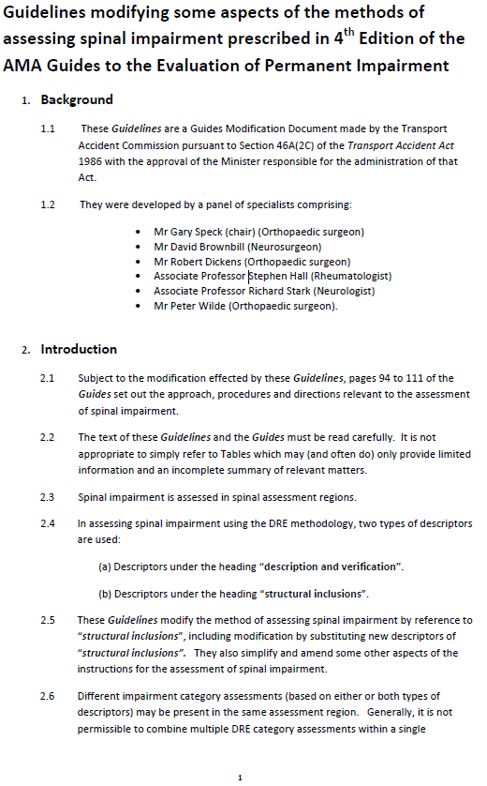
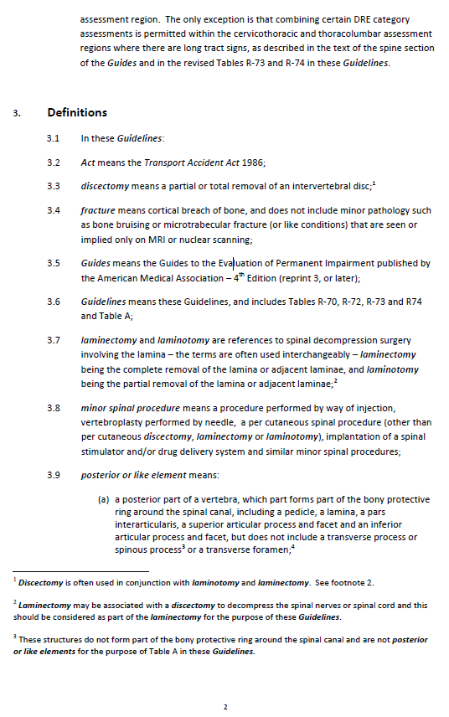
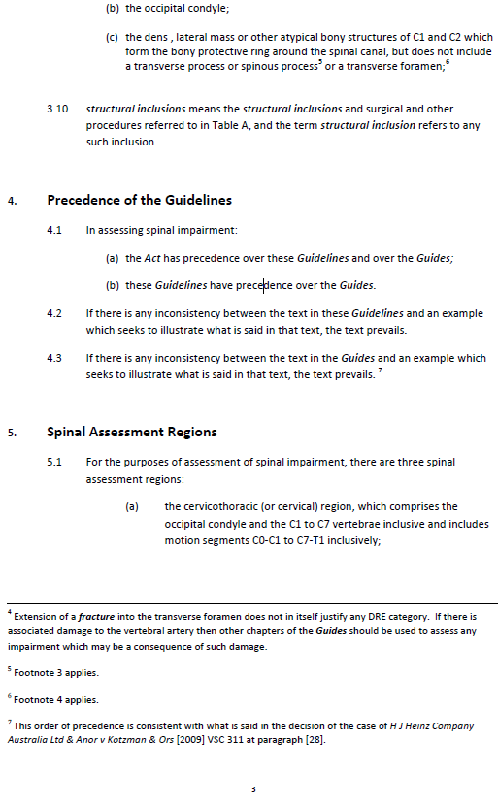
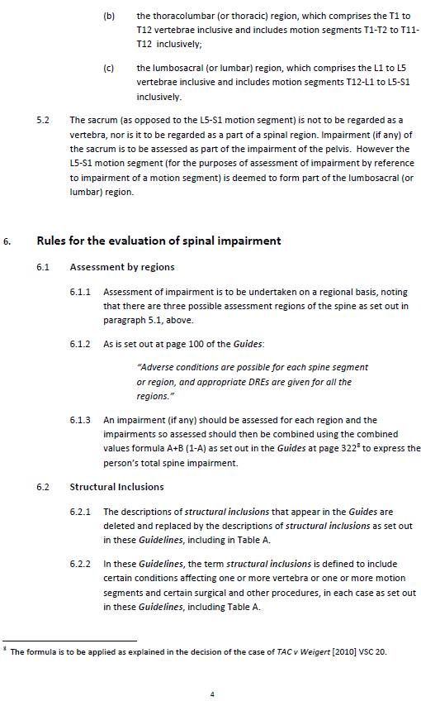
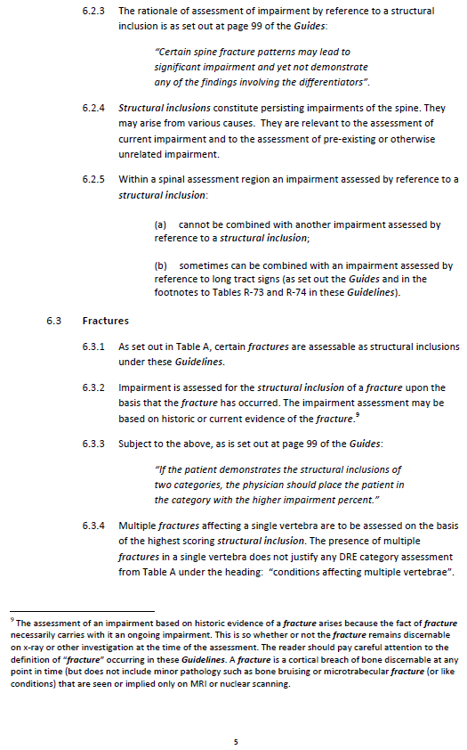
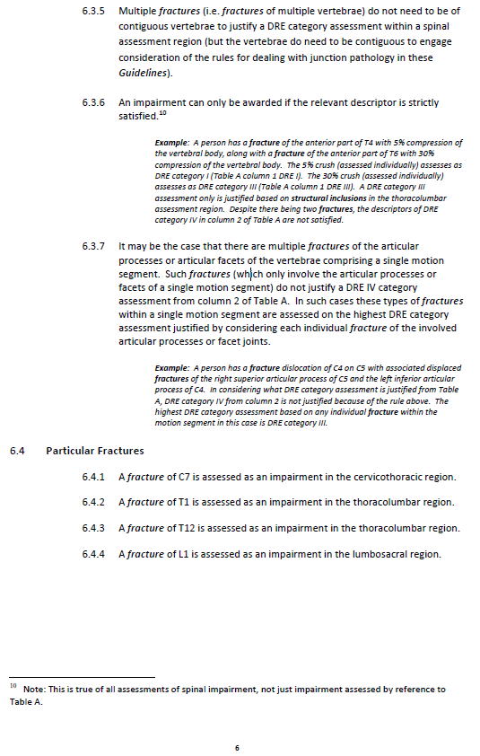
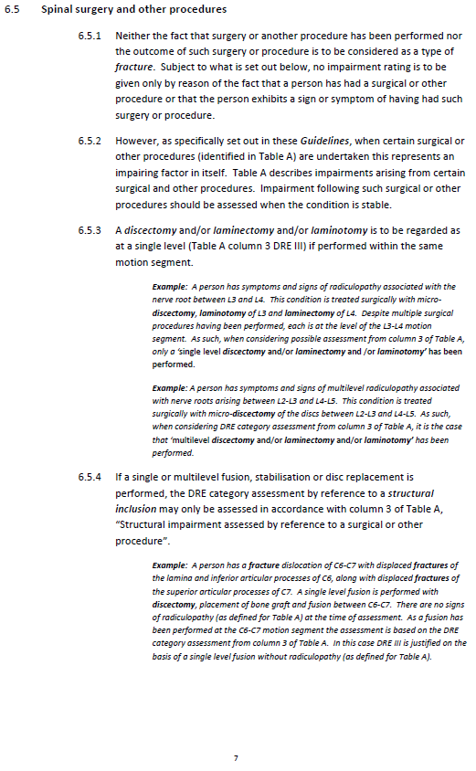
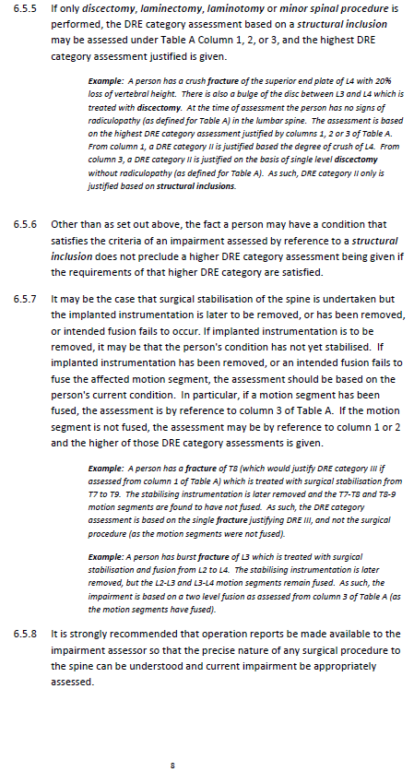
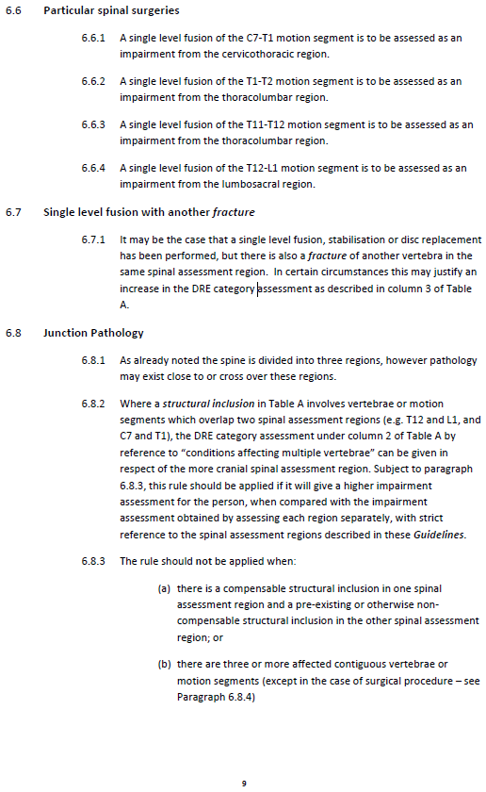
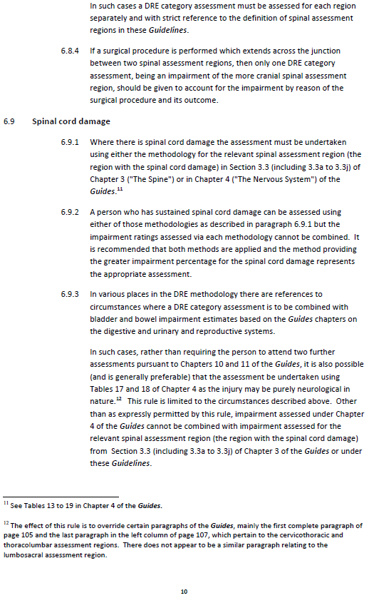
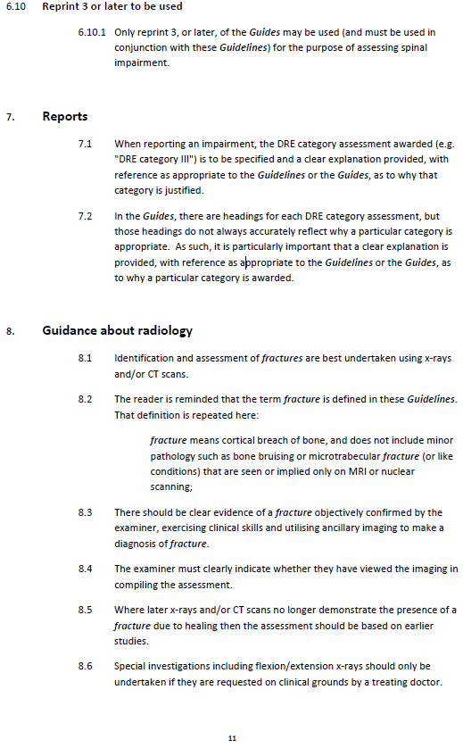
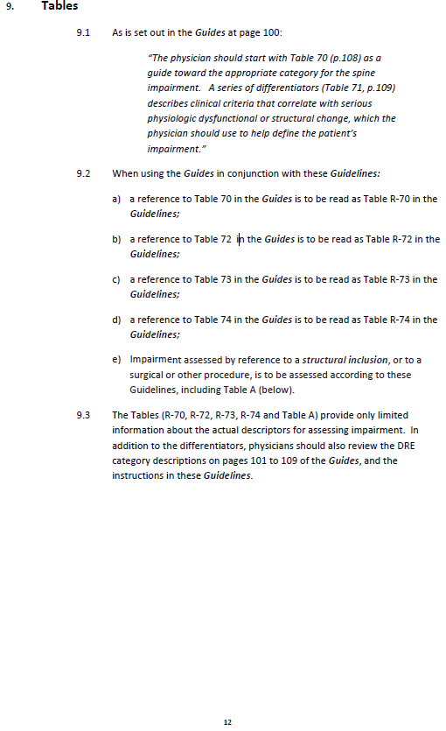
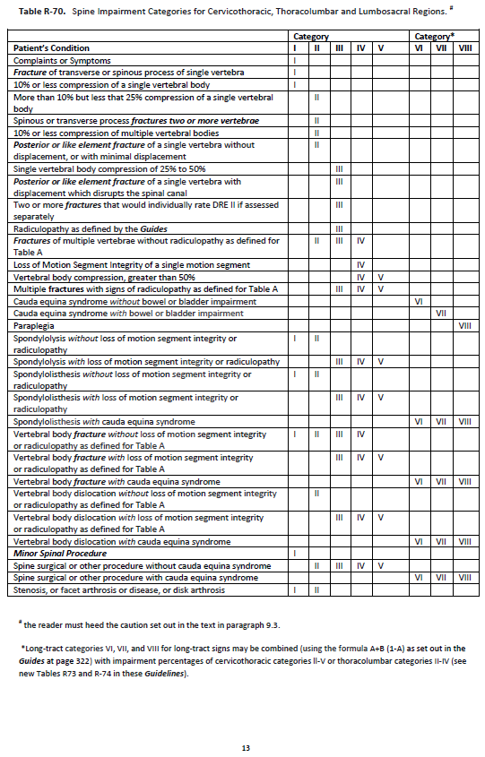
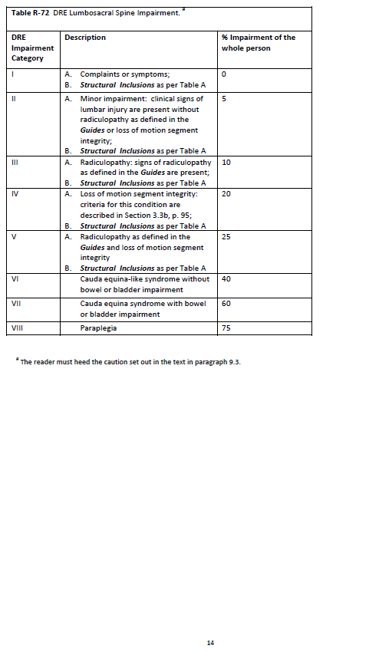
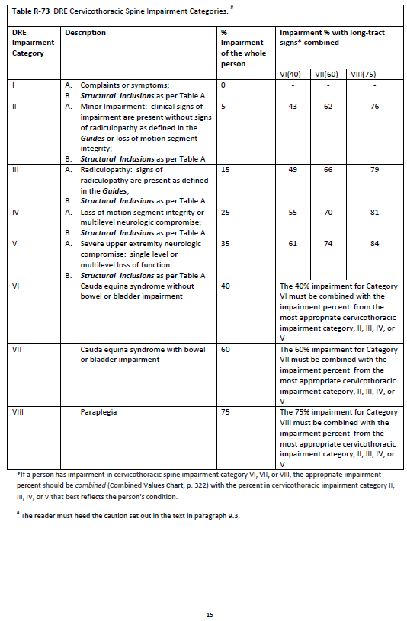
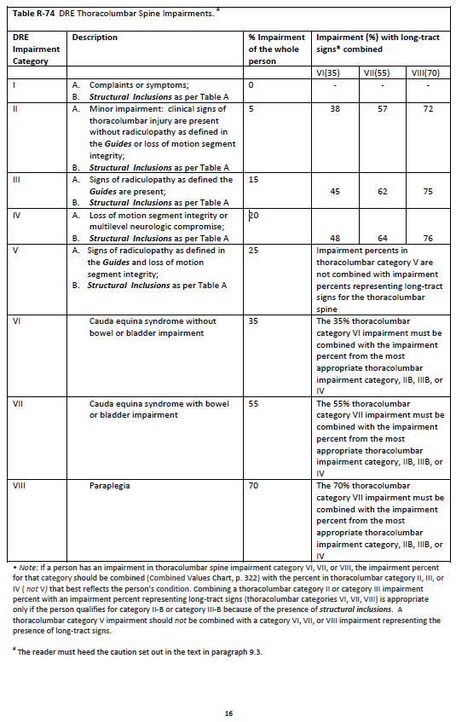
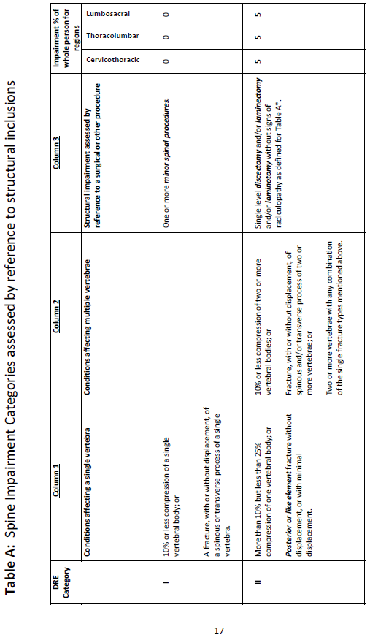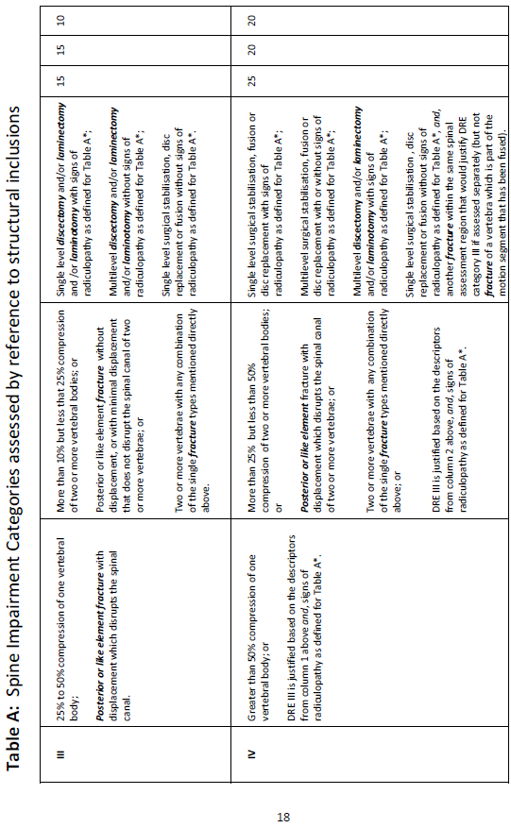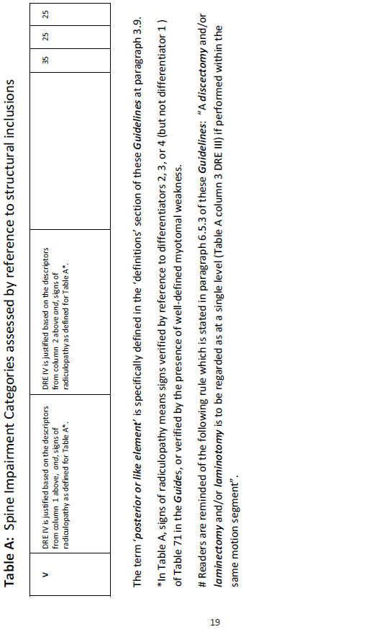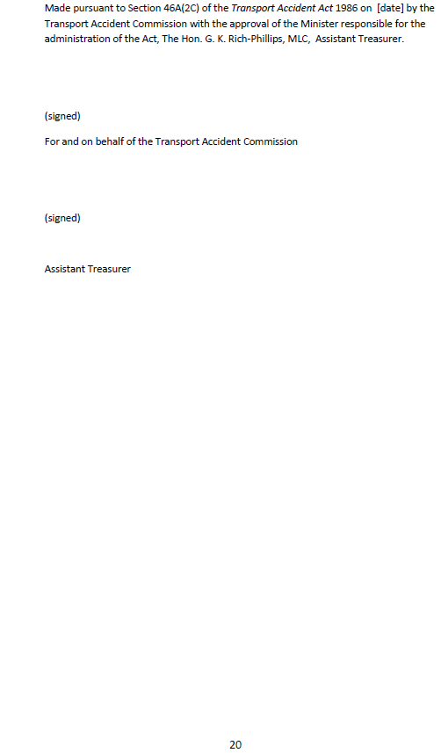

Terms of reference
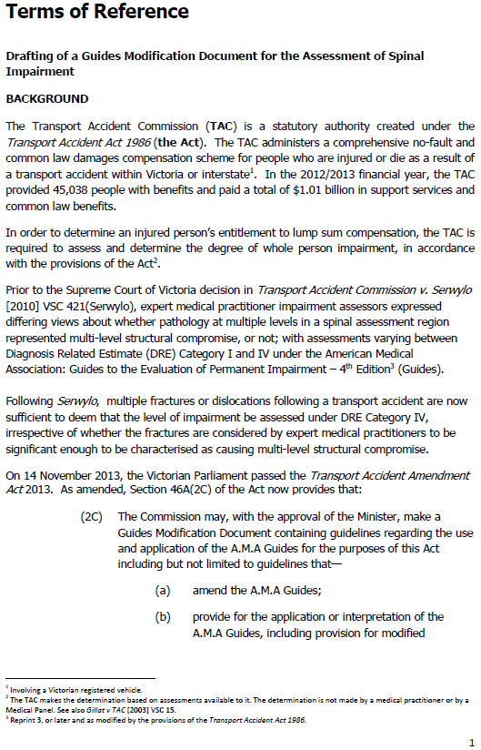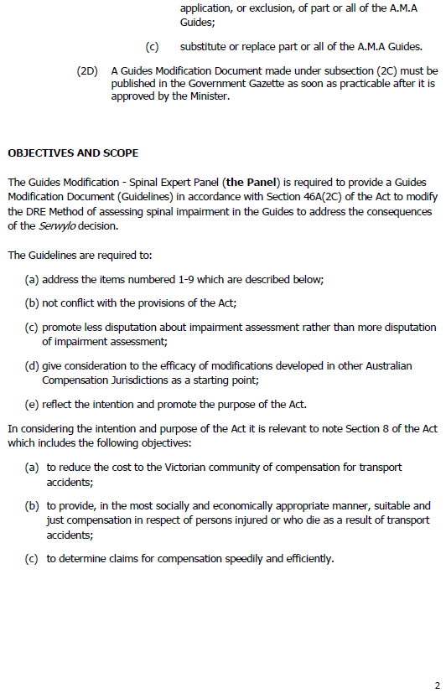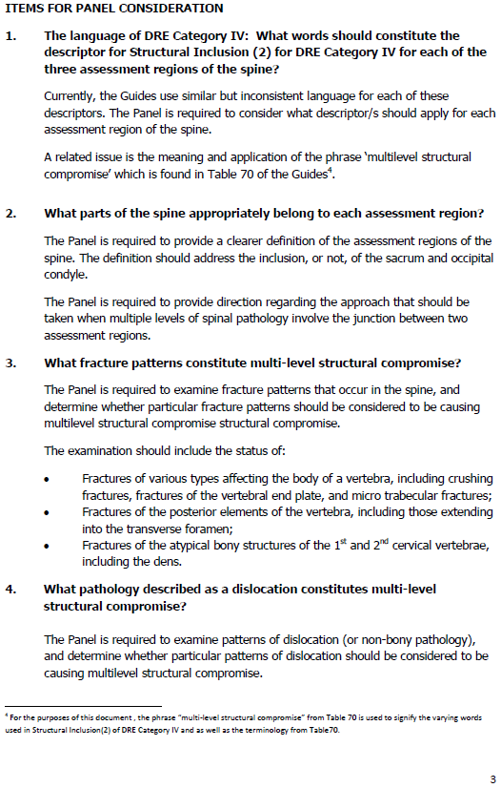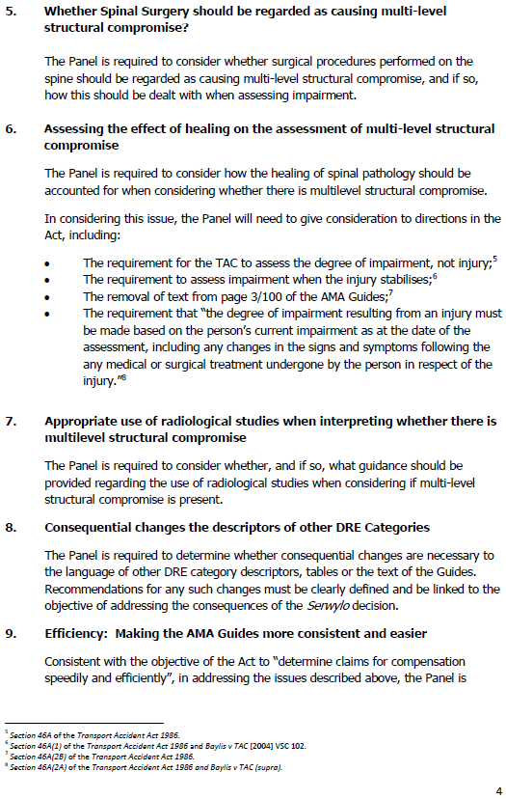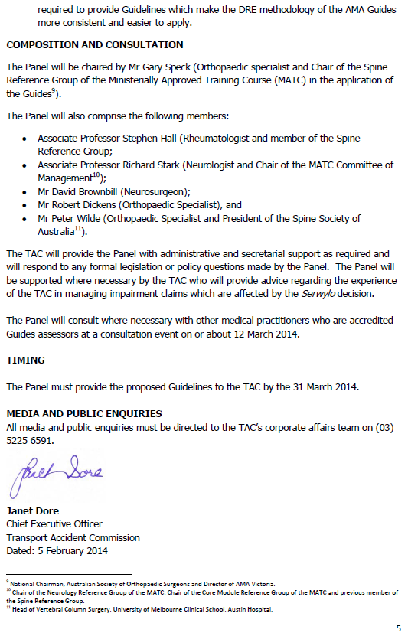

Calculation of cost per accident year and liability amounts resulting from Serwylo
This appendix provides information on the calculations of the cost per accident year and liability amounts resulting from Serwylo and from the GMD, as well as an explanation of the non-linear relationship between number of claimants affected and value of the transfer between claimants with multiple spinal fractures and the scheme under each implementation option.
It should be noted that all figures outlined in this section are estimates only, and are based on assumptions that are uncertain. The underlying data was provided by either the TAC itself or various other sources as indicated in the text. Estimates relating to cost and liability have been provided in consultation with PwC Actuarial, which is the TAC’s actuary.
It is important to note here that any reduction in compensation to claimants would reduce cost pressure on the scheme. From a cost-benefit analysis perspective, this impact simply represents a transfer of resources or redistribution between two groups in society. Transfers can only be regarded as enhancing community wellbeing if a decision is made that one group derives more value from the resources than the other. In this case, we do not make this assumption and so the cost-benefit impact of this transfer is therefore nil.
Post-Serwylo cost and liability calculations
Data provided by the TAC covering impairment claims over the past decade identified that on average, there are 1,500 impairment claims per year. In order to identify the impact of Serwylo, we identified the proportion of claimants with spinal injuries in the DRE II or DRE III category whose WPI was likely to increase to DRE IV or above as a result of the consequences arising from Serwylo. This is outlined in Table 13.
Table 13: Number of Serwylo affected claims per year
 | Proportion of line above | Number of claims
Total Impairment Claims per year | N/A | 1,500
Spinal injury proportion | 43% | 645
DRE 2 or 3 proportion of spinal injuries | 90% | 581
Proportion affected following Serwylo (likely to increase to DRE IV) | 27% (11% of total) | 159
Source: PwC analysis of TAC data.
Following Serwylo, three compensation types were affected:
- Impairment lump sum benefits.
- Common law damages.
- Additional LOEC benefits.
In each case, we have worked out a cost per new accident year, which is broadly the number of claims affected multiplied by the average increase per claim. In addition, we have defined the increase in current liability to the TAC.
The current liability is the amount of funds owing to claimants still in the system. This is comprised of the total cost of accidents in each past year, less the amount not yet paid out in respect of those accidents. TAC data has shown that the number of accidents and the average cost of accidents have remained relatively constant over the recent past. Therefore, it is appropriate to use an estimation of the current year cost to calculate a retrospective liability measure.
Figure 3 below outlines an example of the total liability for 2014. The orange square represents the total cost of impairment claims to the TAC in the most recent year, which we assume to be relatively consistent. The liability is then the sum of this cost over past years less the compensation entitlements already paid out. The liability is represented by the blue triangle in the diagram below. Everything outside the blue triangle is assumed to have been paid. Mathematically, we can apply a liability multiplier to the cost per new accident year for each compensation type based on TAC data surrounding the average time taken for compensation to be paid out. Conceptually, the liability multiplier reflects the average number of years between accident date and final payment date. In terms of the three compensation types dealt with in this analysis, impairment benefits are traditionally paid out the soonest, and therefore have the lowest liability multiplier. Common law payments, which have to go through the court system traditionally take longer, while additional LOEC compensation is a recurring amount that can be paid until the claimant reaches retirement age. In essence, a longer lag between accident and average payment date equals a higher liability multiplier.
Figure 3: Liability multiplier example
 |  | Payment Year
 |  | Yr0 | Yr1 | Yr2 | Yr3 | Yr4 | Yr5
Accident Year | 2009 |  |  |  |  |  | X
Accident Year | 2010 |  |  |  |  | X | X
Accident Year | 2011 |  |  |  | X | X | X
Accident Year | 2012 |  |  | X | X | X | X
Accident Year | 2013 |  | X | X | X | X | X
Accident Year | 2014 | X | X | X | X | X | X

- Impairment benefits
The data provided by the TAC showed that the average increase in impairment benefits per claim amounted to $27,000, equating to a total increase of $4.3 million per new accident year and a liability impact on impairment benefits of $15.5 million (refer to Table 14).
Table 14: Cost relating to Serwylo on impairment benefits
Change in impairment cost and liability | Value
Number of claims with change in WPI | 159
Average increase in impairment benefit | $27k
Cost per new accident year | $4.3m
Liability multiplier | 3.6
Change in liability | $15.5m
Source: PwC analysis of detailed TAC data.
- Common law damages
Due to the uncertain nature of common law payments, there are a number of factors to consider.
Taking into account the number of claimants affected by the consequences arising from Serwylo that are already receiving common law payments, the change in serious injury as a result of the new WPI assessment and the requirement that the client was not at fault, we have estimated the number of additional claims to be 20.6 (refer Table 15 below). At an average cost of $270,000 per claim, this equates to a total cost for new claims of $5.5 million.
Our analysis also considered existing common law claims that will be settled prior to the impairment benefit. In these cases, new common law claims will not be generated. However, we have assumed that the damages amount for these claimants is likely to increase in practice as a higher impairment score may factor in to the settlement process. It is important to note that common law damages are based on the level of pain and suffering, loss of future earnings and contributory negligence. Therefore, WPI is only one input into the calculation of the settlement amount. Given this, we have assumed that common law damages are half as sensitive to changes in WPI as impairment benefits are (impairment benefits are almost exclusively determined by WPI). Our estimate of the increase per claim is therefore half of the per claim impairment increase of $27,000 ($14,000). The data showed that there will be on average 34 of these cases per year, producing a total cost of $0.5 million. Added to the $5.5 million above, the total cost is $6.0 million.
Lastly, from data provided by the TAC we can estimate that approximately half of claimants receiving impairment benefits will be eligible for common law payments (that is, qualify as ‘seriously injured’ and not be the at fault party). Claimants receiving both impairment benefits and common law settlement will have the latter payment offset against the former (regardless of which is paid out first). As outlined in Table 14, the increase in impairment per new accident year is $4.3 million. Therefore, approximately half of this increase ($2.1 million) will be offset against the increase in common law settlement. This takes the total net increase for common law damages to $3.9 million. Refer to Table 15 for a summary of the calculation.
Table 15: Cost relating to Serwylo on common law damages
Change in common law cost | Value
Number of claims with change in WPI | 159
Already receiving common law | 80
Potential additional common law claims | 79
Proportion of claims where claimant not at fault | 40%
Proportion that will now reach SI threshold | 65%
Additional claims- Impairment received | 20.6
Average cost per claim | $270k
Cost for new claims | $5.5m
Claims that have not yet received impairment | 34
Increase in settlement size | $14k
Cost for existing claims | $0.5m
Cost per new accident year | $6.0m
Offset from impairment benefits | -$2.1m
Net cost per new accident year | $3.9m
Source: PwC analysis of detailed TAC data.
The liability increase post-Serwylo is estimated as $20.7m (refer to Table 16). The offset from impairment figure is calculated by multiplying the $2.1m offset in Table 15 by the impairment benefit liability multiplier of 3.6.
Table 16: Common law damages liability change from Serwylo
Change in common law liability | Value
Cost per new accident year | $6.0m
Liability multiplier | 4.7
Change in liability (prior to overlap adjustment) | $28.4m
Offset from impairment | -$7.7m
Change in liability | $20.7m
Note: Figures may not sum exactly due to rounding
Source: PwC analysis of detailed TAC data.
- Additional LOEC benefits
The key additional assumptions relating to the effect on LOEC following Serwylo are:
- the proportion of claims expected to now exceed WPI of 50 per cent
- the average cost of these claims.
We have estimated that 8 per cent of claimants will experience an increase above the 50 per cent WPI threshold and the average benefit per claimant will be approximately $500,000. In addition, we have taken into account that as per above, approximately 50 per cent of claimants are receiving common law damages and will therefore experience a reduced LOEC benefit. The number of additional income claims post-Serwylo is estimated to be 6.4, equating to a cost of $3.2 million per new accident year, as shown in Table 17.
Table 17: Cost relating to Serwylo on additional LOEC benefits
Change in LOEC cost | Value
Number of claims with change in WPI | 159
Proportion not receiving common law | 50%
Proportion exceeding 50% post-Serwylo | 8%
Additional LOEC claims beyond 3 years | 6.4
Average cost | $500k
Cost per new accident year | $3.2m
Source: PwC analysis of detailed TAC data.
The liability impact must take into account that the LOEC benefits are paid out on an ongoing basis into the future. Therefore, the discount rate used is lower when calculating liability estimates than cost estimates. This increases the average cost per claim to $700,000. This means that for liability purposes the total cost per year is $4.5 million, as opposed to the $3.2 million calculated above. The total liability impact is $31.3 million, as shown in Table 18
Table 18: Additional LOEC benefits liability change from Serwylo
Change in LOEC liability | Value
Additional LOEC claim beyond 3 years | 6.4
Average cost | $700k
Cost per year | $4.5m
Liability multiplier | 7
Total liability increase | $31.3m
Note: Figures may not sum exactly due to rounding
Source: PwC analysis of detailed TAC data.
The total costs and liability impact resulting from the consequences of Serwylo are summarised in Table 19.
Table 19: Estimated change in costs and liability impact following Serwylo
Change in LOEC liability | Estimated cost per new accident year | Estimated change to liability
Impairment Lump Sum Benefits | $4.3m | $15.5m
Loss of Earnings Capacity Benefits | $3.2m | $31.3m
Common Law Damages | $3.9m | $20.7m
TOTAL | $11.4m | $67.5m
Source: PwC analysis of detailed TAC data
Post-GMD cost and liability calculations
The TAC estimates that the GMD is likely to restore 80 per cent of the number of claimants with multiple spinal fractures to the pre-Serwylo state. To estimate the cost and liability saving to the scheme, it is necessary to use a weighted average of the percentage of claimants affected for each type of additional compensation entitlement. As shown in Table 20 and Table 21, the actual cost saving of the GMD as a proportion of the post-Serwylo impact is 74.5 per cent. This is lower than the 80 per cent of claimants affected as it takes into account changes in common law and LOEC payments, which are a subset of impairment claims and expected to be less sensitive to the GMD changes.
Table 20: Scheme cost impact following GMD implementation
Type of compensation | Post-Serwylo impact per new accident year | Estimated impact of GMD (%) | Estimated impact of GMD ($) | Residual post-Serwylo impact
Impairment Lump Sum Benefits | $4.3m | -80% | -$3.4m | $0.9m
Loss of Earnings Capacity Benefits | $3.2m | -78% | -$2.5m | $0.7m
Common Law Damages | $3.9m | -65% | -$2.6m | $1.3m
TOTAL | $11.4m | -74.5% | -$8.5m | $2.9m
Note: Figures may not sum exactly due to rounding
Source: PwC analysis of detailed TAC data.
The estimated saving to the scheme per new accident year once the GMD is implemented is therefore $8.5 million.
Table 21: Liability impact following GMD implementation
Type of compensation | Post-Serwylo impact per new accident year | Estimated impact of GMD (%) | Estimated impact of GMD ($) | Residual post-Serwylo impact
Impairment Lump Sum Benefits | $15.5m | -80% | -$12.4m | $3.1m
Loss of Earnings Capacity Benefits | $31.3m | -78% | -$24.4m | $6.9m
Common Law Damages | $20.7m | -65% | -$13.5m | $7.2m
TOTAL | $67.5m | -74.5%* | -$50.3m | $17.2m
Note: Figures may not sum exactly due to rounding
Source: PwC analysis of detailed TAC data.
The GMD is estimated to reverse 74.5 per cent of the TAC’s current liability if applied to all claimants in the scheme. This translates to a liability saving of $50.3 million, leaving a residual liability of $17.2 million.
Table 22 outlines how much of this potential liability saving is actually realised under the proposed implementation options. Under Implementation Option 1, the liability saving is zero as only future claimants are affected, and therefore the full post-Serwylo liability to existing claimants will remain. However, in Implementation Option 2, all existing claimants will be subject to the new GMD, except those who undergo their impairment assessments between 1 July 2014 and 31 December 2014.Therefore, the post-Serwylo liability to all existing claimants except those who are assessed within this timeframe will be cleared. The liability saving is estimated to be $46 million, which is the full $50.3 million worth of existing claimant liability minus the cost of the six months’ worth of claimants that the GMD will not apply to under Implementation Option 2 ($8.5 million/2 = $4.3 million).
Table 22: Liability saving captured under each implementation option
Type of compensation | Post-Serwylo impact per new accident year
Additional liability incurred post-Serwylo | $67.5m
Potential liability reversed by GMD | $50.3m
Liability reversed under Implementation Option1 | $0m
Liability reversed under Implementation Option 2 | $46m
Source: PwC analysis of detailed TAC data
Number of claims affected vs value of transfer under each implementation option
Table 23: Extract of equity impact and transfer under each implementation option
Type of compensation | Implementation Option 1 | Implementation Option 2 | Difference | Percentage difference
Number of claimants affected | 1251 | 1788 | 537 | 43%
Value of transfer | $68.4m | $114.4m | $46m | 67%
Source: PwC analysis of detailed TAC data
As shown in Table 23, Implementation Option 2 affects 43 per cent more claimants but represents an additional transfer of 67 per cent. This nonlinearity is based on differences in average cost between existing and future claimants. The transfer value in Implementation Option 1 is based on future claimants only, and is therefore a function of the cost per new accident year of $8.5 million, outlined in Table 20. The largest component of this cost relates to impairment benefits, which account for approximately 40 per cent ($3.4 million/$8.5 million).
On the other hand, the transfer value of Implementation Option 2 is based partially on the payments owing to existing claimants, which is represented by the liability calculations outlined in Table 21. The liability figure of $50.3m is heavily dominated by the LOEC benefits ($24.4 million/$50.3 million = 49 per cent). This is due to LOEC benefits traditionally taking much longer to pay out than the other two compensation types, which are lump sum in nature.
Therefore, the weighting between the three compensation types for future and existing claimants differs. This has important implications on the transfer values as LOEC benefits have a much higher average cost per claimant associated with them than impairment benefits due to their ongoing nature (Refer Table 14, Table 15 and Table 17).
Hence, the 516 existing claimants affected under Implementation Option 2 have compensation entitlements that are skewed towards LOEC benefits, and therefore have a higher average cost associated with them.
Furthermore, the liability calculation that is the basis of the difference between the transfer amounts for the two options ($46 million) also uses a discount rate that is lower than the discount rate associated with the future claimant cost calculation (refer to footnote 77 for explanation). This has the effect of inflating the transfer of Implementation Option 2 and is therefore also partially responsible for the non-linear relationship between the number of claims and the difference in the value of the transfer.

Letter outlining Expert Panel considerations for GMD

Transport Accident Act 1986 (Vic)
Or 25 per cent for assessment of the cervical spine.
This percentage is based on PwC’s detailed analysis of TAC data and the TAC’s assessment of a significant number of individual cases.
All analysis in this RIS is based on the expected release date of the GMD, 1 July 2014.
Victorian Competition and Efficiency Commission, Adjusting the Balance: Inquiry into Aspects of the Wrongs Act 1958, draft report, Victoria, November 2013, p6.
Ibid
Based on figures outlined at the beginning of Chapter 5
As the calculations in this RIS are as at the expected release date of 1 July 2014, the number of claimants affected is equal to ten years minus two months (1 July 2014 to 31 August 2014) of future claimants. This is calculated by: (1,590 - (159*2/12)) * 80% = 1,251
1,251/2,315=54%
Calculated as the number of future claimants for all other injuries (excluding multiple spinal fractures) from Table 8, less two months of claimants between 1 July 2014 and 31 August 2014. Calculated as: 13,410 – (1,341*(2/12)) = 13,187.
A claimant is assumed to enter the scheme on their accident date and exit the scheme on the date of receiving their final compensation payment (this may be impairment, LOEC or common law settlement). The number of ‘existing claimants’ therefore refers to all claimants that are within this bracket.
Calculated as 80 per cent of the claimants in the scheme as at 1 July 2014 less the six months of claimants who will be assessed between 1 July 2014 and 31 December 2014, equal to (725 – 159/2)*80% = 516
1,590 * 80% + 516 = 1,788
1,788/2,315 = 77%
19,525 – 1,341 (one year’s worth of non-spinal related accidents) = 18,184
Annual incremental transfer due to the GMD (refer Appendix C) = $11.4 million * 74.5% = 8.5 million Using a nominal discount rate of 7.5% and an inflation rate of 3.75% (equalling to a real discount rate of 3.75% used in NPV calculations) NPV for Implementation Option 1 (10 years) – $8.5m*10/12 (to exclude first two months) = $68.4.million. Implementation Option 2 figure is calculated using the NPV figure calculated in Implementation Option 1 of $68.4 million (transfer away from future claimants) plus the calculated transfer from existing claimants (equal to the liability saving) of $46 million (refer footnote 17) Total = $68.4m + $46m = $114.4m. Discount rates: The nominal discount rate used in NPV calculations is derived from the TAC’s long term forecasted investment return: This discount rate was applied for consistency with that used in the calculation of the cost per new accident year figure ($11.4 million), which was used as an input. The inflation rate used in the NPV calculations is a forecasted average weekly earnings growth figure based on historical data. This was considered a more appropriate measure than CPI as compensation based on loss of earnings is indexed with average weekly earnings.
The TAC’s current liability to existing claimants has been estimated to be $67.5m. In addition, the GMD is estimated to reduce the additional compensation to claimants resulting from the consequences of Serwylo by 74.5 per cent. Therefore, the maximum liability saving from an option that is implemented immediately is $67.5m * 74.5% = $50.3m. However, Implementation Option 2 does not affect six months’ worth of claimants who will still be compensated under the post-Serwylo state, therefore their liability saving will not be recognised. As the per year cost from the consequences of Serwylo is estimated to be $11.4m, the liability figure is $50.3m – 0.5(11.4m * 74.5%) = $46 million.
C R Sunstein, ‘The Cost-Benefit State: The Future of Regulatory Protection’, Section of Administrative Law and Regulatory Practice, American Bar Association, USA, 2002, 190.
Victorian Competition and Efficiency Commission, Adjusting the Balance: Inquiry into Aspects of the Wrongs Act 1958, draft report, Victoria, November 2013, 5.
CTP stands for ‘Compulsory Third Party’ levy, which refers to the TAC charge that all motor vehicle owners pay for transport accident insurance as part of their annual registration.
It should be noted that all figures outlined in this section (and in the remainder of the RIS) are estimates only, and are based on assumptions that are uncertain. The underlying data was provided by either the TAC itself or various other sources as indicated in the text. Estimates relating to cost and liability have been produced in consultation with PwC Actuarial, which is the TAC’s actuary.
. Implementation Option 2 involves 43% more claims than Implementation Option 1, however the associated cost is 67% higher, mainly reflecting the fact that – unlike Implementation Option 1 – Implementation Option 2 affects existing claimants as well as new accidents and there is a different benefit mix (and therefore cost) outstanding between existing claimants and new accidents. For example, LOEC benefits, which involve a higher average cost, figure more prominently for existing claimants.
Department of Treasury and Finance Victoria, Victorian Guide to Regulation (Edition 2.1), Department of Treasury and Finance, Melbourne, August 2011.
Section 8 of the Act.
National Institute of Health, MedilinePlus, ‘Spinal Fusions’, http://www.nlm.nih.gov/medlineplus/ency/article/002968.htm, accessed April 2014.
Section 93(4)(c) of the Act.
It should also be noted that DRE Category IV is the only descriptor in the Guides that actually mentions multiple fractures. There are no other clearly written descriptors that provide alternative assessment categories for multiple fractures of varying severity.
‘Actual level of impairment’ as determined by medical practitioners based exclusively on structural compromise (the pre-Serwylo case).
In particular, sections 10(1)a and 12H(1)a of the Subordinate Legislation Act 1994.
Department of Treasury and Finance Victoria, Victorian Guide to Regulation (Edition 2.1), Department of Treasury and Finance, Melbourne, August 2011.
Department of Treasury and Finance Victoria, Victorian Guide to Regulation (Edition 2.1), Department of Treasury and Finance, Melbourne, August 2011, 72
Transport Accident Act 1986 (Vic), section 11.
This percentage is based on PwC Actuarial’s detailed analysis of TAC data and the TAC’s assessment of a significant number of individual cases. Further detail is provided in Chapter 5.
Claimants may still be entitled to recover common law damages if their injury was a ‘serious injury’ pursuant to section 93 of the Act.
See Appendix B.
A claimant is assumed to enter the scheme on their accident date and exit the scheme on the date of receiving their final compensation payment (this may be impairment, LOEC or common law settlement). The term ‘existing claimants’ refers to all claimants that are within this bracket.
Information provided by the TAC.
Informed by the TAC.
This percentage is based on PwC’s detailed analysis of TAC data and the TAC’s assessment of a significant number of individual cases.
A claimant is assumed to enter the scheme on their accident date and exit the scheme on the date of receiving their final compensation payment (this may be impairment, LOEC or common law settlement). The number of ‘existing claimants’ therefore refers to all claimants that are within this bracket. Data provided by TAC has shown that there is an estimated 6,840 existing claimants in the scheme as at 1 July 2014.
Source: TAC. Additionally, the average time taken for a claimant to pass through the scheme has also remained relatively stable over time. Therefore, we can assume that the number of people within the scheme at any given time is approximately 6,840.
It should be noted that this figure represents the maximum number of claimants that can be affected by the GMD. The figure may be lower as the number of existing claimants may include a small number that have already conducted their impairment assessment and are only waiting for their payment. As the time between impairment assessment and payment is generally quite low, we assume that the number of claimants in this category is minimal.
PwC analysis of TAC data over time.
We assume that this figure will continue to remain static for the duration of the calculation period of ten years.
Victorian Competition and Efficiency Commission, Adjusting the Balance: Inquiry into Aspects of the Wrongs Act 1958, draft report, Victoria, November 2013, p6.
Ibid
Based on figures outlined at the beginning of Chapter 5
As the calculations in this RIS are as at the expected release date of 1 July 2014, the number of claimants affected is equal to ten years’ minus two months’ (1 July 2014 to 31 August 2014) worth of future claimants. This is calculated by: (1,590 - (159*2/12)) * 80% = 1,251
1,251/2,315=54%
Calculated as the number of future claimants for all other injuries (excluding multiple spinal fractures) from Table 8, less two months of claimants between 1 July 2014 and 31 August 2014Calculated as: 13,410 – (1,341*(2/12)) = 13,187.
The cost represents the value of the time of medical practitioners who are undertaking the training, Estimated on the basis of up to 132 hours at $350 p/hour plus GST in professional fees that may be required to be paid for development and facilitation of up to six training sessions for doctors who wish to be trained in the use of the GMD. 132 hours @ $350 p/hour plus 10% GST =$50,820
C R Sunstein, ‘The Cost-Benefit State: The Future of Regulatory Protection’, Section of Administrative Law and Regulatory Practice, American Bar Association, USA, 2002, p190.
Victorian Competition and Efficiency Commission, Adjusting the Balance: Inquiry into Aspects of the Wrongs Act 1958, draft report, Victoria, November 2013, p5.
CTP stands for ‘Compulsory Third Party’ levy, which refers to the TAC charge that all motor vehicle owners pay for transport accident insurance as part of their annual registration.
Annual incremental transfer due to the GMD (refer Appendix C) = $11.4 million * 74.5% = 8.5 million Using a nominal discount rate of 7.5% and an inflation rate of 3.75% (equalling to a real discount rate of 3.75% used in NPV calculations) NPV (10 years) – $8.5m*10/12 (to exclude first two months) = $68.4.million. Nominal discount rate is derived from the TAC’s long term forecasted investment return: This discount rate was applied for consistency with the calculation of the cost per new accident year figure ($11.4 million) that was used as an input. The inflation rate is a forecasted average weekly earnings growth figure based on historical data. This was considered a more appropriate measure than CPI as compensation based on loss of earnings is indexed with average weekly earnings.
Based on figures outlined at the beginning of Chapter 5
(725 – 159/2)*80% = 516
1,590 * 80% + 516 = 1,788
1,788/2,315 = 77%
19,525 – 1,341 (one year’s worth of non-spinal related accidents) = 18,184
Strictly speaking, existing claimants do not have an entitlement or right to receive a certain level of compensation prior to their assessment, however grievances may stem from the reduction in the potential level of compensation that a claimant can receive given a set of injury characteristics.
If the assessment date specified was 1 July 2014, 580 (725*80%) claimants would have their rights and entitlements altered. However, as the assessment date is 1 January 2015, we effectively remove six months’ worth of multiple spinal fracture claimants who will still be assessed under the post-Serwylo case and therefore not have their rights and entitlements altered. As the annual number of multiple spinal fracture assessments impacted by the GMD is assumed to be 127 (159*80%), we estimate the number of related assessments in six months to be approximately 64. Therefore, the number of persons whose entitlements change under Implementation Option 2 is 516 (580 – 64 = 516)
127*(3/12) = 32
$67.5m* 74.5% - 0.5(11.4m* 74.5%) = $46m. This represents the 74.5% of the existing liability (as at 1 July 2014) that is reversed by the GMD, less the six months’ worth of payments (for the claimants who undergo assessments between 1 July 2014 and 31 December 2014) from the liability that will be paid on the post-Serwylo basis. Refer to Appendix C for further detail.
67.5m (Total liability denoted in Appendix C) – 46m = $21.5m.
Figure is calculated using an NPV figure calculated in Implementation Option 1 of $68.4 million (transfer away from future claimants) plus the calculated transfer from existing claimants (equal to the liability saving) of $46 million. Total = $68.4m + $46m = $114.4m.
Refer to Appendix C for an explanation of the relationship between number of claimants affected and the value of the transfer under both implementation options.
C R Sunstein, ‘The Cost-Benefit State: The Future of Regulatory Protection’, Section of Administrative Law and Regulatory Practice, American Bar Association, USA, 2002, p190.
Victorian Competition and Efficiency Commission, Adjusting the Balance: Inquiry into Aspects of the Wrongs Act 1958, draft report, Victoria, November 2013, p5.
Department of Treasury and Finance Victoria, Victorian Guide to Regulation (Edition 2.1), Department of Treasury and Finance, Melbourne, August 2011, p93
Department of Treasury and Finance Victoria, Victorian Guide to Regulation (Edition 2.1), Department of Treasury and Finance, Melbourne, August 2011, p94.
This assumption is based on TAC time series data that shows that the number of claims has remained approximately constant over the past decade or so. The assumption is also consistent with that used in our cost-benefit analysis. Data has also suggested that the cost per claim has not differed materially year on year, due to the stable mix of injuries. There is no reason to suggest that there will be any significant change to these trends in the foreseeable future.
Note that all liability figures in this analysis have been calculated using discount rates implied by the 31 December 2012 government bond yields. Refer to: F2 Capital Market Yields- Government Bonds < http://www.rba.gov.au/statistics/tables/>.
Figures may not sum exactly due to rounding
This refers to claims that are still eligible for common law prior or subsequent to Serwylo, however may have their settlement amount affected.
Note that we have subtracted the claimants receiving common law prior to Serwylo rather than subsequent to it. This proportion assumes that the additional claimants receiving LOEC benefits and that receiving common law damages following Serwylo are separate populations. The estimate is therefore an upper bound as there could be some overlap between the two, which would reduce the affected population and the total cost. However, as the average costs differ between the two compensation types (LOEC is higher), it is reasonable to assume that claimants who were entitled to common law damages may still continue on LOEC, which would mean minimal overlap.
Lower discount rates (than those used in the annual cost estimates) have been used for liability calculation here based on the discount rates implied by the 31 December 2012 government bond yields, which are 5.50% in the long run. This is due to the requirements of the accounting standard AASB1023 and the actuarial standard PS300, which stipulates that risk free valuation rates must be used to discount future cash flows. Refer to: F2 Capital Market Yields- Government Bonds at < http://www.rba.gov.au/statistics/tables/>. The risk free rates have been implicitly used in the calculation of the liability of the other two compensation types as well, however the difference in the average cost calculation was immaterial due to the shorter duration of the payments. As there is no standard for annual cost estimates, it was deemed that the TAC long run forecasted investment rate of return of 7.50% was a more appropriate estimate.
The remaining 21 of the 537 claimants affected under Implementation Option 2 but not Implementation Option 1 relate to those injured between 1 July 2014 and 31 August 2014, and are therefore still considered as future claimants for the purpose of our analysis.

